More Damning and More Disturbing Evidence for the Report ‘Scientific Expert Report on the COVID-19 Epidemic Response in Ireland’
November 2021

The following provides supporting evidence and supplementary evidence for the ‘Scientific Expert Report on the COVID-19 Epidemic Response in Ireland’ by Jay Bhattacharya, MD, PhD and Professor of Medicine in Stanford University, USA. Approximately 33% of this Report.
Dr. Dolores Cahill, Professor of Science and Immunology, UCD. Immunologist.
Dr. Anne McCloskey, medical doctor
Dr. Patrick Morrissey, medical doctor
Mr. Edward Shanahan, Barrister in Ireland and author of Section U of this paper with assistance from D.E. MSc (NUI Galway and University of Oxford)
Special Note
The information and evidence contained in this document exposes threats to the health and well being of all persons including all civilians, all members of the gardai (police), the DPP office, the judiciary, elected politicians, the military, industrial workers, professional workers, doctors, nurses, services workers, unions, etc. The purpose of this book of evidence and prior books is to save lives and expose wrong doing and the aforementioned threats. This is in accordance with the Irish Constitution, Irish laws, Human Rights laws and international laws and treaties.
Excess Mortality in Ireland by October 2021
This has been compiled by Kieran Morrissey who has presented statistics and statistical analysis for courts in the past. This excess mortality reached 2,356 excess deaths by October 2021. This uses the most up to date death statistics from RIP.ie . This rise occurred while hospital admissions for covid19 were very low. These excess deaths start with the introduction of covid19 vaccines in January 2021. Excess deaths for all of 2020 were 300. How did covid19 vaccines kill more people than covid19 ? is the Absolute All Cause Mortality Risk for covid19 vaccines being measured in Ireland ? is the Absolute All Cause Mortality Risk for Lockdowns and cancelled hospital appointments being measured in Ireland ? do they have the competence to do these measurements ? This Absolute All Cause Mortality Risk should also be categorised by age groups. See charts below.

Weekly
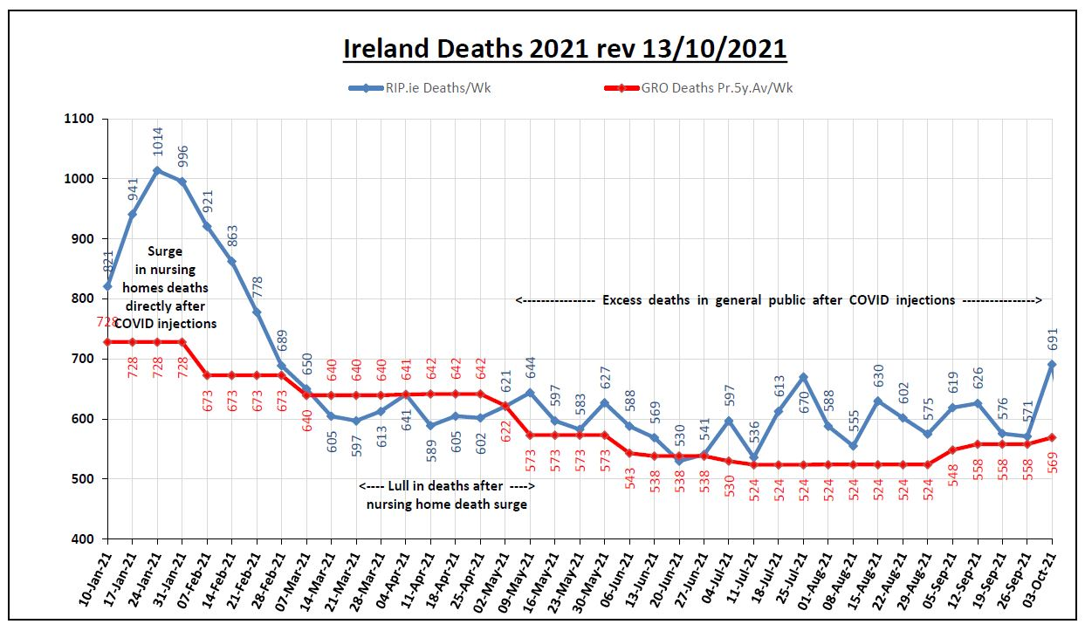
Monthly – RIP.ie VS NPHET figures
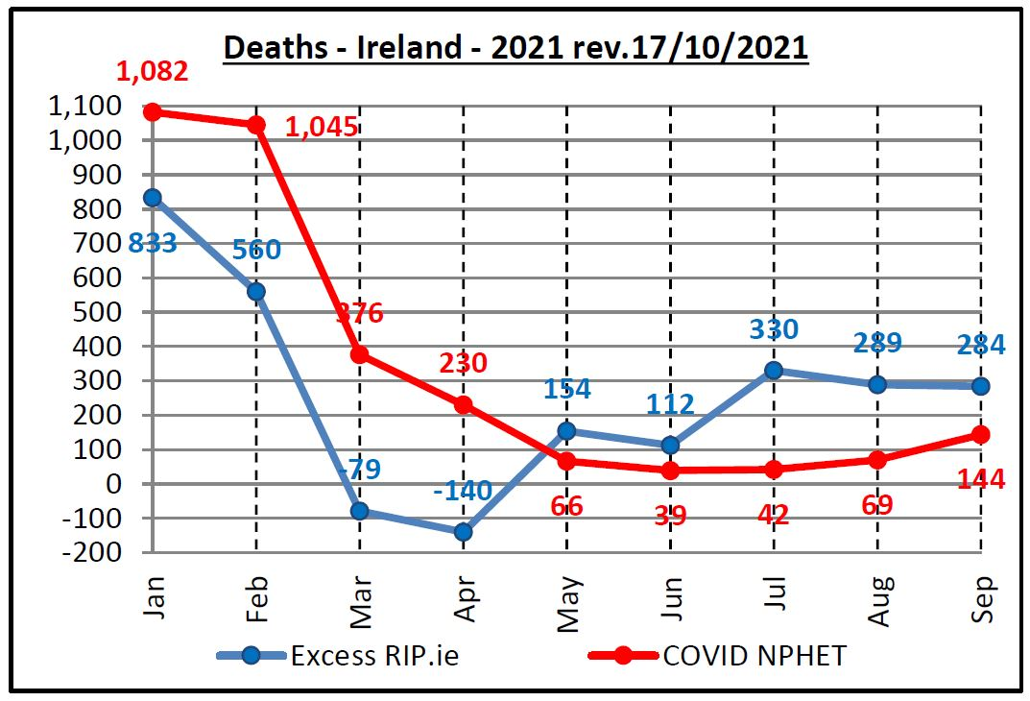
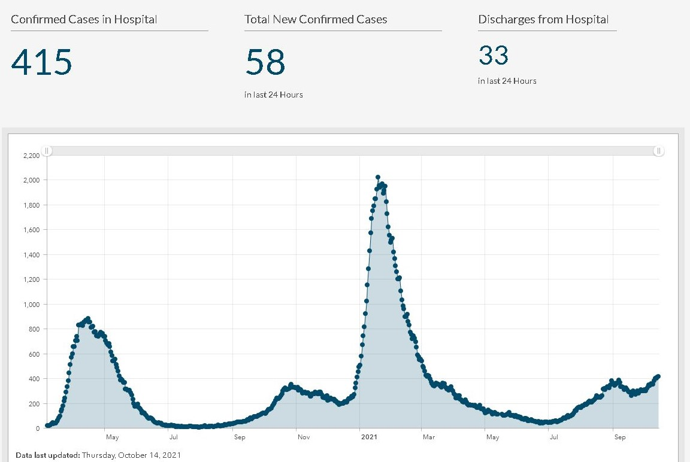
Source: https://covid19ireland-geohive.hub.arcgis.com/pages/hospitals-icu--testing

Updated Statistics 31 October, 2021
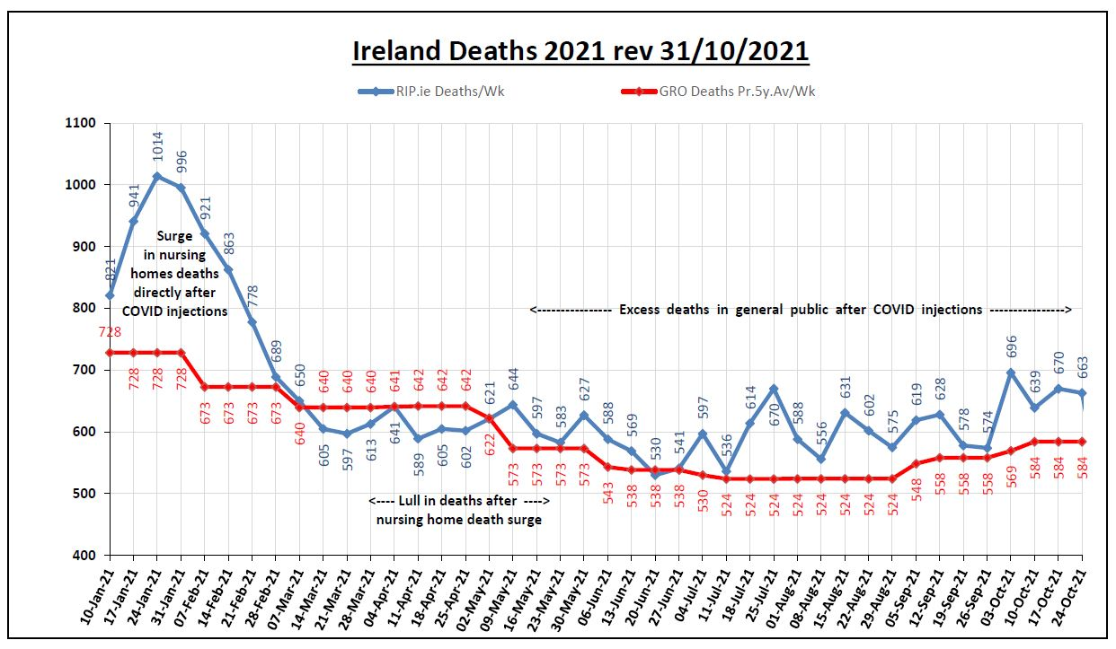
Massive rise in nursing home deaths in January and Feburary 2021 after covid vaccinations in them. This is very significant.
Excess Mortality up to 24 October 2021 in Ireland. Total Excess Mortality by end of October 2021 is 2,540 people and rising sharply. It is projected to rise to 4,000 people or more by the end of 2021. If the number of deaths become exponential in Winter due to many factors, the number could rise to more than 10,000. This is a National Emergency. By comparison, excess mortality for 2020, the year of the covid pandemic was 340 people.
We need an immediate investigation of the 2,540 excess deaths up to November 2021 to establish what is causing it and what role the covid vaccines are playing in this and what role the denial of safe and effective medicines for covid19 play in this. Also the role played by unlawful and illegal lockdowns which led to the cancellation of 200,000 hospital and clinic appointments for cancers, heart diseases, neurological diseases, respiratory diseases and other serious illnesses will need to be investigated. This has the characteristics of murder or manslaughter. We attach international evidence which corroborates these Irish findings.

Excess Mortality in Highly Vaccinated Countries
Most Highly covid vaccinated countries
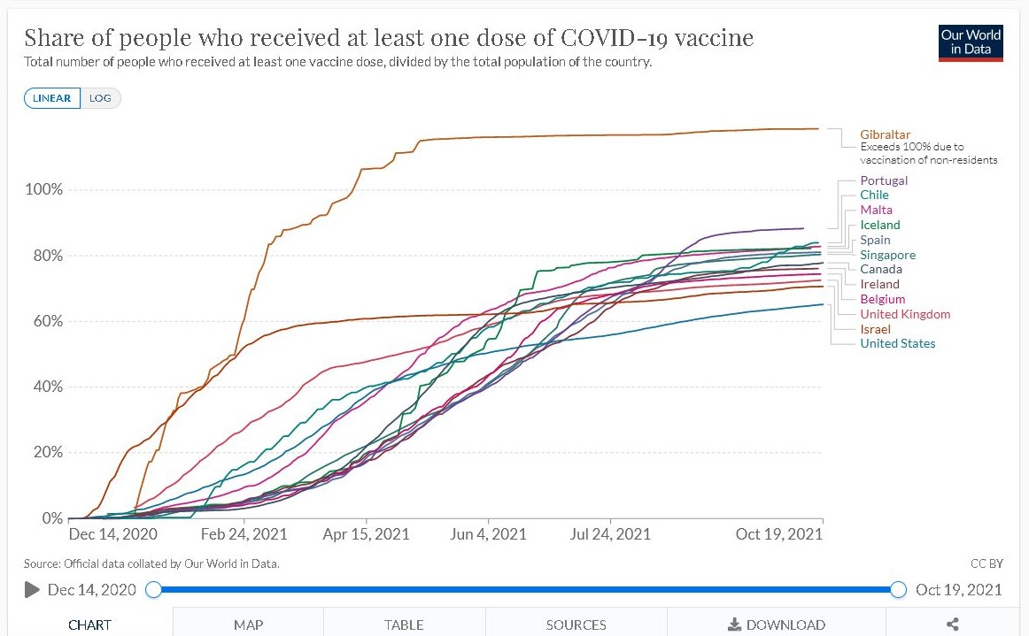
Excess Mortality by highly vaccinated country
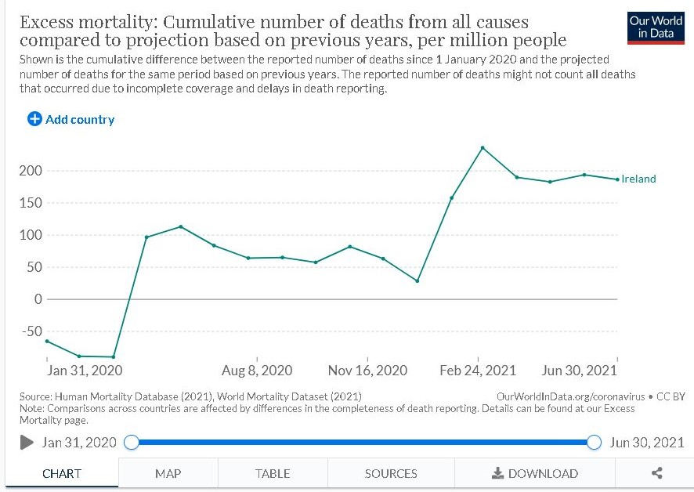
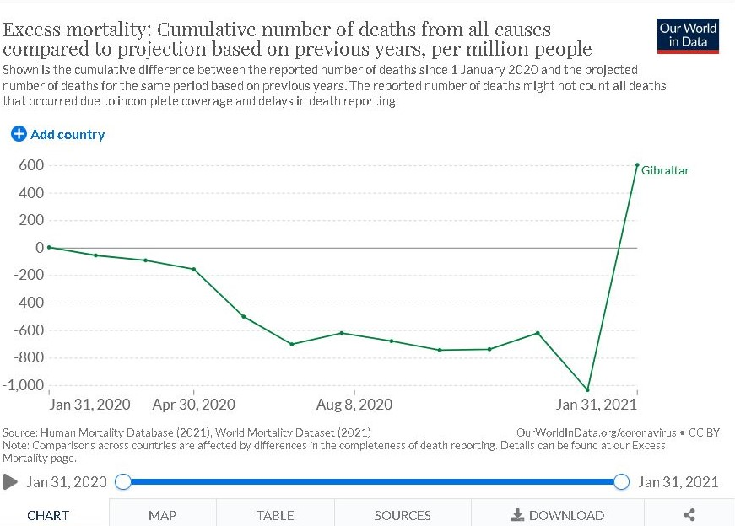
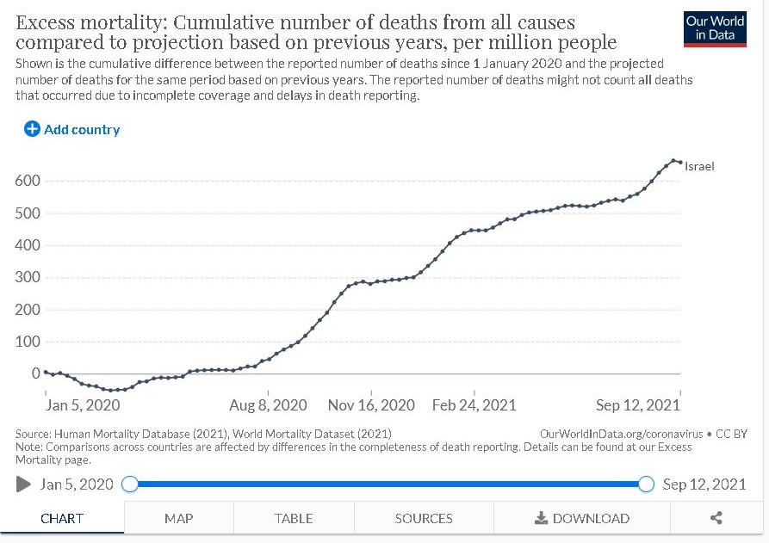

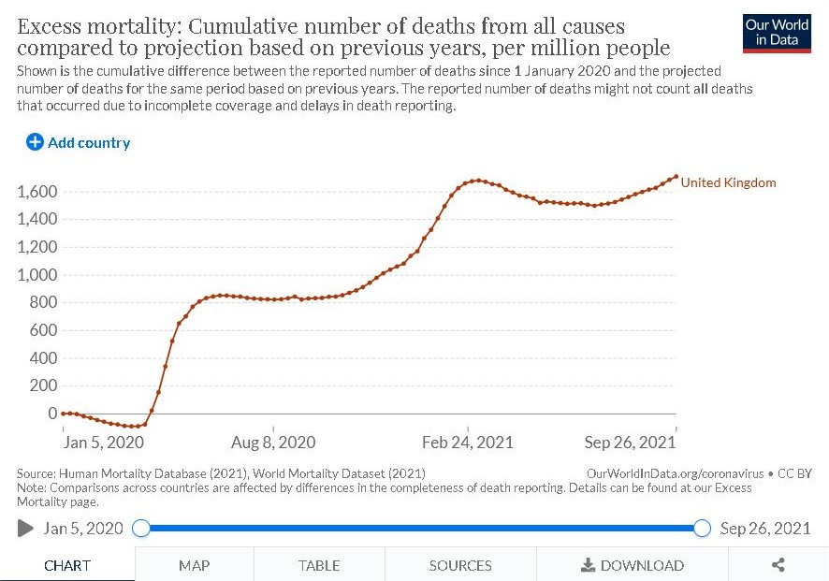
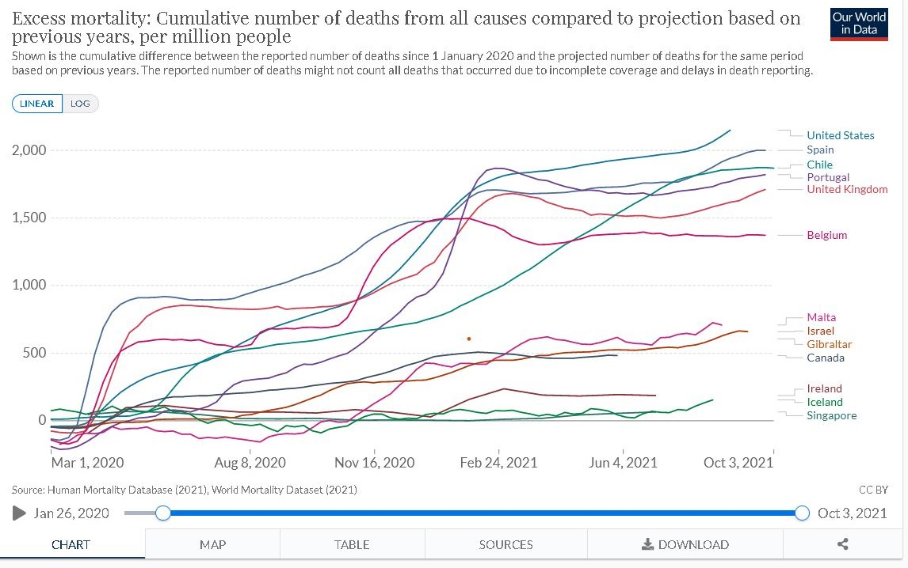
Source: https://ourworldindata.org/
Gibraltar is the most striking. Excess mortality was below zero and in minus figures until covid19 vaccinations began in February 2021. Then excess mortality suddenly increased sharply and has continued to rise in 2021. This is shocking. This is excellent evidence of the excess mortality associated with the covid19 vaccines. The figures for these countries show a sharp increase in excess mortality in 2021 after the introduction of covid19 vaccines in January or February 2021. There is a clear correlation between countries with high vaccination rates and rising or high excess mortality. All governments and health authorities should immediately implement Absolute All Cause Mortality Risk measures for the covid19 vaccines and Remdesivir and Midazalom (administered in nursing homes). And the Absolute All Cause Mortality Risk for Lockdowns in terms of thousands / millions of cancelled hospital appointments for serious diseases, and the increase in suicides and mental illnesses. And the Absolute All Cause Mortality Risk for the safe and effective medicines – Ivermectin, Hydroxychloroquine, etc. This Absolute All Cause Mortality Risk and Excess Mortality should be categorised by age groups.
In highly vaccinated countries, covid19 deaths are low in October 2021, yet excess mortality is rising. The correlation between covid19 vaccinations and excess mortality needs to be fully investigated and prioritised in all countries, including Ireland.

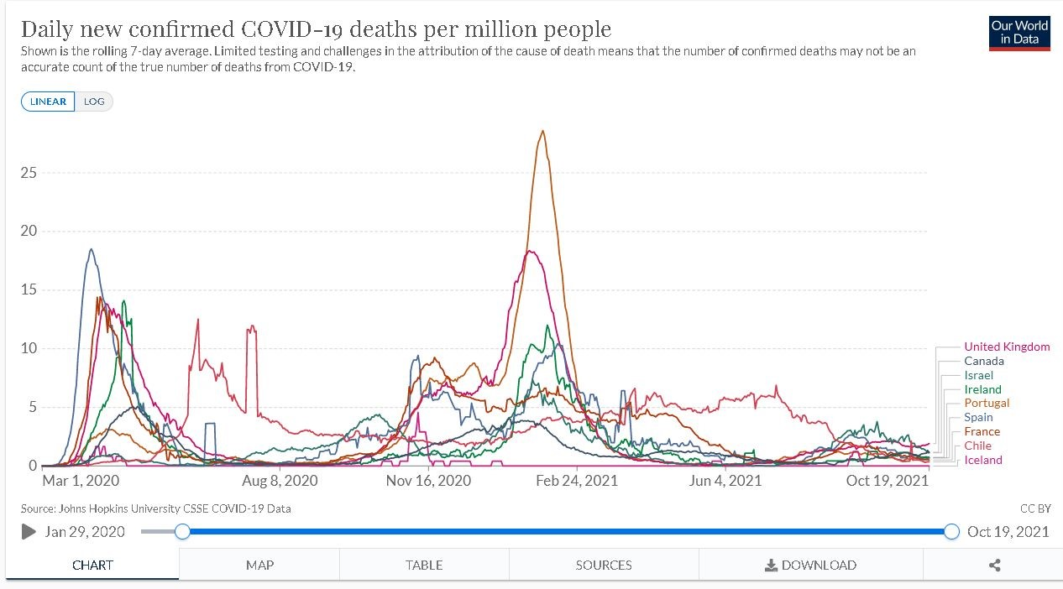

Factors involved in Excess Mortality and Absolute All Cause Mortality
The WHO database called VigiAccess tracks the Side Effects and Injuries and Disabilities of Covid19 Vaccines. Its available at http://www.vigiaccess.org/
For the Pfizer covid19 vaccine called ‘Cominarty’ there is 115 pages of side effects, injuries and disabilities many of which can cause death and is downloadable at https://www.data-analytica.org/side-effects.pdf
For the term ‘covid-19 vaccine’ there is 146 pages of side effects, injuries and disabilities many of which can cause death and is downloadable at https://www.data-analytica.org/side-effects2.pdf and continued on https://www.data-analytica.org/side-effects2a.pdf
Official statistics from governments and state health authorities around the world show a high number of deaths and injuries and disabilities from the covid19 vaccines, see https://www.data-analytica.org/page2.htm
The covid19 vaccines caused a big increase in deaths in nursing homes in Ireland in 2021
The following video produced by Kieran Morrisey, engineer and statistician provides evidence of this
https://vimeo.com/636552884
This ties in with similar findings in Britain in 2021, see news article https://theexpose.uk/2021/02/25/care-home-covid-deaths-have-increased-by-240-since-vaccinations-began/
The scientific study and facts by Dr. Jessica Rose sheds light on this important issue
See https://www.data-analytica.org/rose.pdf
See National Security Emergency – New Public Health Threat section below for more information about this particular problem.
Banning of Covid19 Vaccines and Covid19 Passports
- Sweden, Denmark, Iceland and Finland have banned moderna vaccine for people under 30 in October 2021
- Slovenia banned the Jansen vaccine in October 2021
- The tweet below sums up the covid19 facts and statistics in Baltic countries.
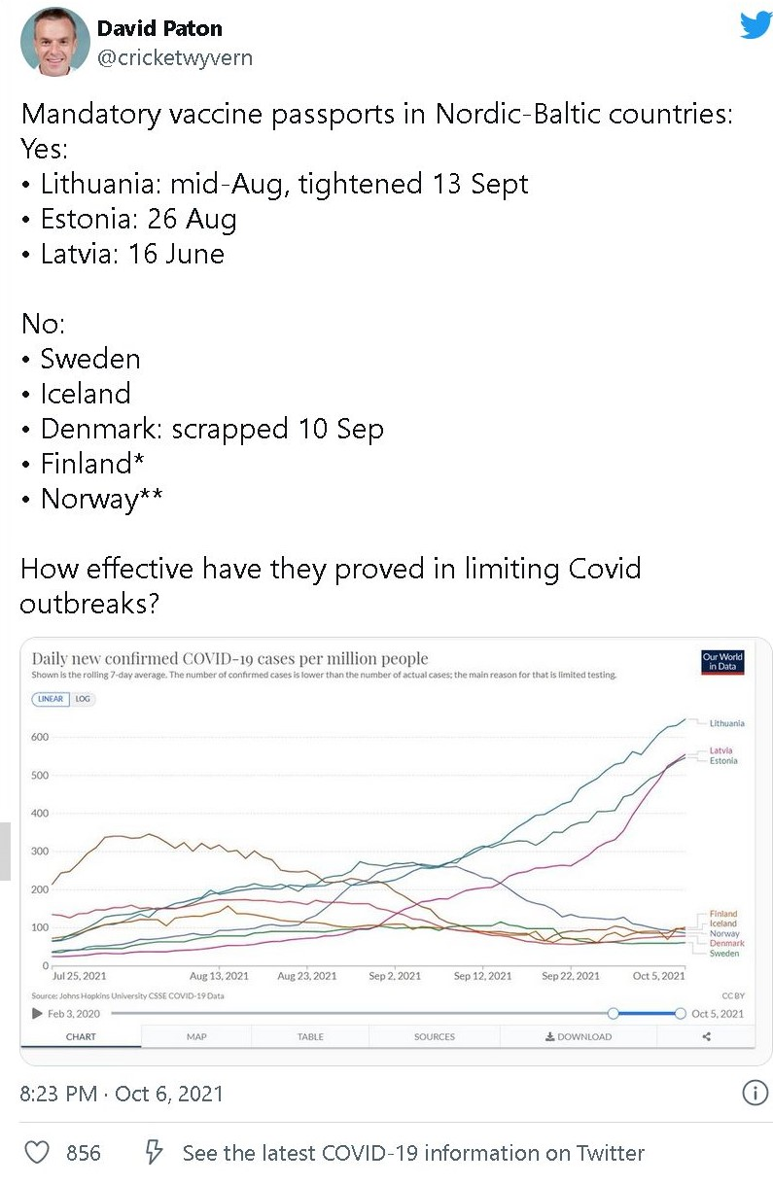
Science shows Covid19 Vaccines are ineffective and dangerous
- The government health authority in Britain, the PHE, has produced reports showing a collapse in the effectiveness of covid19 vaccines. The vaccine effectiveness is in minus figures for most age groups and this is worsening every month. The minus figures for vaccine effectiveness mean the unvaccinated have more protection than the vaccinated.
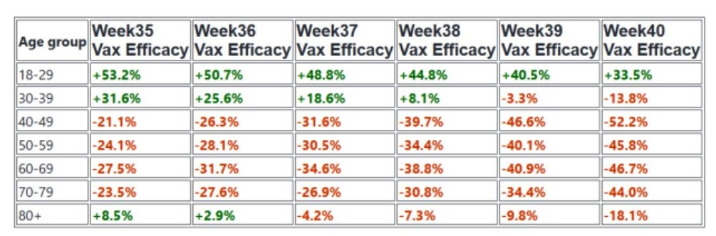
PHE Reports verifying the table and figures above
https://assets.publishing.service.gov.uk/government/uploads/system/uploads/attachment_data/file/1016465/Vaccine_surveillance_report_-_week_36.pdf
https://assets.publishing.service.gov.uk/government/uploads/system/uploads/attachment_data/file/1018416/Vaccine_surveillance_report_-_week_37_v2.pdf
https://assets.publishing.service.gov.uk/government/uploads/system/uploads/attachment_data/file/1019992/Vaccine_surveillance_report_-_week_38.pdf
https://assets.publishing.service.gov.uk/government/uploads/system/uploads/attachment_data/file/1022238/Vaccine_surveillance_report_-_week_39.pdf
https://assets.publishing.service.gov.uk/government/uploads/system/uploads/attachment_data/file/1023849/Vaccine_surveillance_report_-_week_40.pdf
https://assets.publishing.service.gov.uk/government/uploads/system/uploads/attachment_data/file/1025358/Vaccine-surveillance-report-week-41.pdf
News report about this: https://theexpose.uk/2021/10/10/comparison-reports-proves-vaccinated-developing-ade/ and https://www.algora.com/Algora_blog/2021/10/18/colin-power-died-of-vaxx-caused-immunodeficiency
- News report from Britain showing continuing collapse in covid vaccine effectiveness into minus figures. The unvaccinated are better protected against covid19.
https://dailysceptic.org/2021/10/23/infection-rates-for-vaccinated-aged-40-79-hit-double-the-rates-in-the-unvaccinated/
- HSPC in Ireland
The HPSC has reported that 55.7% of covid19 deaths in Ireland were vaccinated people by 16 October 2021. See attached report - ‘Vaccination Status of COVID-19 Deaths in Ireland between 1st April2021 and 16th October 2021’
https://www.hpsc.ie/a-z/respiratory/coronavirus/novelcoronavirus/surveillance/vaccinationstatusweeklyreports/Death%20and%20Vaccination%20Report.pdf
- By mid September 2021, Waterford was the most highly covid vaccinated county in Ireland at 99% for adults. Waterford also had the highest rate of covid19 infections in mid October 2021. Carlow is similar as it has the second highest covid vaccination rate and the second highest covid19 infection rate in October 2021. The covid vaccines are proving to be ineffective at stopping infections. They may be driving new covid19 infections , particularly new variants. Also, the defects already outlined in the PCR tests for covid19 in prior books of evidence need to be factored into this situation. News reports below:
https://www.irishexaminer.com/news/arid-40704104.html
https://citizenfreepress.com/column-3/covid-is-surging-in-waterford-ireland-where-99-7-percent-are-double-vaccinated/
Vaccinated patients as young as 30 require ICU treatment
Irish Independent, October 2, 2021
and Regulator receives 80 reports of heart inflammation after Covid-19 vaccines in Ireland
https://www.irishtimes.com/news/health/regulator-receives-80-reports-of-heart-inflammation-after-covid-19-vaccines-1.4694295
- Covid19 cases are rising and quite high in all highly vaccinated countries.

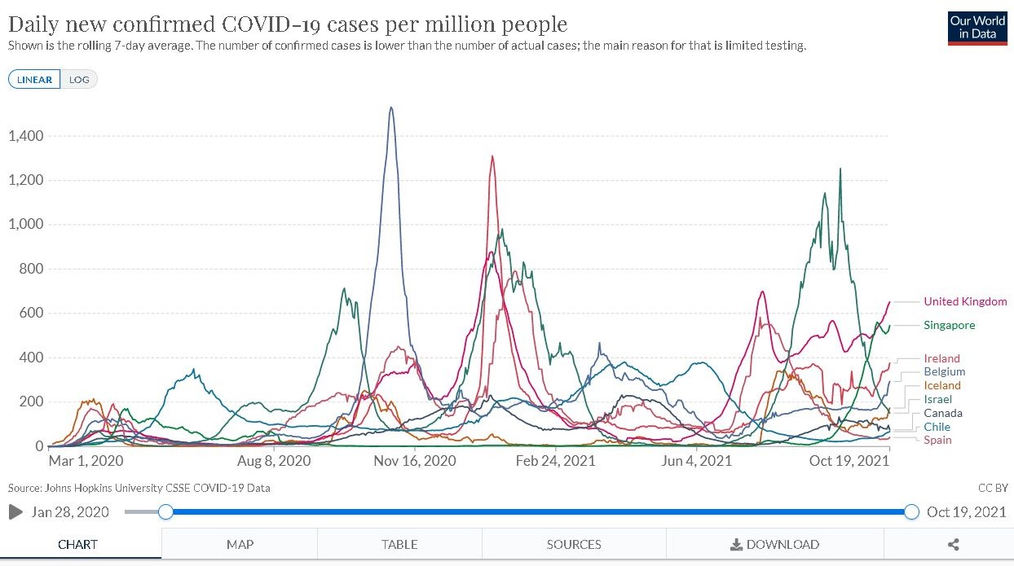

Covid19 cases rose sharply in all of these highly vaccinated countries from June 2021 up to the present, October 2021. It is highly unusual for a virus to spread during the Summer months. The rise in covid19 cases was much higher and more prolonged after vaccinations in January 2021 than in 2020 prior to vaccinations. This is more evidence that the covid19 vaccinations are not working and also that the spike protein being created in the bodies of vaccinated people is triggering positive tests for covid19.
A news report about this was published recently using statistics and charts from Our World in Data web site. https://healthimpactnews.com/2021/study-covid-19-vaccines-increase-deaths-and-hospitalizations-from-covid-19-based-on-analysis-of-most-vaccinated-countries/
- Covid-19 & Vitamin D. 2020 & 2021 : Nature and anti-nature
by Dr. David Grimes, medical doctor and Gastroenterologist in the UK
http://www.drdavidgrimes.com/2021/10/covid-19-vitamin-d-2020-2021-nature-and.html
He presents a detailed medical and scientific analysis of covid19 and vaccines. It is a devastating criticism and condemnation of the experimental covid19 vaccines.
Excerpt
‘ In the UK during the summer of 2021 we have experienced between 30 and 50 times more cases of Covid-19 per day (green line) compared to 2020 (blue line). We expect an increase during the autumn, but we expected fewer rather than more cases in 2021 than in 2020.’
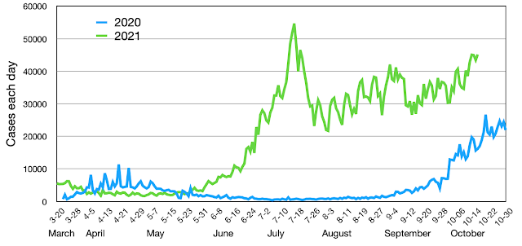
- The following video presentation with statistics shows covid19 deaths rose sharply after covid vaccinations in many countries around the world.
https://www.youtube.com/watch?v=WR-pqrMWu3E
or https://www.data-analytica.org/Covid-Deaths.mp4 or https://www.bitchute.com/video/uJ4LjO6sLJCL/
- October 7th - Taiwan deaths from COVID-19 vaccination exceeds deaths from COVID-19
https://medicaltrend.org/2021/10/10/taiwan-death-from-covid-19-vaccination-exceeds-death-from-covid-19/
- EudraVigilance – which monitors vaccine deaths and injuries – has logged (up to October 9th) 1,038,776 reports of 2,536,526 adverse events, including 27,242 deaths.
- DAEN Australia – the equivalent of the Yellow Card reporting system – has logged (up to September 29th) 63,672 reports of 204,746 adverse events, including 566 deaths. The highest number of vaccine deaths and injuries in Australian history.
- Latest UKHSA report shows Vaccinated accounted for 82% of Covid-19 Deaths & 65% of Hospitalisations in England over the past 4 weeks
https://theexpose.uk/2021/10/22/england-82-percent-covid-19-deaths-vaccinated/
- UK government report shows that N antibody levels are collapsing in covid vaccinated people. This makes them more vulnerable to covid19 infection and other viral infections.
https://assets.publishing.service.gov.uk/government/uploads/system/uploads/attachment_data/file/1027511/Vaccine-surveillance-report-week-42.pdf
- Important Scientific Study from Harvard University
Increases in COVID-19 are unrelated to levels of vaccination across 68 countries and 2947 counties in the United States
Eur J Epidemiol. 2021 Sep 30 : 1–4. doi: 10.1007/s10654-021-00808-7
https://www.ncbi.nlm.nih.gov/pmc/articles/PMC8481107/
“countries with higher percentage of population fully vaccinated have higher COVID-19 cases per 1 million people.”
- There has been a case of reactivation of hepatitis C infection following the Pfizer vaccination.
https://www.ncbi.nlm.nih.gov/labs/pmc/articles/PMC8412816/
- Waning of BNT162b2 vaccine protection against SARS-CoV-2 infection in Qatar
https://www.nejm.org/doi/10.1056/NEJMoa2114114
- Antibody levels decrease after two doses of Pfizer vaccine – study
Jerusalem Post, October 2021
https://www.jpost.com/health-and-wellness/coronavirus/antibody-levels-decrease-after-two-doses-of-pfizer-vaccine-study-681260

Johns Hopkins data proves covid shots causing majority of illness and death. Very Important scientific study and data.
https://duckduckgo.com/?q=johns+hopkins+data+proves+covid+shots+causing+majority+of+illness+and+death&t=h_&ia=web

Sydney, Australia: All New COVID Hospitalizations Involve Vaccinated Individuals Except One
https://wsau.com/2021/07/26/sydney-australia-all-new-covid-hospitalizations-involve-vaccinated-individuals-except-one/

Vaccinated people make up 75% of recent COVID-19 cases in Singapore, but few fall ill
https://www.reuters.com/world/asia-pacific/vaccinated-people-singapore-make-up-three-quarters-recent-covid-19-cases-2021-07-23/
- 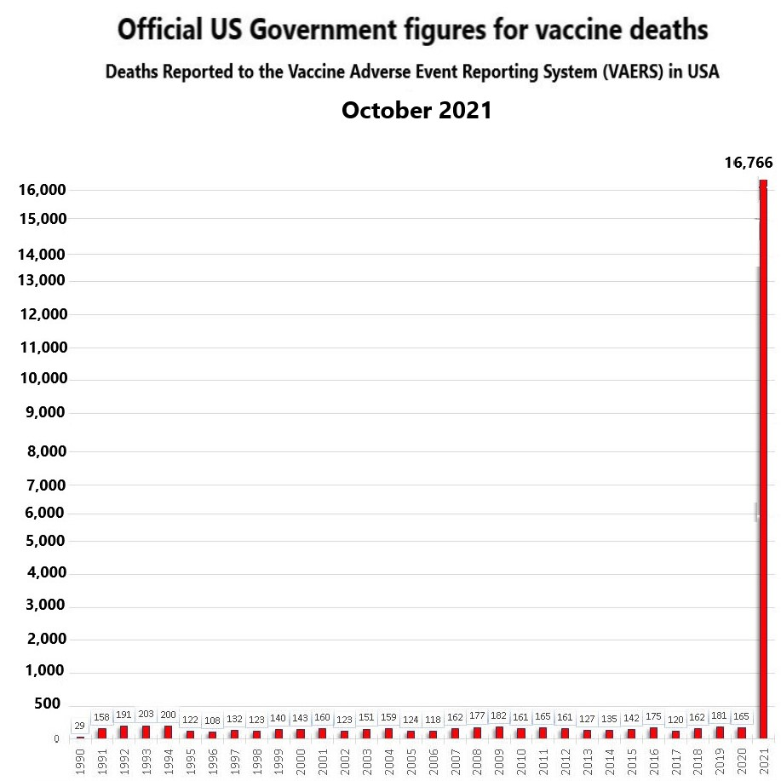
In 2020, 316 million vaccinations were administered. There were only 3 million covid19 vaccinations administered in 2020. In 2021, 320 million vaccinations were administered and most of them were covid19 vaccinations. There was a massive rise in vaccine deaths in 2021 in the USA in 2021.
Every year, 200 – 350 million vaccinations are administered in the USA for the last 30 years. Virgina Stoner in the USA has written about covid19 vaccinations and the comparison to other vaccinations for the last 30 years. You can view this at https://www.virginiastoner.com/

- 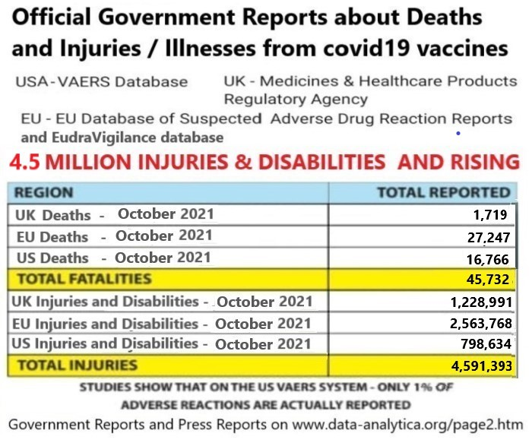
- COVID Vaccines: Necessity, Efficacy and Safety
By Doctors for Covid Ethics
https://www.ukcolumn.org/index.php/article/banned-paper-doctors-risk-versus-benefit-assessment-of-covid-jabs

STUDY: Government’s Own Data Reveals that at Least 150,000 Probably DEAD in U.S. Following COVID-19 Vaccines
https://www.data-analytica.org/rose.pdf and
https://healthimpactnews.com/2021/study-governments-own-data-reveals-that-at-least-150000-probably-dead-in-u-s-following-covid-19-vaccines/
- Whistleblower Lawsuit ! Government Medicare Data Shows 48,465 DEAD Following COVID Vaccinations
Click on video link - https://www.bitchute.com/video/4AG2lLSrJTiS/

- BREAKING: AI-powered DoD data analysis program named “Project Salus” SHATTERS official vaccine narrative, shows A.D.E. accelerating in the fully vaccinated with each passing week
https://www.cracknewz.com/2021/10/breaking-ai-powered-dod-data-analysis.html
- The SARS-CoV-2 Delta variant is poised to acquire complete resistance to wild-type spike vaccine
Liu et al. September 2021
https://www.biorxiv.org/content/10.1101/2021.08.22.457114v1.full.pdf
- Study Destroys Justification for Vaccine Mandates
CDC and State Health Department scientists find similar or higher viral load of Covid-19 virus among the vaccinated as compared to the unvaccinated
https://aaronsiri.substack.com/p/study-destroys-justification-for
- The covid19 vaccines caused a big increase in deaths in nursing homes in Ireland in 2021
The following video produced by Kieran Morrisey, engineer and statistician provides evidence of this>
https://vimeo.com/636552884
This ties in with similar findings in Britain in 2021, see news article https://theexpose.uk/2021/02/25/care-home-covid-deaths-have-increased-by-240-since-vaccinations-began/
- Scotland: Covid-19 deaths are rising and official data shows 87% of the people who have died were Vaccinated
https://rightsfreedoms.wordpress.com/2021/08/02/covid-19-deaths-are-rising-and-official-data-shows-87-of-the-people-who-have-died-were-vaccinated/
- Infection rates in England in vaccinated people aged 40-49 is now more than double the rate in the unvaccinated. PHE Data Shows, as Vaccine Effectiveness Hits -109% (minus 109%)
https://dailysceptic.org/2021/10/15/infection-rate-in-vaccinated-people-in-their-40s-now-more-than-double-the-rate-in-unvaccinated-phe-data-shows-as-vaccine-effectiveness-hits-minus-109/
- URGENT: Covid vaccines will keep you from acquiring full immunity EVEN IF YOU ARE INFECTED AND RECOVER - https://alexberenson.substack.com/p/urgent-covid-vaccines-will-keep-you/comments
- Scientific research findings showing a high rate of deaths and disabilities in covid vaccinated children. Far higher risk for children from covid vaccine death and injuries and disabilities than from covid19 infection, hospitalization or death. And there are similar high risks for adults of all age groups. Research by Steve Kirsch who has presented his findings to the FDA at FDA meets in the USA.
www.data-analytica.org/kirsch.pdf and Cost benefit by age analysis: The COVID vaccines kill more people than they save for all age groups at https://www.skirsch.com/covid/VCage.pdf
Steve Kirsch can be subpoenaed to testify in courts.
- Official UK government statistics show that covid19 infections are the same or more for covid vaccinated people as for unvaccinated people over the age of 30. The vaccines are making no difference to the rate of covid19 infections for those over 30. Chart below.
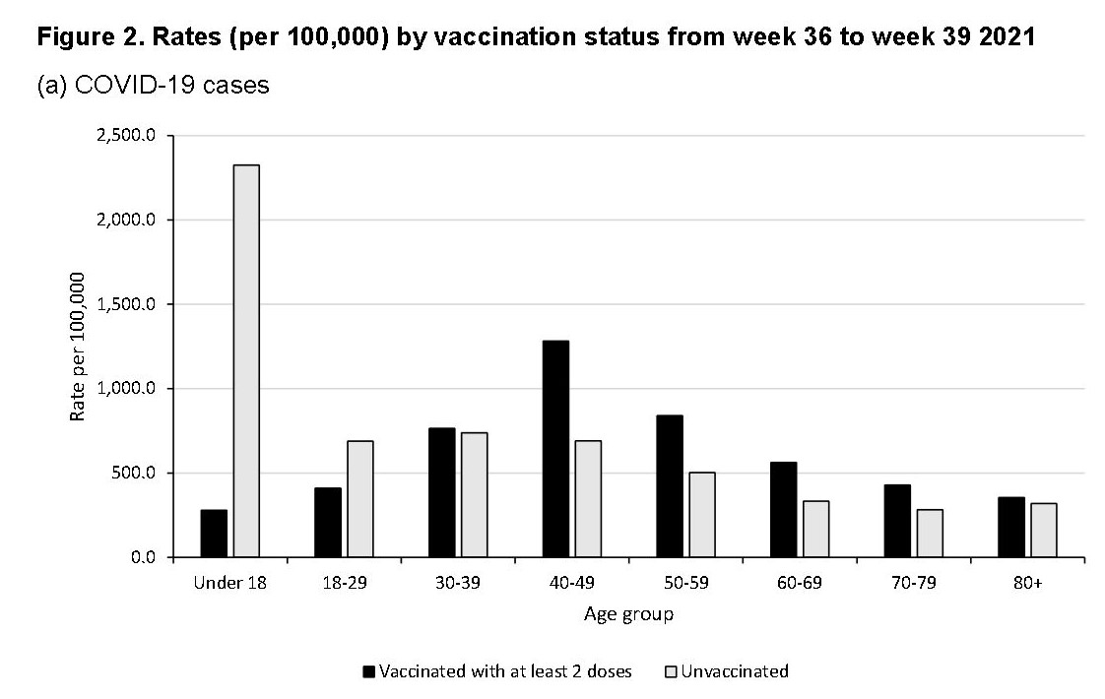
- There have been calls for clearer ONS data on the rise in deaths of young males in England and Wales. Investigation of official ONS data indicates that since the Covid vaccine has been rolled out to teens, there has been a significant increase in deaths in this age group.
https://www.ntd.com/calls-for-clearer-data-on-young-male-deaths_688368.html
https://theexpose.uk/2021/10/13/teen-deaths-125-percent-higher-since-covid-vaccination-ons-data/
- According to an updated report published on October 14th, the MHRA Yellow Card reporting system has recorded a total of 1,228,991 events based on 372,878 reports. The total number of fatalities reported is 1,719.
- Pfizer (22.7 million first doses, 19.8 million second doses) now has one Yellow Card in 188 people vaccinated. Deaths: 1 in 40,391 people vaccinated (562).
- AstraZeneca (24.9 million first doses, 24 million second doses) has one Yellow Card in 106 people vaccinated. Deaths: 1 in 22,514 people vaccinated (1,106).
- Moderna (1.5 million first doses, 1.2 million second doses) has one Yellow Card in 90 people vaccinated. Deaths: 1 in 75,000 people vaccinated (20).
Overall, one in every 132 people vaccinated (0.76%) have experienced a Yellow Card adverse event. The MHRA has previously estimated that the Yellow Card reporting rate may be approximately 10% of actual figures.
https://www.gov.uk/government/publications/coronavirus-covid-19-vaccine-adverse-reactions/coronavirus-vaccine-summary-of-yellow-card-reporting

National Security Emergency – New Public Health Threat
Analysis of Pfizer vaccine and other covid19 vaccines under a microscope by scientists and medical doctors. And analysis of the blood covid vaccinated people under a microscope by scientists and medical doctors.
The Pfizer vaccine for covid19 is examined under a microscope by Dr. Erik Enby, a Swedish scientist, who is also a Physician and Researcher in the following video. He used an interference contrast microscope.
The video is provided here for evidence purposes for the police and courts. His findings are on the Stew Peters news show in the USA.
https://odysee.com/@photoviapop:8/pfizer:0c or https://vimeo.com/591730259 or https://www.bitchute.com/video/hyEOkMPfA56k/
Many small living organisms were observed and they are moving in different directions and also forming colonies or biofilms and breeding. This is what is being injected into people and these organisms are living and breeding inside humans. These type of living organisms and structures are found in the blood and organs of people with chronic illnesses. These type of vaccines are a public health threat.
Separate scientific research by Dr. Carrie Madej in the USA has confirmed these findings in covid19 vaccines. She examined the Moderna and Johnson and Johnson under a microscope and found living organisms and colonies of these and also found metallic substances and graphene. She presented her findings on the Stew Peters news show in the USA.
https://carriemadej.com/uncategorized/the-stew-peters-interview/
And she found similar living organisms and colonies of these in the Pfizer vaccines
https://rumble.com/vnzy9f-shocking-dr.-carrie-madej-releases-first-look-at-pfizer-vial-contents.html
This corroborates the scientific findings of top scientist Dr. Robert Young presented in prior books of evidence in this case. Using an electron microscope, he examined both covid vaccines and the blood of vaccinated people and found evidence of serious blood abnormalities, living organisms and metallic objects in the covid vaccines . He presented his findings on the Stew Peters news show in the USA.
https://rumble.com/vm7iyp-dr.-robert-young-whats-in-covid-shots-why-graphene-who-is-responsible.html and microscope findings and scientific findings on his web site at https://www.drrobertyoung.com/post/the-vaccine-death-report-millions-have-died-from-the-injections and https://www.bitchute.com/video/Z2sAH0Woz38r/
More corroboration of this is the findings of Dr. Zandre Botha. She found horrific and very serious blood abnormalities and deformities and foreign objects and structures. She found metallic circular objects with connectors which join up together and other strange structures in the covid vaccine vials.
She presented her findings on the Stew Peters news show in the USA.
https://rumble.com/vnbgal-never-before-seen-blood-doctor-reveals-horrific-findings-after-examining-vi.html
And this corroborates the findings of Dr. Barbel Gitala, a German medical doctor who found serious blood abnormalities in covid19 vaccinated people when examining it under a microscope.
https://rumble.com/vldaex-vaxxed-patients-blood-examined-horrific-findings-revealed-by-german-physici.html or https://thetruedefender.com/watch-german-physicians-reveal-horrific-findings-in-the-blood-of-vaxxed-patients/
Dr. Franc Zalewski found strange parasites inside covid19 vials and they appear to be laying eggs and breeding. Graphene was also found. His findings are on the Stew Peters news show in the USA.
https://rumble.com/vnslor-jab-scientist-discovers-hatching-eggs-parasites-birthed-after-injection.html
and scientific lecture about this by Dr. Zelewski at https://www.bitchute.com/video/45rx8vafSfWS/ and analysis of this at https://jamesfetzer.org/2021/10/parasitic-organism-dubbed-the-thing-found-in-covid-vaccines-dr-franc-zalewski-thats-why-theres-graphene-added-inside-the-vaccines-which-nourishes-the/
Strange parasites removed from the bodies of covid vaccinated people. Parasites are very similar to what was found in scientific studies of vaccinated blood and vaccine vials above. Findings presented on the Stew Peters news show in the USA.
https://rumble.com/vnehhz-horror-exclusive-video-captures-organism-from-vaxxed-soldiers-body.html
Philippe van Welbergen from the UK has also found serious blood abnormalities and foreign objects in the blood of covid vaccinated people under a microscope. Images are provided by him.
https://coronanews123.wordpress.com/2021/09/19/uk-health-practitioner-shows-blood-cell-clumping-in-microscope-slides-calls-on-scientists-to-step-forward/ and https://www.youtube.com/watch?v=-SQRWlI3o_Y
Dr. Jane Ruby a scientist with many years experience in vaccine development and trails in the USA has a sworn affidavit attesting to these facts and to serious defects in and dangers associated with the covid19 vaccines and she has called them to be halted immediately. See sworn affidavit at www.data-analytica.org/Ruby.pdf
Dr. Jane Ruby can be subpoenaed into Irish courts to testify.
Project Veritas in the USA will release shocking videos and images of the contents of covid19 vaccines and the blood of covid vaccinated people in November 2021.
This is matter of National Security for Ireland and many other countries. We ask scientists and government bodies and Universities worldwide to :
(a) replicate this study of Pfizer vaccines and all other covid19 vaccines
(b) replicate studies of vaccinated blood within 1 hour of vaccination followed by 2 to 24 hours after vaccination and 2 days to 4 weeks after vaccination.
(c) autopsies of dead vaccinated people to determine how the covid vaccine caused death.
And that covid vaccines are halted until such time as these studies are completed. This is a serious public health threat and has the characteristics of a biological weapon.
Informed Consent NOT given by those persons who received the covid19 vaccines. This is a clear breach of Irish criminal laws and Irish civil laws and the Nuremberg Code and Geneva Convention and of similar laws in other countries.
Evidence showing the Side Effects and Injuries and Disabilities of Covid19 Vaccines.
Covid19 Vaccines have the longest list of side effects and injuries of all vaccines in history according to the WHO and it’s VigiAccess system and to VAERS in USA and the EMA database for vaccine injuries in the EU and the MHRA in Britain. This is causing massive pressure on Hospitals and Medical Clinics.

Informed consent has not been given by those persons who received the covid vaccines. They were not told about the deaths and injuries and disabilities caused by the covid vaccines. They were not told about all of the contents of the covid vaccines. They were not told about parasites and metallic objects in the covid19 vaccines. They were not told about the blood abnormalities caused by covid vaccines. They were not told about the rise in excess mortality from the covid vaccines. They were not told about the side effects of the covid vaccines as listed below and in prior books of evidence in this case. They were not told that covid vaccines were in Phase 3 trials. They were not provided with the information in this document and in other books of evidence in this case.

The WHO database called VigiAccess tracks the Side Effects and Injuries and Disabilities of Covid19 Vaccines. Its available at http://www.vigiaccess.org/
For the Pfizer covid19 vaccine called ‘Cominarty’ there is 115 pages of side effects, injuries and disabilities and is downloadable at https://www.data-analytica.org/side-effects.pdf
For the term ‘covid-19 vaccine’ there is 146 pages of side effects, injuries and disabilities and is downloadable at https://www.data-analytica.org/side-effects2.pdf and continued on https://www.data-analytica.org/side-effects2a.pdf

Official statistics from governments and state health authorities around the world show a high number of deaths and injuries and disabilities from the covid19 vaccines, see https://www.data-analytica.org/page2.htm

Dr. Jane Ruby a scientist with many years experience in vaccine development and trials in the USA has a sworn affidavit attesting to these facts and to serious defects in and dangers associated with the covid19 vaccines and she has called them to be halted immediately. See sworn affidavit at www.data-analytica.org/Ruby.pdf
Dr. Jane Ruby can be subpoenaed into Irish courts to testify. j
Expert Advice for the Irish Medical Council and the Irish Medical Authorities and Bodies and NPHET and Minister for Health in Ireland : Evidence Based Medicine for treating covid19 and it’s variants
- Ivermectin – the findings of scientific studies and scientists showing its safety and effectiveness.
Remdesivir has more side effects and is more dangerous. But Big Pharma makes massive profits out of Remdesivir and government advisors and government ministers have conflicts of interest.
https://www.youtube.com/watch?v=sn3VR31taWo
The effectiveness and safety of Ivermectin treating covid19 and its variants has been scientifically proven, see https://ivmmeta.com/
Banning and Blocking and Depriving a nation of safe and effective treatments for an infection or disease is a form of Treason.
- Dr. Peter McCullough is an Internist, Cardiologist, Epidemiologist, and Professor of Medicine at Texas A & M College of Medicine, Dallas, Texas in USA. He has experience in successfully treating many covid19 patients in the USA. He has a vast medical and scientific knowledge of the covid19 virus and pandemic and is highly regarded in medical and scientific circles globally. In this news interview he provides medical advice and scientific advice to medical doctors and Hospital doctors and consultants.
News interview - https://freeworldnews.tv/watch?id=616a2ce3b88f394aec5aa3a9
and https://twitter.com/Kukicat7/status/1448336581358665733?t=go1sFEuNObtknKH07xYKaA&s=19
- The medical doctors and scientists involved in Front Line COVID-19 Critical Care Alliance, at https://covid19criticalcare.com/
- Zelenko protocol
Dr. Vladimir Zelenk has successfully treated over 1,000 covid19 patients in the USA
https://vladimirzelenkomd.com/
- The Fareed and Tyson protocol
https://www.thedesertreview.com/news/dr-george-fareed-and-dr-brian-tyson-share-early-treatment-protocol/article_7728815e-3ca2-11eb-8a08-7b4b0156c181.html
- COVID Vaccines: Necessity, Efficacy and Safety
Doctors for Covid Ethics
https://www.ukcolumn.org/index.php/article/banned-paper-doctors-risk-versus-benefit-assessment-of-covid-jabs
- Dr. Carrie Madej - https://twitter.com/MEIKANBOM/status/1448569750133432321?t=gVABzmtrzP1W85-UdSpb5g&s=19
- NEBRASKA Attorney General : Docs Can Prescribe Ivermectin, Hydroxychloroquine
https://thehighwire.com/news/nebraska-ag-docs-can-prescribe-ivermectin-hydroxychloroquine/

Scientific research findings around the world about Ivermectin and Hydroxychloroquine
Chamie-Quintero study - https://c19ivermectin.com/chamiequintero2.html
https://joannenova.com.au/2021/02/in-peru-ivermectin-cut-covid-deaths-by-75-in-6-weeks-cheap-safe-and-quite-ignored/
https://www.paulcraigroberts.org/2021/09/02/ivermectin-in-africa-blocks-covid/ https://www.paulcraigroberts.org/2021/08/08/the-suppression-of-ivermectin-is-a-criminal-act/

The covid19 vaccines caused a big increase in deaths in nursing homes in Ireland in 2021. Medical experts agree that there are safe and effective medicines which can be used as an alternative to covid vaccines.
The following video produced by Kieran Morrisey, engineer and statistician provides evidence of this
https://vimeo.com/636552884

Why Is the FDA Attacking a Safe, Effective Drug?
Wall Street Journal, July 28 2021
https://www.wsj.com/articles/fda-ivermectin-covid-19-coronavirus-masks-anti-science-11627482393

Natural Immunity vs covid19 vaccines. Natural Immunity is far superior.

91 Research Studies Affirm Naturally Acquired Immunity to Covid-19: Documented, Linked, and Quoted
https://brownstone.org/articles/79-research-studies-affirm-naturally-acquired-immunity-to-covid-19-documented-linked-and-quoted/

Natural Immunity and Covid-19: Thirty Scientific Studies to Share with Employers, Health Officials, and Politicians
https://brownstone.org/articles/natural-immunity-and-covid-19-twenty-nine-scientific-studies-to-share-with-employers-health-officials-and-politicians/amp/

A Systematic Review of the Protective Effect of Prior SARS-CoV-2 Infection on Repeat Infection
https://www.medrxiv.org/content/10.1101/2021.08.27.21262741v1

High-affinity memory B cells induced by SARS-CoV-2 infection produce more plasmablasts and atypical memory B cells than those primed by mRNA vaccines
https://www.cell.com/cell-reports/fulltext/S2211-1247(21)01287-0

Reckless Endangerment of Children from covid19 vaccines

CDC: Teens Injected with COVID Shots have 7.5 times More Deaths, 15 times More Disabilities, 44 times More Hospitalizations than All FDA Approved Vaccines in 2021
https://healthimpactnews.com/2021/cdc-teens-injected-with-covid-shots-have-7-5-x-more-deaths-15-x-more-disabilities-44-x-more-hospitalizations-than-all-fda-approved-vaccines-in-2021/

Scientific research findings showing a high rate of deaths and disabilities in covid vaccinated children. Far higher risk for children from covid vaccine death and injuries and disabilities than from covid19 infection, hospitalization or death. Research by Steve Kirsch who has presented his findings to the FDA at FDA meets in the USA. Scientific Report - www.data-analytica.org/kirsch.pdf
Steve Kirsch can be subpoenaed to testify in courts.

Deaths among male Children are 83% higher than the 5-year-average since they were given the Covid-19 Vaccine - https://theexpose.uk/2021/10/27/deaths-among-male-children-increased-by-89-percent-since-given-covid-19-vaccine/

Canadian Politician demands urgent investigation into rise of sudden deaths among Teens following Covid-19 Vaccination
https://theexpose.uk/2021/10/27/politician-demands-investigation-sudden-deaths-teens-after-covid-vaccination/
- FDA experts ask why Kids are “dropping like flies” right after getting the Covid-19 Vaccine as they meet to debate authorisation of the Pfizer jab for 5-11-year-olds
https://theexpose.uk/2021/10/26/fda-experts-ask-why-kids-are-dropping-like-flies-right-after-getting-the-covid-19-vaccine/

Treason
The Evidence shows that covid19 vaccines and accompanying control systems are being used to overthrow Democracy and Democratic Government and Constitutional rights and Human Rights. This is Treason. Deliberately ignoring mass deaths in nations from covid19 vaccines is also Treason.
The following American news channel interview between Stew Peters and Karen Kingston, A Pfizer whistleblower, exposes new Patents and new government policies and plans and international agreements in 2021 to introduce new control systems for covid19 vaccinations and future vaccinations which have the effect of destroying Constitutional rights and Human Rights and overthrowing Democratic government and Democracy itself in many countries around the world including Ireland. Australia is the test case for western democracies and is now implementing it in October 2021. This is treason and plans to implement it in Ireland and other democracies is treason.
https://www.bitchute.com/video/JlnscNAliNCw/
Patent - https://patents.google.com/patent/US20210082583A1/en
https://www.ncbi.nlm.nih.gov/pmc/articles/PMC2048949/
Corroboration of this Treason
the 'Lockstep' programme first proposed by the Rockefeller foundation in 2010. This proposes a harsh top down approach to dealing with several types of crisis, such as imposing national lockdowns in countries around the world and this was enforced during the covid19 'pandemic' in 2020. This 'Lockstep' programme was further developed by Event 201 hosted by the Johns Hopkins Center for Health Security, WHO, and Bill Gates Foundation in Autumn 2019, a few months before the covid19 pandemic began.
Lockstep programme of the Rockefeller Foundation - https://www.data-analytica.org/rockefeller.pdf
Event 201 - https://www.google.com/search?q=event+201
Governments and elected politicians have a legal and Constitutional duty of care to their peoples and nations. They know about the dangers of these covid19 vaccines and they know about safe and effective medicines for covid19. The high and rising numbers of deaths and injuries and disabilities from the experimental covid19 vaccines are an attack on peoples and nations and the rule of law and Constitutional rights and Human Rights in nations. This includes Ireland. If governments and elected politicians and senior civil servants refuse to do something about this, they are guilty of Treason.

Legal cases against Vaccine Mandates in USA

24 State Attorney generals have written to President Joe Biden and will be taking legal cases against him and his vaccine mandate
News - https://okcfox.com/news/local/24-state-attorney-generals-write-letter-to-pres-biden-on-vaccine-mandate
Letter - https://ago.wv.gov/Documents/AGs'%20letter%20to%20Pres.%20Biden%20on%20vaccine%20mandate%20(FINAL)%20(02715056xD2C78).PDF
and Letter is attached to the end of this document

The Senate in France voted against making the Covid vaccine mandatory.
https://www.italy24news.com/News/221979.html
Birth Defects caused by the covid19 vaccines
- Babies born with tails and body hair and one eye and other genetic defects from covid19 vaccinated parents
https://www.stopworldcontrol.com/disorders/

Masks
- Retired surgeon Dr Tony Hinton in UK has publicly stated that masks are useless against covid19 and viruses.
https://twitter.com/talkRADIO/status/1451504526893137921

More evidence to show Lockdowns killed and are killing people

Eightfold rise in number waiting more than six weeks for cancer tests
https://www.telegraph.co.uk/news/2021/10/09/eightfold-rise-number-waiting-six-weeks-cancer-tests/

Deaths in 2020 in the USA

Age-Adjusted Mortality Is at 2004 Levels. Yet They Tell Us Covid Is Worse Than the 1918 Flu.
https://mises.org/wire/age-adjusted-mortality-2004-levels-yet-they-tell-us-covid-worse-1918-flu

Corruption and Conflicts of Interest

Dr. Astrid Stuckleberger, a top scientist and University Professor in Switzerland, who worked for the EU and several Swiss federal agencies and also worked for the WHO for many years is now a WHO Whistleblower. She has stated the pandemic is over exaggerated and is a fraud and that conflicts of interest and profiteering are driving this fraud in many countries. She has presented evidence to the legal team of Reiner Fuellmich in Germany. This evidence is of international relevance.
https://www.astridstuckelberger.com/covid-19/

Dr. Luc Montagnier the discoverer of the AIDS virus and Nobel Prize winner and one of the top scientists in the world has warned about the dangers of the covid19 vaccines and he was a strong critic of lockdowns and he has used science to justify his position. He asserts that the covid19 vaccines are creating the new variants, through ADE. He has condemned the abuse of science, and the conflicts of interest and corruption involved in this covid19 issue. This has been reported in the international press and media.
False Statistics about covid19
- There Is No Pandemic - https://www.ukcolumn.org/index.php/article/there-is-no-pandemic and https://in-this-together.com/ukc/DrJD-Analysis.pdf and https://www.ukcolumn.org/article/deceptive-construction-why-we-must-question-covid-19-mortality-statistics
The UK Column, October 2021
Alleged Foreknowledge of the covid19 Pandemic and the Filing of Patents for Profit
- A Patent for a covid19 testing kit was filed in 2015 by a well connected person. This was four years before the covid19 outbreak in December 2019. This is a matter which should be investigated by the authorities. This same person filed Patents for accessing and using the biometric data of people, which requires the insertion of chips into the human body and new control systems for controlling populations and undermining Constitutional rights and Human Rights in 2015. This is also a matter which should be investigated by the authorities.
https://worldwide.espacenet.com/publicationDetails/inpadocPatentFamily?DB=&ND=3&FT=D&date=20200903&CC=US&NR=2020279585A1&KC=A1
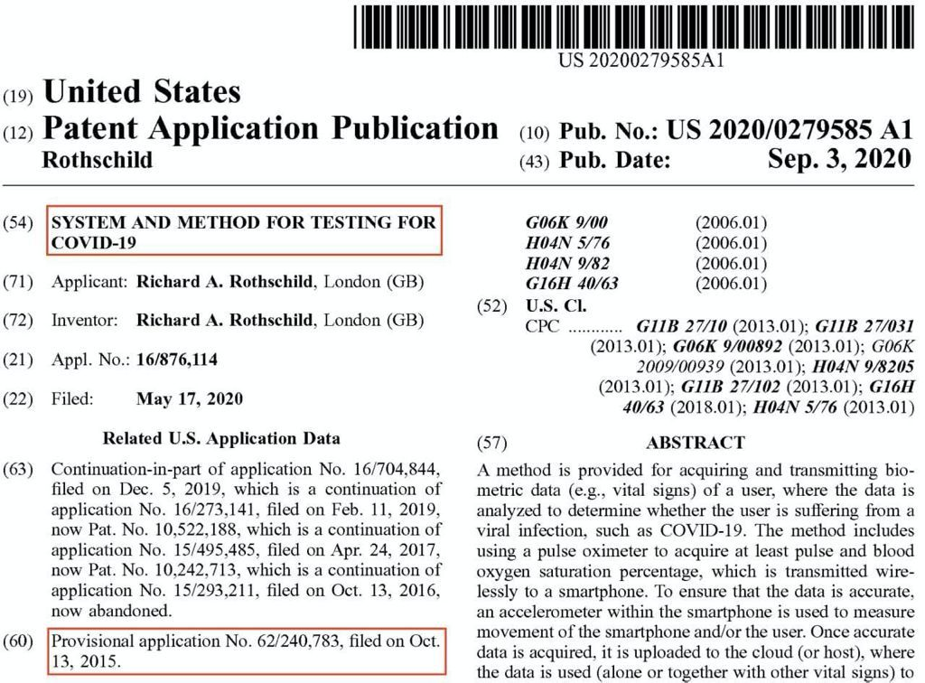
Attached Documents Section
- HSPC in Ireland
The HPSC has reported that 55.7% of covid19 deaths in Ireland were vaccinated people by 16 October 2021. See attached report - ‘Vaccination Status of COVID-19 Deaths in Ireland between 1st April2021 and 16th October 2021’
https://www.hpsc.ie/a-z/respiratory/coronavirus/novelcoronavirus/surveillance/vaccinationstatusweeklyreports/Death%20and%20Vaccination%20Report.pdf
- 24 State Attorney generals have written to President Joe Biden and will be taking legal cases against him and his vaccine mandate
News - https://okcfox.com/news/local/24-state-attorney-generals-write-letter-to-pres-biden-on-vaccine-mandate
Letter - https://ago.wv.gov/Documents/AGs'%20letter%20to%20Pres.%20Biden%20on%20vaccine%20mandate%20(FINAL)%20(02715056xD2C78).PDF
- Dr. Ryan Cole, a medical doctor and Pathologist and Fellow of the Mayo Clinic provides a lecture about autopsies carried out on dead covid vaccinated people and injured covid vaccinated people and shows slides of serious damage to organs and blood vessels. This provides strong scientific and medical evidence to corroborate what is stated in our books of evidence.
https://rumble.com/vogxan-scientist-shows-vaccine-effects-in-autopsies.-dont-believe-it-see-for-yours.html
- New Nuremberg Trials – Crimes Against Humanity
https://justice4poland.com/2021/10/18/new-nuremberg-trials-crimes-against-humanity/?fbclid=IwAR3HC0mT-mbuDHQEmGFzInANSJSy-iLpE2GxeXHKZM1rToqvQ8JkCdIb5RM

