For Use in Courts in Ireland and other Countries
Scientific Expert Report on the COVID-19
Epidemic Response in Ireland
By Jay Bhattacharya, MD, PhD and Professor of Medicine in Stanford University, USA. Approximately 33% of this Report.
Dr. Dolores Cahill, Professor of Science and Immunology, UCD. Immunologist.
Dr. Anne McCloskey, medical doctor
Dr. Patrick Morrissey, medical doctor
Mr. Edward Shanahan, Barrister in Ireland and author of Section U of this paper
with assistance from David Egan MSc (NUI Galway and University of Oxford)
April 2021
Supporting Evidence
Evidence 1: We attach statistics and statistical analysis of actual deaths and excess mortality figures for 2020 and 2021 by Kieran Morrissey an Engineer and Statistics Expert who has given statistical evidence in courts in the past titled ‘Study of COVID-19 deaths claimed by NPHET/data.gov.ie between March 2020 and March 2021 using GRO/CSO death data combined with RIP.ie death notices’ April 2021 as Supporting Evidence. Also available on www.data-analytica.org/km.htm
Evidence 2: We attach a DVD with statistics and statistical analysis of deaths and excess mortality in Ireland by Joe Henry an Engineer and Statistics Expert and John Murphy an Engineer and Statistics Expert presented on an Irish News Channel as Supporting Evidence.
Evidence 3: We attach a recently published book 'Corona, False Alarm?: Facts and Figures' by Professor Sucharit Bhakdi and Dr. Karina Reiss as Supporting Evidence. These are top German medical doctors, Professors and Epidemiologists, who are world renowned Experts in their fields. Their book ‘Corona False Alarm? Facts and Figures ‘ provides the scientific evidence and facts about covid19, False Positives, etc.
Evidence 4: We attach a scientific Report as Supporting Evidence from The Health Advisory and Recovery Team (HART) which is a group of highly qualified doctors, scientists, economists, psychologists and other academic experts who published this Report titled ‘Covid-19 Response’ in March 2021 in Britain. Report is available at https://www.hartgroup.org/wp-content/uploads/2021/03/240321-Updated-HART-review.pdf
Evidence 5: We attach a scientific Report as Supporting Evidence - ‘COVID-19 & Public Health Totalitarianism: Untoward Effects on Individuals, Institutions and Society’ by Dr. Peter Breggin, a highly experienced medical doctor and psychiatrist which was filed in a Federal court in Ohio, in USA, on August 31, 2020.

Table of Contents
A. | Does Covid-19 pose a real or imminent serious threat to the health of the population? | 4
B. | What are RT-PCR tests? What is a Cycle Threshold and What is the Likelihood of Infection with Covid-19 with a CT over 30? How Does a Positive PCR Result Correlate to Ireland’s Definition of a “Case” of Covid-19? | 40
C. | Are the Lockdowns a Disproportionate Response ? How does covid19 compare to previous pandemics in history? | 46
D. | What were the Total Deaths and Excess Mortality for 2020 and Comparison to Previous Years | 60
E. | Were the Irish Hospitals overwhelmed and overcrowded and over capacity with a  pandemic from March to December 2020 and for 2021 ? | 66
F | Were there effective medicines for covid19 in 2020 and 2021 ? | 77
G | Was there pre-existing immunity to coronaviruses developed over many years and  centuries which conferred protection for most people against covid19 | 80
H | How common is the spread of the SARS-CoV-2 virus by individuals who are infected,  but display no symptoms? how common is asymptomatic transmission ? | 83
I | What are the principles that govern good health policy and public health practice? | 86
J | Are the lockdowns necessary to protect the health and well-being of the general population? Were Lockdowns a failure and where is the scientific evidence? | 88
K | What are the harms of lockdowns on the health of the population? Do these harms damage or destroy the Common Good, the Greater Good, the Public Interest? | 97
L | Are the harms of the lockdowns equitably distributed? | 108
M | What is the magnitude of the risk children pose in disease spread? Is there any  rationale for lockdown related restrictions on children? | 109
N | Do Restrictions on the Activities of Young Adults Play an Important Role in Disease  Spread? Do Young adults face particular harms from the lockdown restrictions? | 119
O | Can religious services be held safely? Are there particular benefits that derive from communal singing? | 121
P | Can restaurants and bars be opened safely to customers? Are there particular benefits  that derive from eating in community? | 124
Q | Can gyms, martial arts studios, and other venues offering opportunities for physical  activities open with minimal risk of disease spread? Are there particular benefits to  health that derive from access to such facilities? | 126
R | Alternatives to Lockdowns. Do other measures exist that would achieve the goal of the government to protect the population from the Covid-19, but that would have less or no impairments on the freedoms and liberties of the population? If yes, what are they? | 128
S | Is there immunity obtained after being infected and cured from Covid-19? | 131
T | What is herd immunity? What is the most effective way to reduce harm until endemic equilibrium? | 134
U | What are the effects of lockdowns on Human Rights, Constitutional Rights, Natural Law Rights, Legal rights, Democratic Rights, and the Right to Scientific Freedom and Inquiry? | 137
V | What are the views of the Experts such as top scientists, medical doctors, epidemiologists, professors, statisticians, nobel laureates about covid19 and lockdowns? | 152

A. Does Covid-19 pose a real or imminent serious threat to the health of the population?

Supporting Evidence
Evidence 1: We attach statistics and statistical analysis of actual deaths and excess mortality figures for 2020and 2021 by Kieran Morrissey an Engineer and Statistics Expert who has given statistical evidence in courts in the past titled ‘Study of COVID-19 deaths claimed by NPHET/data.gov.ie between March 2020 and March 2021 using GRO/CSO death data combined with RIP.ie death notices’ April 2021 as Supporting Evidence. Also available on www.data-analytica.org/km.htm
Evidence 2: We attach a DVD with statistics and statistical analysis of deaths and excess mortality in Ireland by Joe Henry an Engineer and Statistics Expert and John Murphy an Engineer and Statistics Expert presented on an Irish News Channel as Supporting Evidence.
Evidence 3: We attach a recently published book 'Corona, False Alarm?: Facts and Figures' by Professor Sucharit Bhakdi and Dr. Karina Reiss as Supporting Evidence. These are top German medical doctors, Professors and Epidemiologists, who are world renowned Experts in their fields. Their book ‘Corona False Alarm? Facts and Figures ‘ provides the scientific evidence and facts about covid19, False Positives, etc.
Evidence 4: We attach a scientific Report as Supporting Evidence from The Health Advisory and Recovery Team (HART) which is a group of highly qualified doctors, scientists, economists, psychologists and other academic experts who published this Report titled ‘Covid-19 Response’ in March 2021 in Britain. Report is available at https://www.hartgroup.org/wp-content/uploads/2021/03/240321-Updated-HART-review.pdf
Evidence 5: We attach a scientific Report as Supporting Evidence - ‘COVID-19 & Public Health Totalitarianism: Untoward Effects on Individuals, Institutions and Society’ by Dr. Peter Breggin, a highly experienced medical doctor and psychiatrist which was filed in a Federal court in Ohio, in USA, on August 31, 2020. It is a comprehensive examination of the facts and evidence about covid19.

The Context and Circumstances
National lockdowns and other social restrictions were imposed in Ireland from March to December 2020 and January to April 2021 and further into 2021. In January 2021 Leo Varadkar the ex Prime Minister publicly stated that lockdowns will last until Christmas 2021 and for a few more years. So we could have lockdowns in 2022, 2023, 2024, 2025, etc. The lockdowns began on March 16th 2020 and there was a continuous series of extensions of the lockdown throughout 2020 and into 2021, and now these lockdowns will last until Christmas 2021 and for a few more years. Leo and other government ministers have also stated that lockdowns will continue after mass vaccinations. There is also government and media & press talk of a 'zero covid19 strategy', but for hundreds of years it has proved impossible to achieve zero colds and zero flu's and covid19 belongs to this class of viruses which are constantly mutating and adapting for thousands of years. This is another example of the outrageous and bizarre statements and 'strategies' by state employees, and their accompanying extremely disproportionate measures.
The lockdowns from March 2020 up to February 2021 have already destroyed thousands of Irish businesses and are set to bankrupt many more, and caused very high levels of unemployment between 20% - 30% unemployment, put Ireland into massive national debt and government budget deficits, caused recession which may lead to a prolonged recession or depression for many years, and a few more years of lockdowns would worsen this and destroy Ireland. There is also the cancellation of many thousands of hospital appointments and procedures for many other diseases and illnesses caused by the lockdowns. And the lockdowns have led to denial of Constitutional rights, Natural Law rights and Human Rights for the Irish people and nation which may continue over the next few years. This is unacceptable and this is an outrageous abuse of power. These extreme lockdown measures which are a big threat to Ireland, to the Irish economy, to Irish society, to tax revenues and the funding of the government and vital public services, to law and order, to Constitutional and Human Rights, and to the nation state must be addressed and stopped in terms of Proportionality in Law. This will require more thorough scientific analysis of covid19 and lockdowns and legal challenges against lockdowns in the Civil, Constitutional and Criminal courts in Ireland, Europe and the UN. This paper is written for this purpose.
Analysis of the Facts and Evidence
The best evidence on the infection fatality rate from SARS-CoV-12 infection (that is, the fraction of infected people who die due to the infection) comes from seroprevalence studies. The definition of seroprevalence of COVID-19 is the fraction of people within a population who have specific antibodies against SARS-CoV-2 in their bloodstream. Seroprevalence studies provide better evidence on the total number of people who have been infected than do case reports or a positive reverse transcriptase-polymerase chain reaction (RT-PCR) test counts; these both miss infected people who are not identified by the public health authorities or do not volunteer for RT-PCR testing. Because they ignore unreported cases in the denominator, fatality rate estimates based on case reports or positive test counts are substantially biased upwards.

According to a meta-analysis2 by Dr. John Ioannidis of every seroprevalence study conducted to date of publication with a supporting scientific paper (74 estimates from 61 studies and 51 different localities around the world), the median infection survival rate from COVID-19 infection is 99.77%. For COVID-19 patients under 70, the meta-analysis finds an infection survival rate of 99.95%. A separate meta-analysis3 by scientists independent of Dr. Ioannidis’ group, reaches qualitatively similar conclusions.
A US CDC report4 found that there were between six and 24 times more SARS-CoV-2 infections than cases reported between March and May 2020. This study is based on serological analysis of blood samples incidentally collected by commercial laboratories in 10 cities nationwide, although the CDC does not provide the infection fatality rate estimate implied by their seroprevalence studies reviewed by Dr. Ioannidis above.
The latest research findings from Dr. John Ioannidis in March 2021 suggest a global Infection Fatality Rate of 0.15% and approximately 2 billion infections ^{4a} . This is similar to a flu season.

In September 2020, the CDC updated its current best estimate of the infection fatality ratio – the ratio of deaths to the total number of people infected – for various age groups.5 The CDC estimates that the infection fatality rate for people ages 0-19 years is 0.003%, meaning infected children have a 99.997% survivability rate. The CDC’s best estimate of the infection fatality rate for people ages 20-49 years is 0.02%, meaning that young adults have a 99.98% survivability rate. The CDC’s best estimate of the infection fatality rate for people age 50-69 years is 0.5%, meaning this age group has a 99.5% survivability rate. The CDC’s best estimate of infection fatality rate for people ages 70+ years is 5.4%, meaning seniors have a 94.6% survivability rate.
The mortality danger from COVID-19 infection varies substantially by age and a few chronic disease indicators.1 For a majority of the Irish population, approximately 90% of the population, including the vast majority of children and young adults, COVID-19 infection poses less of a mortality risk than seasonal influenza. By contrast, for older populations, mainly those over 70, – especially those with severe comorbid chronic conditions – COVID-19 infection poses a high risk of mortality, on the order of a 5% infection fatality rate. Though this is comparable to deaths from other causes such as Winter illnesses every year in the form of flu’s and colds and pneumonia, and the Fatality Rate for cancers, heart diseases, neurological illnesses, respiratory illnesses, bacterial pneumonia, colds, flu’s, endocrine illnesses, alzheimers, dementia, and many chronic illnesses are 5% or more those over 70, and especially those over 80, yet we do not have national lockdowns for these illnesses.
A study of the seroprevalence of COVID-19 in Geneva, Switzerland (published in the Lancet)6 provides a detailed age break down of the infection survival rate in a preprint companion paper7 99.9984% for patients 5 to 9 years old; 99.99968% for patients 10 to 19 years old; 99.991% for patients 20 to 49 years old; 99.86% for patients 50 to 64 years old; and 94.6% for patients above 65.
I estimated the age-specific infection fatality rates from the Santa Clara County seroprevalence study8 data (for which I am the senior investigator). The infection survival rate is 100% among people between 0 and 19 years (there were no deaths in Santa Clara in that age range up to that date); 99.987% for people between 20 and 39 years; 99.84% for people between 40 and 69 years; and 98.7% for people above 70 years. In fact, in all of California9 through August 20, there have been only two deaths at all among COVID-19 patients below age 18. Also, 74.2% of all COVID-19 related deaths occurred in patients 65 and older.
Deaths per age group is extremely important during the covid19 pandemic. By late July 2020 the following statistics had emerged showing that over 91% of deaths were in the over 65 age group in Europe and 80% of were in the over 65 age group in the USA. Most of these were over 70 and had a few pre-existing illnesses. I enclose statistics from the CDC below.
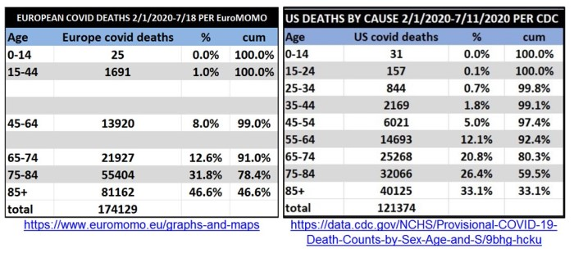
I am aware of official Irish government statistics relating to deaths in Ireland, particularly in the over 70 age group bracket. Charts are provided below. This confirms the findings in other countries and worldwide about covid19, that the overwhelming majority of deaths are in the over 70’s.
The chart below shows the mean age of death was 82 and median age of death was 84 for covid19 in Ireland. This is higher than life expectancy in Ireland. Life expectancy is 81. And 94% of deaths had two or more pre-existing illnesses.
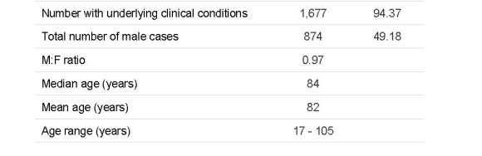
Source: Epidemiology of COVID-19 in Ireland. 4/9/20

CSO figures show that 64% of all deaths were in the over 80 age group category. The median age of death from covid19 is 84 and the mean age of death is 82 both of which are higher than Irish life expectancy, and deaths are highly concentrated in the over 80’s who are at increased risk of death from pre-existing illnesses and from all causes, and this has been the case for hundreds of years. This is very similar to the Winter flu seasons which we have had for hundreds of years. Central Statistics Office (CSO) figures for January 2021 included below.
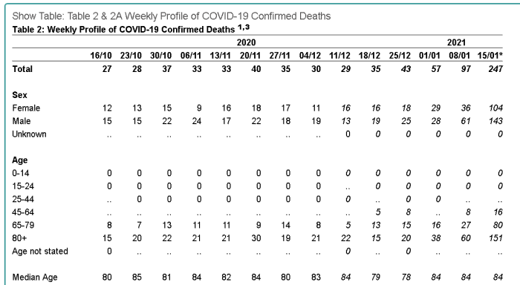
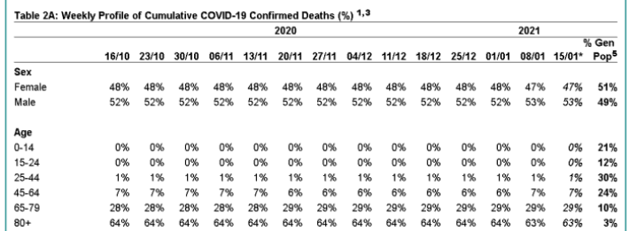
Source: https://www.cso.ie/en/releasesandpublications/br/b-cdc/covid-19deathsandcases/
The Chart in the previous page shows the official Irish government statistics and that 94% of deaths had two or more pre-existing illnesses. In the USA, the CDC also found that 94% of covid19 deaths had 2 or more pre-existing illnesses. Only 6% died specifically of covid19. Screenshot of CDC web site below.
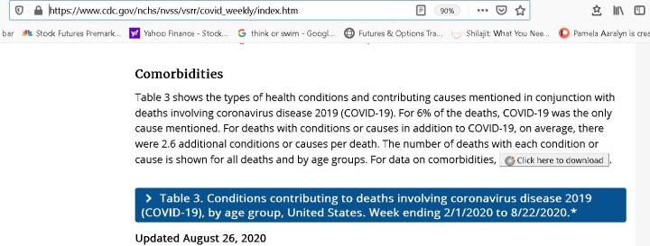
https://www.cdc.gov/nchs/nvss/vsrr/covid_weekly/index.htm
This correlates to findings worldwide. Most of those who died were elderly, over 70, and had two or more pre-existing illnesses.

In addition to the high risk posed by old age and pre-existing illnesses, COVID-19 infection poses an elevated mortality risk for people with certain chronic conditions like diabetes. We now have good evidence on the relative risk posed by the incidence of chronic conditions, so we know that among common conditions, age is the single most important risk factor. For instance, a 65-year-old obese individual has about the same COVID-19 mortality risk conditional upon infection as a 70-year-old non-obese individual.

Most elderly people with pre-existing illnesses and in poor health are confined to nursing homes. This population was highly vulnerable to covid19 and also to the pre-existing illnesses they already had and to Winter illnesses every year and to old age. Government figures show that 62% of covid19 deaths were in nursing homes in Ireland ^{9a}. Dementia or Alzheimer’s disease were most often listed as co-morbidities among Irish aged 70 years or older whose deaths involved COVID-19—especially among those aged 85 or older. And again this is in accordance with international findings.
Internationally the percentage of covid19 deaths in nursing homes and care homes ranges from 60 – 80%. The following statistics show this.
Canada 82% Northern Ireland 80% New Jersey at 76% Ohio 70% Pennsylvania 70%
Arizona 70% Florida 70%
Source: https://lockdownsceptics.org/covid-research/

Most of the deaths in nursing homes were due to putting infected people from hospitals and private homes into nursing homes, failures to supply PPE to personnel and patients, failure to isolate and quarantine, neglect of the physical health and mental & emotional health of patients, and failure to use effective medicines and prophylactics for covid19 in the nursing homes ; these are detailed later in Section F of this Paper, and on www.data-analytica.org/index.htm#med The misuse of ventilators also contributed to a high number of deaths. Patients were denied oxygen treatment and hyperbaric treatment for covid but were put on ventilators often at high pressure and this led to deaths. A New York City study found a 97.2% mortality rate among those over age 65 who received mechanical ventilation ( Safiya Richardson, MD, MPH, et al., Presenting Characteristics, Comorbidities, and Outcomes Among 5700 Patients Hospitalized With COVID-19 in the New York City Area, JAMA 2020 323(20), Apr. 22, 2020.). These same mistakes were worsened by "Do Not Resucicate" orders in North America and Europe.
Some of these mistakes and errors were made in Ireland and Britain in 2020 and into 2021. There were particular problems in the care of elderly COVID-19 patients in nursing homes in Ireland, which were publicly stated by Dr. Marcus de Brun in 2020 and in press and media reports in 2020.¹⁹ Some of the facts in relation to this are outlined on https://www.data-analytica.org/index.htm#nursing . Ireland did very poorly because the government, regulators and management failed to protect the most vulnerable population in the nursing homes by sending COVID infected patients to nursing homes that were unable to isolate them from the rest of the population, greatly increasing patient mortality.¹⁹ Research by Mr. Kieran Morrissey an engineer and statistician shows that increased nursing home deaths were due to dangerous policies by nursing home personnel, medical authorities and the HSE in 2020 and 2021 and this is the subject of legal investigations in Ireland ^{19a}. Research by Dr. Ivor Cummins shows that the majority of those people who died of covid19 in March - May 2020 in Ireland were too old and ill to be put into ICU in hospitals ( https://thefatemperor.com ). The scientific evidence and statistics show that most deaths were highly concentrated among elderly people with pre-existing illnesses and very ill younger people who were already at high risk of dying in 2020 regardless of covid19.
Canada is a country similar to Ireland in terms of economic and social development and healthcare. According to Statistics Canada,11 “When a pre-existing condition is suspected of putting a person at higher risk of a severe course of COVID-19 resulting in death, the death is counted as a death due to COVID-19 rather than a death due to the pre-existing condition…It is also possible that the death may have been influenced by COVID-19 but caused by another disease or an unintentional injury event. In these situations, COVID-19 should still be recorded on the medical certificates of cause of death…”
Pre-existing conditions can also put people at a higher risk of severe courses of influenza resulting in death, but to my knowledge such deaths are not counted as influenza deaths. Such a discrepancy in counting COVID-19 deaths and influenza deaths makes comparisons between the two respiratory illnesses difficult and results in artificially elevated death statistics due to COVID-19.

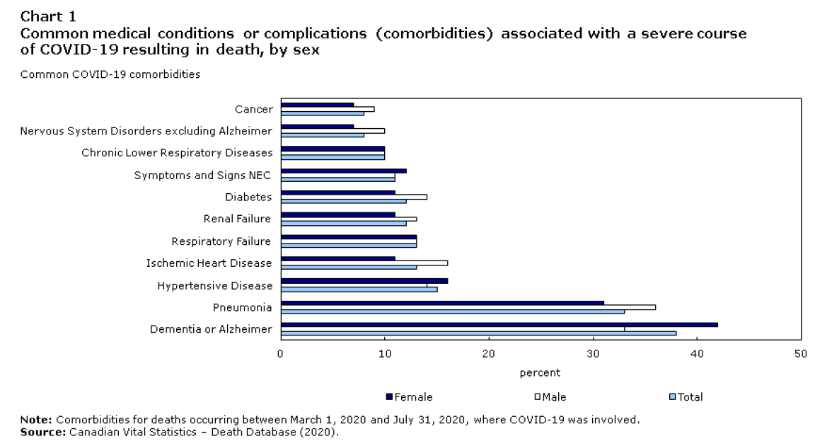
As already stated above, studies in Ireland and the USA show that approximately 94% of covid19 deaths had two or more pre-existing illnesses. In Italy, 96% of all covid19 deaths had two or more pre-existing illnesses ^{9c} . And old age was also a major factor in these covid deaths in Ireland, USA and Italy and worldwide. The issue of False Positives is particularly relevant here as there is evidence worldwide that PCR tests with high cycle counts are delivering a False Positive rate for covid19 of 90% or more. This is highly significant, as it means over 90% of covid19 cases may not be covid19, and there is a high risk that the pre-existing illnesses or old age as mentioned above were mislabeled as ‘covid19’. These other illnesses and old age were capable of killing people and the cause of death may have been these other illnesses and old age in a significant number of cases. Every year, for thousands of years old people with pre-existing illnesses have died of colds, flu’s, bacterial pneumonia, viral pneumonia, respiratory disorders, heart attacks, dementia diseases, complications of cancers, etc.. Statistics released by the Irish government and HIQA show that deaths for covid19 were over-estimated by at least 419 by July 2020. These reveal many people died with covid19 but not specifically of covid19. These people would have died in 2020 of heart disease, cancers, old age, liver failure, lung diseases, alzheimers, etc. and should not have been included as covid19 deaths - Analysis of excess all-cause mortality in Ireland during the COVID-19 epidemic
According to scientific research, PCR cycles of 30 - 34 provide False Positives of 70% or more while cycles of 35 to 45 provide False Positives of 90% - 100% ¹⁵². This is especially the case if the people tested are asymptomatic. Most developed countries, including Ireland used PCR cycles of 35 – 45 for covid19 in 2020 and 2021 and this led to a massive increase in False Positives or “covid19 cases".
This is very important and needs to be prioritized in all analysis of covid19 deaths as most covid19 deaths involved persons who were elderly and / or with two or more pre-existing illnesses which were quite capable of causing death and may have caused death but were mislabeled as ‘covid19’. The issue of False Positives for covid19 is central to getting precise and exact estimates for covid19 deaths in Ireland and worldwide.
We will examine the scientific evidence for this in paragraphs below :

- The scientific paper behind the PCR test for covid19 has been found by top scientists and experts to have several defects and flaws and is not fit for purpose
The Corman-Drosten paper published in January 2020 provided the details for PCR tests for covid19 in Europe and worldwide in 2020. This has been used for all PCR tests for covid19 worldwide in 2020 and 2021. The following scientific research paper published in November 2020 rebutts and rejects the Corman-Drosten paper and shows that the rate of False Positives is 97% in this PCR test for covid19. Link to paper below.
External peer review of the RTPCR test to detect SARS-CoV-2 reveals 10 major scientific flaws at the molecular and methodological level: consequences for false positive results.
Borger et al. Eurosurveillance, November 2020 https://cormandrostenreview.com/report/
This scientific paper written by 22 top scientists calls for Drostens’ paper to be retracted and the PCR test for covid19 to be ended as it has ten fatal flaws, many defects, too many conflicts of interest, and gives too many False Positives and is not fit for purpose. One of the flaws they listed was with the recommended cycle time value:
‘ In case of virus detection, >35 cycles only detects signals which do not correlate with infectious virus as determined by isolation in cell culture; if someone is tested by PCR as positive when a threshold of 35 cycles or higher is used (as is the case in most laboratories in Europe & the US), the probability that said person is actually infected is less than 3%, the probability that said result is a false positive is 97%.’
This means the number of covid19 cases and deaths are exaggerated and highly inflated and cannot be trusted. Research now confirms that PCR test cycles of 30 or more leads to a high percentage of False Positives for covid19. They have called the PCR test for covid19 “useless”. This is a very definitive statement. This is corroborated by other scientific research below and by clinical evidence below and by a court case.
- There is a class action lawsuit being brought by Dr Reiner Fuellmich and his team in various countries against “the manufacturers and sellers of the defective PCR tests”. Dr Fuellmich explains the lawsuit in this video - https://www.youtube.com/watch?v=ENuqsz2QVs8 and at https://www.conservativewoman.co.uk/the-many-scandals-of-the-pcr-test-part-3/ . Dr Fuellmich has publicly stated that we have a ‘Pandemic of False Positives’. He has also served cease and desist papers on Professor Christian Drosten, co-author of the Corman-Drosten paper which was the first and WHO-recommended PCR protocol for detection of SARS-CoV-2. Dr Fuellmich has detailed the conflicts of interest and crimes committed by Drosten and others involved in the PCR test and covid19 scandal and the legal case against them. This is ready for the German courts and for courts in other countries.
According to German lawyer, Dr. Fuellmich, Professor Christian Drosten was also involved in the promotion of fear and panic through giving over inflated predictions of deaths and second waves and third waves in the Swine Flu pandemic of 2008 – 09. This panic was misused to sell unsafe vaccines.
- Portuguese Court rules PCR test is unreliable as evidence for covid19 infection and illness
An important ruling by a Portuguese court stated that PCR tests are not reliable and cannot be used as evidence of covid19 infection and illness. This revolves around the fact PCR is not specific for covid19, does not isolate the virus, does not identify viral load, uses too many cycles, and only identifies fragments of a coronavirus and has a False Positive rate of 97%.
Citing Jaafar et al. (2020;), the court concluded that “if someone is tested by PCR as positive when a threshold of 35 cycles or higher is used (as is the rule in most laboratories in Europe and the US), the probability that said person is infected is <3%, and the probability that said result is a false positive is 97%.” The court further notes that the cycle threshold used for the PCR tests currently being made in Portugal is unknown
Citing Surkova et al. (2020)), the court further stated that any diagnostic test must be interpreted in the context of the actual probability of disease as assessed prior to the undertaking of the test itself, and expresses the opinion that “in the current epidemiological landscape of the United Kingdom, the likelihood is increasing that Covid 19 tests are returning false positives, with major implications for individuals, the health system and society.”
“Given how much scientific doubt exists — as voiced by experts, i.e., those who matter — about the reliability of the PCR tests, given the lack of information concerning the tests’ analytical parameters, and in the absence of a physician’s diagnosis supporting the existence of infection or risk, there is no way this court would ever be able to determine whether C was indeed a carrier of the SARS-CoV-2 virus, or whether A, B and D had been at a high risk of exposure to it.”
Sources: https://duckduckgo.com/?q=portuguese+court+pcr+covid&t=h_&ia=web and https://lockdownsceptics.org/2020/11/16/latest-news-195/#portuguese-appeals-court-deems-pcr-tests-unreliable
- In public statements released in December 2020 and January 2021, the World Health Organization finally acknowledged that PCR cycles were too high and there was a high risk of False Positives The WHO owned up to what hundreds of thousands of doctors and medical professionals have been saying for months - the PCR test used to diagnose COVID-19 is a hit and miss process with the PCR count far too high and too many false positives. https://www.zerohedge.com/medical/who-finally-admits-pcr-tests-create-false-positives and https://www.who.int/news/item/14-12-2020-who-information-notice-for-ivd-users and https://www.who.int/news/item/20-01-2021-who-information-notice-for-ivd-users-2020-05
- An important study¹⁵¹ was published in the European Journal of Clinical Microbiology & Infectious Diseases. The study aimed to determine when it would be safe to discharge COVID-19 patients in Marseille, France. The authors observed a significant relationship between Ct value and culture positivity rate (see Fig. 1). Samples with Ct values of 13–17 all led to positive culture. Culture positivity rate then decreased progressively according to Ct values to reach 12% at 33 Ct. No culture was obtained from samples with Ct > 34. See Chart below.
Fig. 1
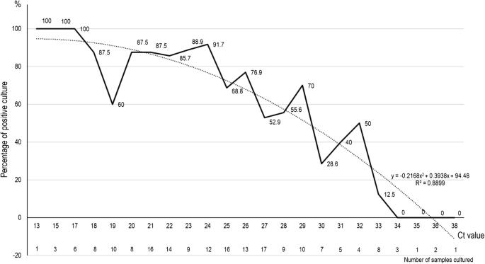

Percentage of positive viral culture of SARS-CoV-2 PCR-positive nasopharyngeal samples from Covid-19 patients, according to Ct value (plain line). The dashed curve indicates the polynomial regression curve
The study above concluded that patients with Ct values equal or above 34 did not excrete infectious viral particles.
- In mid-November 2020, Dr. Anthony Fauci of the NIH in USA admitted that the PCR Test's high count is misleading: “What is now sort of evolving into a bit of a standard,” Fauci said, is that “if you get a cycle threshold of 35 or more … the chances of it being replication-confident are minuscule.”
“It’s very frustrating for the patients as well as for the physicians,” he continued, when “somebody comes in, and they repeat their PCR, and it’s like [a] 37 cycle threshold, but you almost never can culture virus from a 37 threshold cycle.”
So, I think if somebody does come in with 37, 38, even 36, you got to say, you know, it’s just dead nucleotides, period.”
- Important Scientific papers and findings and scientific news reports worldwide about False Positives below :
Covid-19: Tests on students are highly inaccurate, early findings show
BMJ 2020; 371 doi: https://doi.org/10.1136/bmj.m4941
https://www.bmj.com/content/371/bmj.m4941
Duration of infectiousness and correlation with RT-PCR cycle threshold values in cases of COVID-19, England, January to May by Singanayagam A, Patel M, Charlett A, Lopez Bernal J, Saliba V, Ellis J, et al. 2020. Eurosurveillance. 2020;25(32):2001483. 2020
According to a careful study published in Eurosurveillance (a top journal in the field of epidemiology), if 27 cycles are needed for a positive test, the false positive rate is 34%; if 32 cycles are needed for a positive test, the false positive rate is 72%, and if 37 cycles are needed for a positive test, the false positive rate is 92%.¹⁵² If more than 40 cycles are needed for a positive test, the functional false positive rate is nearly 100%.
“Correlation Between 3790 Quantitative Polymerase Chain Reaction–Positives Samples and Positive Cell Cultures, Including 1941 Severe Acute Respiratory Syndrome Coronavirus 2 Isolates”. Rita Jaafar, Sarah Aherfi, Nathalie Wurtz, Clio Grimaldier, Thuan Van Hoang, Philippe Colson, Didier Raoult, Bernard La Scola, Clinical Infectious Diseases, ciaa1491, https://doi.org/10.1093/cid/ciaa1491
Viral cultures for COVID-19 infectious potential assessment - a systematic review. Jefferson T, Spencer EA, Brassey J, Heneghan C.. Clin Infect Dis. 2020 Dec 3:ciaa1764. doi: 10.1093/cid/ciaa1764. Epub ahead of print. PMID: 33270107. https://academic.oup.com/cid/advance-article/doi/10.1093/cid/ciaa1764/6018217
Post-lockdown SARS-CoV-2 nucleic acid screening in nearly ten million residents of Wuhan, China.Cao, S., Gan, Y., Wang, C. et al. Nat Commun 11, 5917 (2020). https://doi.org/10.1038/s41467-020-19802-w) https://www.nature.com/articles/s41467-020-19802-w
Risk of False Results with the Curative SARS-Cov-2 Test for COVID-19: FDA Safety Communication.
FDA in the USA
FDA Admits PCR Tests Give False Results, Prepares Ground For Biden To "Crush" Casedemic
ZeroHedge News
Articles by Dr. Michael Yeadon, Former Pfizer Chief Science Officer and published scientist
'Lies, Damned Lies and Health Statistics – the Deadly Danger of False Positives' explains the defects in PCR tests for covid19. There are false positives for covid19 in over 80% of cases.
"Pandemic is Over" - Former Pfizer Chief Science Officer Says "Second Wave" Faked On False-Positive COVID Tests. And The PCR False Positive Pseudo-Epidemic by Dr. Michael Yeadon
What SAGE Has Got Wrong by Dr. Michael Yeadon
The COVID-19 RT-PCR Test: How To Mislead All Humanity Into Accepting Societal Lock-Downs
Zero Hedge News
Professor Carl Heneghan of the Centre for Evidence Based Medicine in Oxford University in England published scientific papers on False Positives. He believes it could be over 80%. His scientific article and analysis was published in the Spectator - https://www.spectator.co.uk/article/how-many-covid-diagnoses-are-false-positives-
Are you infectious if you have a positive PCR test result for COVID-19? August 5, 2020, https://www.cebm.net/covid-19/infectious-positive-pcr-test-result-covid-19/
Dr Pascal Sacré is a physician specialized in critical care, author and renowned public health analyst, Charleroi, Belgium. He is a Research Associate of the Centre for Research on Globalization (CRG) . Among thousands of angry doctors arguing PCR tests should not be used is Dr. Pascal Sacré. He wrote that:
“This misuse of RT-PCR technique is used as a relentless and intentional strategy by some governments, supported by scientific safety councils and by the dominant media, to justify excessive measures such as the violation of a large number of constitutional rights, the destruction of the economy with the bankruptcy of entire active sectors of society, the degradation of living conditions for a large number of ordinary citizens, under the pretext of a pandemic based on a number of positive RT-PCR tests, and not on a real number of patients.”
- Flipping between Positive test results and Negative test results, and over and back
In February the health authority in China’s Guangdong province reported that people who have fully recovered from illness blamed on COVID-19, started to test “negative,” and then tested “positive” again - https://www.zmescience.com/science/a-startling-number-of-coronavirus-patients-get-reinfected/
An important paper published in the Journal of Medical Virology showed that 29 out of 610 patients at a hospital in Wuhan had 3 to 6 test results that flipped between “negative”, “positive” and “dubious” - https://onlinelibrary.wiley.com/doi/full/10.1002/jmv.25786
- A brilliant scientific article and analysis of False Positives – ‘ COVID19 PCR Tests are Scientifically Meaningless Though the whole world relies on RT-PCR to “diagnose” Sars-Cov-2 infection, the science is clear: they are not fit for purpose’ By Torsten Engelbrecht and Konstantin Demeter, June 27, 2020
https://www.globalresearch.ca/covid19-pcr-tests-scientifically-meaningless/5717253
I draw the reader’s and court’s attention to the following paragraph in the article above:
‘ Where is the evidence that the PCR tests can measure the “viral load”?
There is also reason to conclude that the PCR test from Roche and others cannot even detect the targeted genes.
Moreover, in the product descriptions of the RT-qPCR tests for SARS-COV-2 it says they are “qualitative” tests, contrary to the fact that the “q” in “qPCR” stands for “quantitative.” And if these tests are not “quantitative” tests, they don’t show how many viral particles are in the body.
That is crucial because, in order to even begin talking about actual illness in the real world not only in a laboratory, the patient would need to have millions and millions of viral particles actively replicating in their body.
That is to say, the CDC, the WHO, the FDA or the RKI may assert that the tests can measure the so-called “viral load,” i.e. how many viral particles are in the body. “But this has never been proven. That is an enormous scandal,” as the journalist Jon Rappoport points out. ‘
- Wang Chen, President of the Chinese Academy of Medical Sciences, conceded in February 2020 that the PCR tests are “only 30 to 50 per cent accurate” - https://www.scmp.com/tech/science-research/article/3049858/race-diagnose-treat-coronavirus-patients-constrained-shortage
- Fragments of Alleged Covid19 and False Positives. Positive Cases are not the same as Illness Cases requiring urgent medical attention.
The fact is, the PCR test is not designed to be used as a diagnostic tool as it cannot distinguish between inactive viruses, viral fragments (or debris) and "live" or reproductive ones. It also cannot measure viral load which is a vitally important factor in terms of infection, infectiousness and transmission of the virus to others. The PCR test is highly sensitive but not specific, it cannot differentiate between covid19 and other coronaviruses. The coronaviruses are over 90% similar and have very similar RNA components. These facts are acknowledged by the CDC and confirmed by the CDC in the USA ^{9d} . If you have a non-reproductive virus or fragments / debris of virus in your body, you will not get sick and you cannot spread it to others, but you will test positive. Positive cases are not the same as illness cases requiring urgent medical attention, but the two have been categorized as one and mixed up by government bodies and the press and media.
An official British government web site has admitted that fragments of covid19 can remain in a human body for 90 days or more even if a person is non infectious, and this can cause persistent false positives for covid19. Recovered and healthy people can test positive for covid19 for months after recovery as viral fragments remain their body. See paragraph from government web site below:
6. SARS-CoV-2 re-testing in staff, patients and residents in health and social care settings
Immunocompetent staff, patients and residents who have tested positive for SARS-CoV-2 by PCR should be exempt from routine re-testing by PCR or LFD antigen tests (for example, repeated whole setting screening or screening prior to hospital discharge) within a period of 90 days from their initial illness onset or test (if asymptomatic) unless they develop new COVID-19 symptoms. This is because fragments of inactive virus can be persistently detected by PCR in respiratory tract samples following infection – long after a person has completed their isolation period and is no longer infectious.
Source: https://www.gov.uk/government/publications/covid-19-management-of-exposed-healthcare-workers-and-patients-in-hospital-settings/covid-19-management-of-exposed-healthcare-workers-and-patients-in-hospital-settings
A recovered and healthy person would get False Positives in PCR tests for covid19 for many months after recovery from covid19.
- In the “CDC 2019-Novel Coronavirus (2019-nCoV) Real-Time RT-PCR Diagnostic Panel“ file from March 30, 2020, for example, it says:
Detection of viral RNA may not indicate the presence of infectious virus or that 2019-nCoV is the causative agent for clinical symptoms” And:
This test cannot rule out diseases caused by other bacterial or viral pathogens.”
And the FDA admits that:
positive results […] do not rule out bacterial infection or co-infection with other viruses. The agent detected may not be the definite cause of disease.”
https://www.fda.gov/media/136151/download
Other coronaviruses which cause colds and flu’s every year can also trigger False Positives for covid19. Scientists also agree that other viruses, bacteria, dead germs, cell debris, and human RNA contain RNA fragments and these could trigger False Positives as the PCR test is too sensitive and not specific enough. These facts are stated in published scientific papers and articles mentioned in bullet points above and below.
- A news article titled ‘Laboratories in US can’t find Covid-19 in one of 1,500 positive tests’ in April 2021, at https://web.archive.org/web/20210214214843/https://www.globalresearch.ca/clinical-lab-scientist-covid-19-fake-wake-up-america/5737013 and https://greatreject.org/laboratories-cant-find-covid-19-in-positive-tests/ has stated that several Universities and Labs in the USA were unable to find covid19 in 1,500 covid19 positive samples. There was no covid19 found but they found Influenza A or B in all the samples. The flu and colds did not disappear in 2020 and 2021 they were mislabeled as ‘covid19’. And many other serious illnesses were also mislabelled as ‘covid19’. Legal actions are being taken against the CDC in the USA. This further confirms the important role of False Positives.

- PCR count values “higher than 40 are suspect because of the implied low efficiency and generally should not be reported,” as stated in the MIQE guidelines. In Ireland and other countries PCR counts of 40 and higher were used for covid19 in 2020 and 2021
MIQE Guidelines - https://www.gene-quantification.de/miqe-bustin-et-al-clin-chem-2009.pdf
- Another type of False Positive has been identified by Dr. John Lee, a pathologist in Britain and this involves people who test positive and have the virus but are asymptomatic and their immune system has either eliminated or is eliminated the virus infection. Quotation from Expert Report, March 2021.
‘ 3. Immunity – people who have the virus ‘on board’ (detectable) but never develop symptoms. This category used to be referred to as “immunity” or “healthy people”. This occurs where, even if a virus is inhaled and present in the respiratory tract, the person is oblivious and remains completely well, as their immune system deals with the infection and they never develop symptoms. The evidence these individuals are a transmission risk is minimal.’
Page 12 of HART Expert Report at https://www.hartgroup.org/wp-content/uploads/2021/03/240321-Updated-HART-review.pdf

- Sweden uncovers 3,700 false positives from COVID-19 test kit
Source: https://medicalxpress.com/news/2020-08-sweden-uncovers-false-positives-covid-.html
- An article in the New York Times where several top scientists were interviewed illustrates this point.
Your Coronavirus Test Is Positive. Maybe It Shouldn’t Be
New York Times, August 29, 2020
https://www.nytimes.com/2020/08/29/health/coronavirus-testing.html
Here is a quote from this important article:
In Massachusetts, from 85 to 90 percent of people who tested positive in July with a cycle threshold of 40 would have been deemed negative if the threshold were 30 cycles, Dr. Mina said. “I would say that none of those people should be contact-traced, not one,” he said.
In three sets of testing data that include cycle thresholds, compiled by officials in Massachusetts, New York and Nevada, up to 90 percent of people testing positive carried barely any virus, a review by The Times found………………………Any test with a cycle threshold above 35 is too sensitive, agreed Juliet Morrison, a virologist at the University of California, Riverside. “I’m shocked that people would think that 40 could represent a positive,” she said.
Dr. Michael Mina of the Harvard School of Public Health in Boston has publicly condemned the high cycle counts which can lead to False Positives for covid19.
- Many scientists and medical doctors who are Experts have alerted the public worldwide about the False Positives in PCR tests for covid19, these people are listed in Section V of this paper. The False Positives lie at the root of their opposition to lockdowns and other restrictive government policies. They have used and continue to use science and medicine to justify their opposition to lockdowns.
- Professor Sucharit Bhakdi and Dr. Karina Reiss, both top German medical doctors, Professors and Epidemiologists, wrote a book called 'Corona, False Alarm?: Facts and Figures' and it has become a bestseller in Germany and in the EU. It exposes the facts and evidence about covid19. It analyses and criticises the PCR test for covid19 and outlines the defects and inaccuracy of this test and the high rate of false positives. Link to book provided below.
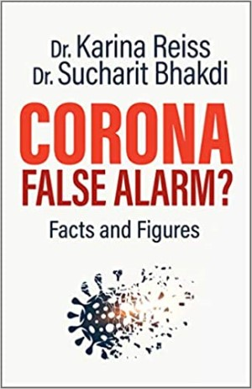 | Link to view it or buy it:  https://www.amazon.co.uk/Corona-False-Alarm-Facts-Figures/dp/1645020576/

- The inventor of the PCR test, Dr. Kerry Mullis stated publicly that PCR was suitable for lab use and research and should not be used for mass diagnostic testing. The PCR test is not specific for active covid19 in the body, does not measure viral load in the body and does not isolate the virus and culture it, and does not follow Koch's Postulates in medicine. The covid19 virus was not isolated, purified and it’s full genome and genes fully identified in 2020 and up to April 2021.
- A medical doctor with many years experience, Dr. Sam Bailey, gives an excellent introduction to the problem of False Positives for covid19 and other defects in the PCR test at https://www.youtube.com/watch?v=Q9GccuvNs9U
- Dr. Joseph Mercola a medical doctor, nutritionist and author in the USA wrote a scientific paper online
Astonishing COVID-19 Testing Fraud Revealed, January 13, 2021
https://articles.mercola.com/sites/articles/archive/2021/01/13/coronavirus-pcr-testing.aspx
He provides an analysis of scientific papers and evidence from around the world about the PCR test for covid19 and the antibody test -
- The Association of American Physicians and Surgeons (AAPS) expressed serious concerns about False Positives in October 2020, see article ‘COVID-19: Do We Have a Coronavirus Pandemic, or a PCR Test Pandemic?’ at https://aapsonline.org/covid-19-do-we-have-a-coronavirus-pandemic-or-a-pcr-test-pandemic/
- In May, 2020, President of Tanzania, John Magufuli rejected and condemned the PCR test for covid19 after it delivered a positive test for covid19 from samples of a goat, a sheep and papaya, which were given human names in tests. This illustrates the problem of False Positives. News report below.
https://www.reuters.com/article/us-health-coronavirus-tanzania/president-queries-tanzania-coronavirus-kits-after-goat-test-idUSKBN22F0KF
- The CDC and the FDA concede that the PCR test cannot be used for diagnosis. A file from March 30, 2020, stated: “Detection of viral RNA may not indicate the presence of infectious virus or that 2019-nCoV is the causative agent for clinical symptoms” and “This test cannot rule out diseases caused by other bacterial or viral pathogens.” - CDC 2019-Novel Coronavirus (2019-nCoV) Real-Time RT-PCR Sources: Diagnostic Panel, Centers for Disease Control and Prevention, https://www.fda.gov/media/134922/download and
Accelerated Emergency Use Authorization (Eua) Summary Covid-19 Rt-Pcr Test(Laboratory Corporation Of America),” https://www.fda.gov/media/136151/download
- Corroboration of these False Positives comes in the form of no rise in excess mortality rates and annual deaths in Ireland (and many other countries) in 2020 compared to the previous 10 to 20 years which are detailed in Section D of this paper, wrong predictions by Ferguson in Britain and by SAGE and NPHET and McConkey (in 2020), no overflowing hospitals and no need for building field hospitals, the dismantling of the ‘nightingale hospitals for covid19’ in Britain which had no covid19 patients in most cases, and the high recovery rate and very low Infection Fatality rate of 0.26% for covid19.

- Second Waves, Third Waves, Fourth Waves
According to Dr. Craig, a top Pathologist in Britain, we had a previous Pandemic of False Positives - the Swine Flu in 2009. And it had "second waves" and "third waves", etc. etc. She and many other scientists believe that we have had another Pandemic of False Positives in 2020 and 2021. Her tweet is presented below.
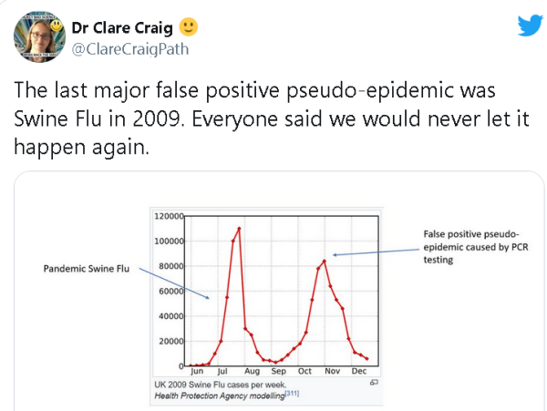
- In 2007, A New York Times report titled, “Faith in Quick Test Leads to Epidemic That Wasn’t,” clearly showed how scientifically inaccurate PCR tests are, and featured many shocking statements from medical experts and scientists on the use of these tests, clearly laying out how they result in false positives and lead to dangerous exaggerations and false alarms.

The Corman-Drosten paper and the tests recommended by the World Health Organization were originally set to 45 cycles, which guarantees a False Positive rate of 97% or more in 2020 and 2021 ^{9e} . The FDA and U.S. CDC followed the guidance of the Corman-Drosten paper and recommended running PCR tests at a CT of 40 - 45 which gives a similar rate of False Positives ^{9f} . In Ireland the PCR tests used cycles between 35 and 45. This guaranteed a high rate of False Positives, a rate of 97% in Ireland. I attach a link to an official government document confirming this:
https://www.hpsc.ie/a-z/respiratory/coronavirus/novelcoronavirus/guidance/outbreakmanagementguidance/PCR%20weak%20results%20guidance.pdf also available at www.data-analytica.org/pcr.pdf
It states the following:
7. Although there may be variation between platforms and amplification efficiency in general standard PCR assays run for 40 cycles: in the case of a commercial, CE marked PCR assay, the assay manufacturer determines for how many cycles the assay should run
A senior executive of the HSE (Irish Health Authority) stated the following to a member of the Irish parliament in October 2020:
The number of PCR cycles used in Ireland is decided by the manufacturer of the assay, so there is no single answer. The HSE uses a wide range of assays. As a general rule, most assays run for 40-45 cycles.
Source: https://www.hse.ie/eng/about/personalpq/pq/2020-pq-responses/october-2020/pq-28704-20-mattie-mcgrath.pdf also available at www.data-analytica.org/mattie.pdf
The use of PCR cycles of 35 to 45 in Ireland means that False Positives for covid19 are over 90% in Ireland and this explains the massive increase in covid19 cases between September 2020 and February 2021. According to scientific research, PCR cycles of 30 - 34 provide False Positives of 70% or more while cycles of 35 to 45 provide False Positives of 90% - 100% ¹⁵². The massive increase in testing in Ireland in late Summer and Autumn 2020 meant that a large number of False Positives were found and called ‘covid19 cases’. These high numbers were used to create mass fear, panic and paranoia in the general population by the government, their NPHET advisors and the press and media in 2020 and 2021. This fear and hysteria created the public support for lockdowns. The lockdowns are based on mass fear, panic, paranoia and hysteria about covid19 and not on Science and scientific findings.

As already stated the massive increase in PCR testing between March 2020 and January 2021 played a key role in identifying more False Positives. A chart showing the massive increase in PCR tests for covid19 is provided below.
PCR Tests from March 2020 to end of January 2021. Over 3 million tests by January 2021. The population of Ireland is 4.8 million. Large increase in False Positives for tests using 35 - 45 cycles – See Chart below
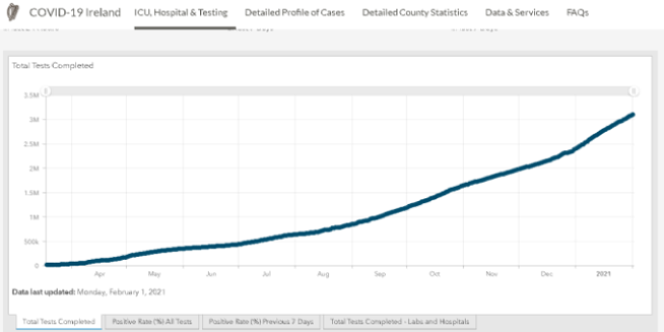
Source: https://covid19ireland-geohive.hub.arcgis.com/ March 2020 – February 2021
The High Rate of False Positives for covid19 due to high cycle counts ( greater than 30) confirmed by scientists, scientific research, WHO, CDC, courts and governments in 2020 and 2021 means that many covid19 cases and deaths may not be covid19 in Ireland and many other countries ^{23b}. More and more tests means higher numbers of False Positives called ‘covid19 cases’ and more public fear, panic and hysteria. The evidence and facts points to the pre-existing illnesses, old age, flu’s, colds, bacterial pneumonia and other Winter illnesses playing a major role in those deaths mislabeled as ‘covid19’.
The False Positives rate has a direct bearing on:
(a) the real number of covid19 cases
(b) the false number of covid19 cases which can promote fear, panic and paranoia
(c) the number of healthy people wrongly classified as covid19 cases or ill / infectious with covid19
(d) the number of people with other illnesses and diseases wrongly classified as covid19
(e) covid19 deaths and non covid19 deaths wrongly classified as covid19
(f) the Case Fatality rate
(g) the Infection Fatality Rate and Actual Fatality Rate per country and world cases and deaths.
The real and accurate figures for cases and deaths is far lower than reported by health authorities and the press and media. They could be 3, 4, 5 or 10 times lower than reported by health authorities and the press and media. This is also the subject of ongoing scientific , legal, police and government investigations in Ireland and worldwide.
Corroboration for this exists in the fact there were a low number of deaths and a very low Infection Fatality Rate for covid19. Further corroboration of this is that Total Deaths for 2020 and Excess Mortality for 2020 in Ireland were similar to the previous 10 years. This is examined later in this paper in Section D. What were the Total Deaths and Excess Mortality for 2020 of this paper.
This has serious implications for Winter illnesses and Winter deaths in Ireland. Coronaviruses are seasonal, they are involved in colds and flu’s, and they tend to infect people between December and April every year. They are a Winter illness and this is the case worldwide. This has been the case for hundreds of years. During the Winter months, colds, flu’s, bacterial and viral pneumonia and respiratory illnesses infect large numbers of people every year, and some of them are other coronaviruses and have many of the symptoms of covid19 and contain many of the viral particles and genes of covid19 and these can trigger False Positives for covid19, especially in light of the defects in the PCR test mentioned above. This has become a factor in the large rise in covid19 cases in Winter 2020 - 21 and the disappearance of colds and flu’s. The chief medical officer, Irish government and press and media claimed there were no flu’s and colds in Ireland in December 2020 and January and February 2021 ; this is highly unusual and unprecedented in Irish history. There have been colds and flu’s every Winter in Ireland for hundreds of years but strangely there were none in Winter 2020-21. I enclose news headline.
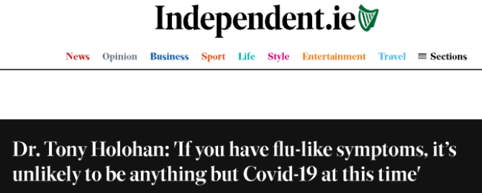
Irish Independent newspaper, January 2021

It is highly unlikely and indeed impossible that all colds and flu’s and bacterial and viral pneumonia and respiratory illnesses and other Winter illnesses suddenly disappeared in December 2020 and January and February 2021. The more probable explanation is that these Winter illnesses existed in 2020 and 2021 but were mislabeled and misinterpreted as covid19 cases. Dr. Patrick Morrissey, a highly experienced medical doctor in Ireland has stated that all doctors have to think of a wide differential diagnosis, otherwise doctors are at risk of missing the true diagnosis. Following the CMO's advice must have led to adverse outcomes because flu-like illness can reflect sepsis and infection from many other sources and he personally had four cases of pneumonia in the two weeks after that statement by Holohan. Two of those bacterial pneumonias were in Covid positive patients i.e. they had dual diagnosis.
A news article titled ‘Laboratories in US can’t find Covid-19 in one of 1,500 positive tests’ in April 2021, at https://web.archive.org/web/20210214214843/https://www.globalresearch.ca/clinical-lab-scientist-covid-19-fake-wake-up-america/5737013 and https://greatreject.org/laboratories-cant-find-covid-19-in-positive-tests/ has stated that several Universities and Labs in the USA were unable to find covid19 in 1,500 covid19 positive samples. There was no covid19 found but they found Influenza A or B in all the samples. The flu and colds did not disappear in 2020 and 2021 they were mislabeled as ‘covid19’. And many other serious illnesses were also mislabelled as ‘covid19’. Legal actions are being taken against the CDC in the USA. This further confirms the important role of False Positives.
In the circumstances, very poor and defective advice was given by the CMO in Ireland with the implication that all flu’s and colds had magically disappeared and that all to be done was to hunker down at home in isolation and to force all one’s contacts into isolation and the whole nation into lockdown. This advice was wrong and dangerous to health. The next paragraph examines this issue of mislabeling illnesses more closely.
Massive increase in covid19 cases but no big increase in covid19 deaths. Why ?
The following charts show a large increase in cases but no big increase in deaths from covid19 from March to December 2020 and in January 2021. There is very low number of covid19 deaths from June to December 2020. The sudden rise in alleged covid19 deaths and many Winter illnesses and deaths from mid December 2020 to the end of January 2021 needs to be seen in the context of the rise in deaths from Winter illnesses which occur at this time every year in Ireland for hundreds of years.
Cases
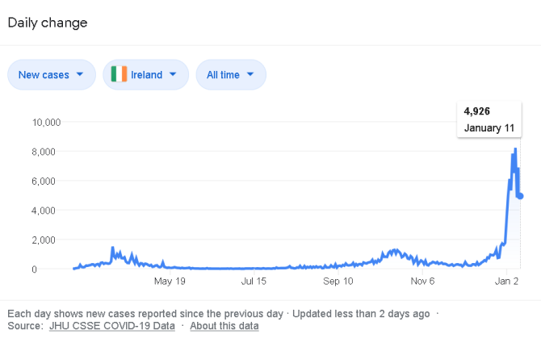
Total cases: 152,539 https://www.worldometers.info/coronavirus/country/ireland/
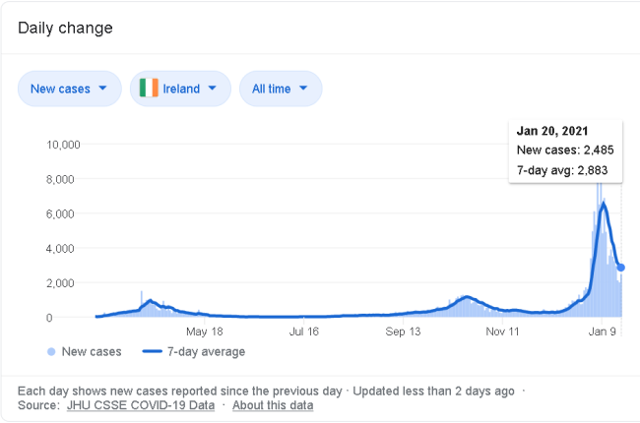
Total Cases: 179,324 https://www.worldometers.info/coronavirus/country/ireland/
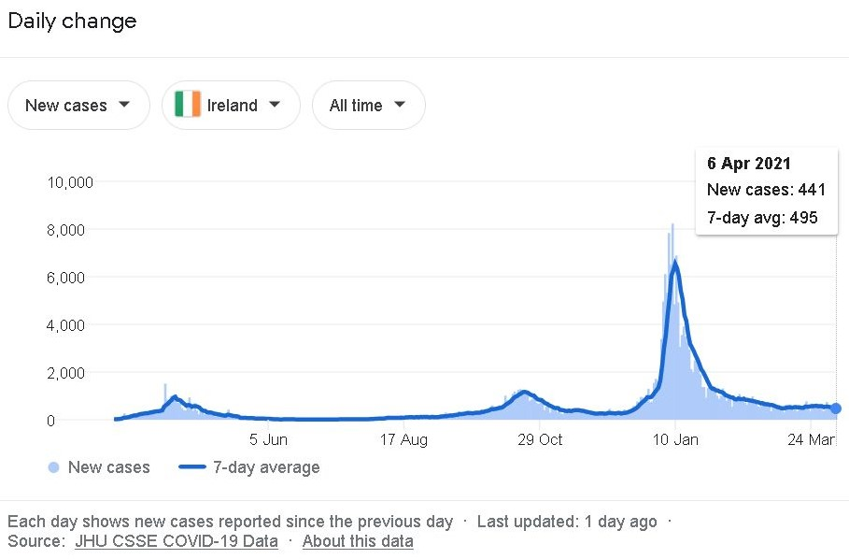
These figures are 7 day averages in this chart
Deaths
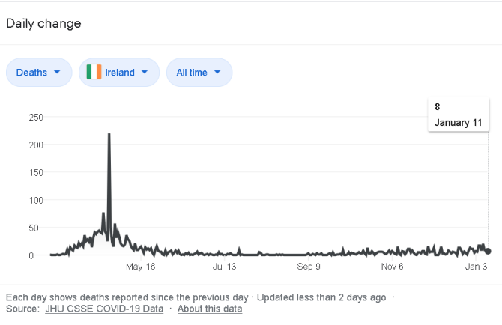
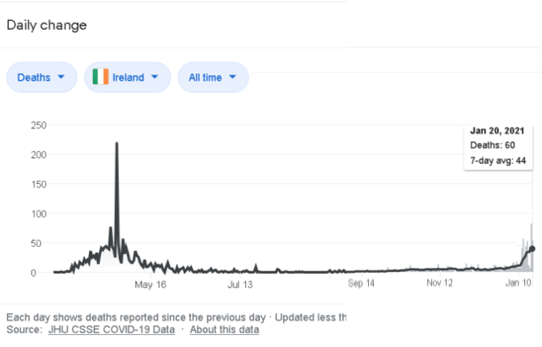
Note: graph above includes total daily deaths and weekly average deaths from September 14 2020 onwards. Total daily deaths are before that date and are preferred for analysis purposes
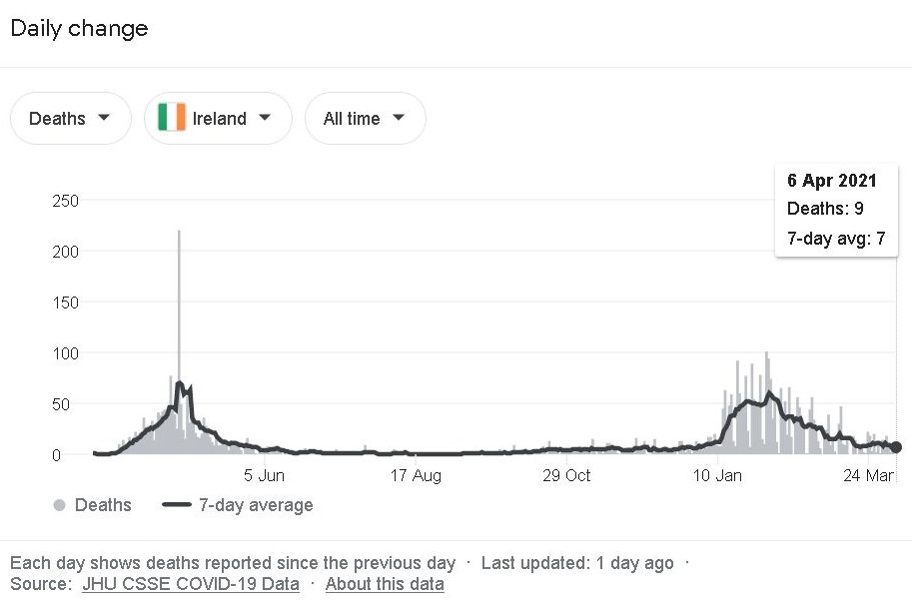
These figures are 7 day averages in this chart.
There were 5,325 positive tests on January 5th 2021 and 4,926 positive tests on January 11th 2021 and 2,485 positive tests on January 20th 2021. And thousands of positive cases in the days between these dates. Ireland had the highest cases per population in the world. The big increases in covid19 cases needs to be put in context here. There was no massive increase in deaths, in terms of thousands of people per day or per week such as in past pandemics. By the end of March or beginning of April 2021, the number of deaths had fallen to very small numbers in line with the decrease in Winter illnesses and flu’s and colds every year, for hundreds of years. Please compare covid19 to previous pandemics on page 57 of this paper.
The False Positives have played a major role in all of this. There is a great need to differentiate covid cases and deaths from non covid cases and deaths, real positives from false positives, the mislabeling of other serious illnesses as ‘covid19’, healthy people wrongly classified as covid19 from genuine cases of covid19, separate people with colds, flu’s and pneumonias and other Winter illnesses from covid19 cases, and differentiate those who died of covid19 specifically and those who died of other illnesses or diseases with covid19 as a secondary condition. The science now shows that the most accurate number of cycles in a PCR test for covid19 is 24 cycles or less for Symptomatic people, backed up by culturing a significant percentage of samples. Symptomatic is a very important factor. Any PCR cycle number above that creates a high risk of False Positives. And all or most of the symptoms of covid19 must be present in the patient and a clinical diagnosis given by a medical doctor. A certain percentage of test samples should be cultured in all testing locations in order to validate tests. This would provide a reliable diagnosis of covid19. Its important that symptomatic people are tested, as testing healthy asymptomatics may lead to False Positives, and condemn healthy un-infected or un-infectious people to quarantine and skew the number of covid cases. This is analysed further later in this paper, in Section B. What are RT-PCR tests? What is a Cycle Threshold and What is the Likelihood of Infection with Covid-19 with a CT over 30? How Does a Positive PCR Result Correlate to Ireland’s Definition of a “Case” of Covid-19?
Virus has not been isolated and its full Genome identified
The covid19 virus has not been isolated and it’s full genome identified as of April 2021. There is a prize of one million euros for the first person who can prove the virus has been isolated, purified, and its full genome identified - The Isolate Truth Fund viewable at https://samueleckert.net/isolat-truth-fund/
This is important as the isolated virus and its full Genome is necessary in order to accurately diagnose infection and to treat the illness and to develop new vaccines. The PCR tests may be identifying a different virus or no virus or viral debris or human rna or cell debris or exosomes. This creates more legal difficulties for the PCR tests, the covid19 numbers and deaths. Also the virus has not been isolated and used to re-infect animals or other subjects to prove it causes disease, as per Koch’s Postulates. This is an important part of medicine and science for 150 years.
Exosomes ?
The scientist Andrew Kaufman formerly of MIT claims to have evidence to show that exosomes are responsible for the pandemic. Dr. Andrew Kaufmann took photos of exosomes under a microscope and compared them with photos of what is claimed to be COVID-19. These two photos were exactly the same. He then examined the genetic composition of the exosomes and that claimed for COVID-19, and it turned out that these two compositions are identical in all respects. Each attaches on the same cellular receptors. They appear to be the same thing. Exosomes are naturally produced by the body in times of stress and as a result of many types of infection and diseases, including cancers, heart diseases, copd and lung diseases, etc.. This exosome finding or theory by Dr. Kaufmann will require further scientific research, peer reviews, and verification.
Lessons from Previous Pandemics and Epidemics
According to Dr. Michael Levitt, the Nobel Prize winner in Science, the covid19 follows the bell shape curve (on graphs) of all previous epidemics and pandemics in history. Dr. Michael Levitt's findings are confirmed by the growing evidence worldwide, see chart below.

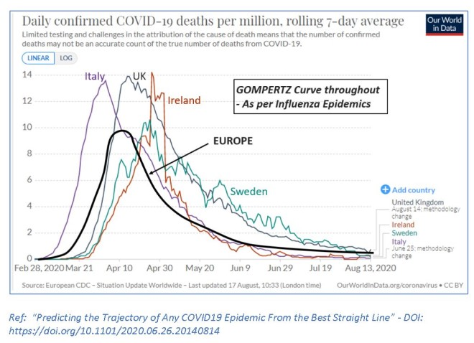

Dr. Michael Levitt's scientific paper goes into some detail about the mathematics of pandemics and epidemics - Predicting the Trajectory of Any COVID19 Epidemic From the Best Straight Line viewable at https://www.medrxiv.org/content/10.1101/2020.06.26.20140814v2
The R value has come to prominence recently in relation to lockdowns. False Positives produce False R's also termed F(R) which leads to a 'Casedemic' where there is a high number of cases, mostly false positives, and a very low death rate and low hospitalisation rate. Though this hospitalisation rate and death rate can be manipulated by mislabelling other illnesses and accidents as 'covid19', so as to invent a higher number of hospitalisations and deaths for covid19. This is particularly true in Winter when Winter illnesses and deaths can all be labelled 'covid19' and the high rate of False Positives in PCR tests can assist this process.

Deaths from vaccines to treat covid19 and More Mislabeling of covid19
In 2021, a new development has added further complications to covid19 diagnosis, covid19 cases and coivd19 deaths. There is evidence that significant numbers of people are dying after getting the vaccine for covid19 or suffering serious side effects and new illnesses from the vaccine. This has been well documented in the press and media and on social media on the Internet, including on www.data-analytica.org/page2.htm . Significant numbers of elderly people are dying in nursing homes, hospitals and at home shortly after getting the vaccine and this has been verified in scientific research ^{9g} and in continuing scientific research worldwide. The long term safety of these experimental covid vaccines has not been established by the manufacturers, and the safety of these vaccines will be assessed in 2021, 2022, 2023 2024, etc.. These vaccines are unlicensed and are experimental and are being trialed on whole populations of countries and have been given emergency permits in Europe and North America. The scientific and medical evidence shows that vaccines do not prevent a person getting covid19 and passing it on to other people. This is an important point as governments are trying to impose vaccine passports and new social controls and lockdown restrictions for people who are unvaccinated.

Evidence is emerging that people who get these vaccines can get infected with covid19. And there is evidence that deaths from these vaccines are being mislabeled as ‘covid19 deaths’ and that deaths rose in nursing homes after covid vaccinations ^{19a} . PCR tests with high rates of False Positives are also playing a role here in this mislabeling of deaths. This is artificially inflating covid19 deaths while under-reporting or disguising deaths caused by the vaccine. This is a serious issue and needs to be rectified by government, regulatory authorities, the press and media, and the police and courts.

The Need for Precision in Tests and Diagnosis and Scientific Freedom and Integrity
The inability to differentiate between dying of covid19 and dying of another illness or disease or covid19 vaccine injuries is an important point and presents a massive problem for governments and their advisors and for Science. The High Rate of False Positives for covid19 has played and continues to play a significant role in this mislabeling and the inability to differentiate between covid19 and non covid19 illnesses. ^{9b}. This is a very new area for Science which bases itself on objective truths, peer review, replication, consistency, no conflicts of interest, open and free debate (not censorship), precision and accuracy. The issues mentioned above raise important scientific questions and legal questions about the validity of lockdowns, and whether they were necessary.

Mislabeling of illnesses and The Domino Effects of Such
Many people who died of cancers, heart diseases, copd and other respiratory disorders, flu's, bacterial pneumonia, diabetes, immune system disorders, dementia and neurological illnesses, the complications of old age, non covid19 diseases, accidents, etc. were mislabelled as covid19 deaths in 2020 and into 2021. This relies on the fact that PCR tests in Ireland used cycles of 35 - 45 which have been proven to give 97% False Positives. Several other countries have done the same. Doctors and Pathologists failed to differentiate between dying specifically of a disease or accident with covid19 or a False Positive test for such AND dying specifically of covid19. The following tweet by Leo Varadkar ex Prime Minister of Ireland, pointed out this problem in a long series of tweets and replies.
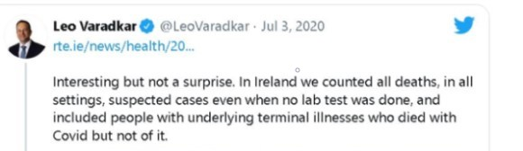
In the USA, there is ongoing controversy over the decision of CDC’s National Vital Statistics System to instruct doctors to presume that all or most patients died of covid-19 in Spring, Summer and Winter of 2020 without a definitive test for cause of death. American hospitals also received financial incentives of $39,000 for every covid19 case put on a Ventilator and $13,000 for every covid19 patient from the government or insurance companies (https://www.globalresearch.ca/hospitals-getting-paid-more-label-cause-death-coronavirus/5709720/amp ). There was an incentive to put patients on ventilators which presented a high risk of death if the ventilator pressure was too high. And this indeed was the case in many instances in 2020. There was a strong financial incentive to label all deaths as covid19 in 2020 and 2021. There is also disturbing evidence from whistleblowers in the USA including nurses and other medical professionals and funeral directors about orders from above to implement dangerous and certain controversial procedures which cost the lives of elderly patients and other patients with covid19 ¹⁰ . And most patients who entered hospitals for other illnesses and injuries during 2020 and 2021 were tested for covid19 and if their test was positive of False Positive then the patient was labeled a covid19 patient and the other illness or disease or injury ignored and often not officially reported as such ¹⁰ . The emphasis was on the positive covid19 test (including false positives). Lena Kay whose father died in 2020 stated the following 'Orders from above by the National Health Service. Anyone who dies during this period should be registered as covid-19.' ¹⁰ . These incentives and new practices and changes had the effect of inflating and exagerrating the covid19 numbers. This is the subject of continuing investigations in many countries.
In Britain, a panel of independent experts was set up in September 2020 to audit all covid19 deaths so as to separate actual covid19 deaths from non covid19 deaths. There was widespread mislabeling of deaths throughout Britain in 2020.
Source: ‘Panel of independent experts prepares audit for ‘every UK Covid death’, 23 March 2021, https://londonlovesbusiness.com/panel-of-independent-experts-prepares-audit-for-every-uk-covid-death/
Government officials, politicians, and senior medical officials are failing to diferentiate between a Positive Test and an actual Case. This is causing a massive rise in non cases mislabelled as 'cases'. A healthy recovered person with a tiny amount of fragments of the covid virus could test positive and a healthy asymptomatic person could test positive. All of these are wrongly labelled 'Cases'. A Case is a person who is symptomatic with moderate to severe symptoms requiring medical attention or hospitalisation.

There are multiple other ‘Domino Effects’ to False Positives and Mislabeling . This inaccuracy in PCR tests means that many other illnesses and deaths were mislabeled as covid19 and this has serious implications for these other illnesses. The treatment and recovery outcomes of these other non covid19 illnesses were adversely impacted by the cancellations of over 200,000 hospital appointments for these other illnesses in 2020 and 2021 due to the national lockdowns and other social restrictions for covid19. This is addressed in another section of this paper in terms of the harms caused by lockdowns.

The mislabeling of many other illnesses and diseases and deaths as covid19 occurred in Ireland and other countries and is the source of continuing investigations by Dr. Dolores Cahill, pathologists, scientists, health authorities, police, and others. Hopefully it will uncover more truths, facts and evidence. This issue has been pointed out and analysed on the Irish web site https://www.data-analytica.org/page3.htm in section (7) Mislabeling many other illnesses and deaths as covid19. The need to Differentiate between dying specifically of a disease or accident with covid19 or a False Positive test of such AND dying specifically of covid19.
Police investigations, military investigations, coroner investigations, private investigations and use of whistleblowers and protected disclosures will be required in the health service, hospitals, nursing homes, and state bodies to determine the scale of False Positives for covid19 in Ireland, the mislabeling of many illnesses as covid19, and the mislabeling of many deaths as covid19 and the conflicts of interest of government advisors and media advisors. I have enclosed an article from the London Times titled ‘Covid Deaths skewed by other illnesses says Coroner’ published on Sunday 18th April 2021 to the end of this section. It states that many covid19 deaths in Ireland were deaths from other causes including terminal illnesses and were mislabeled as covid19.

False Positives for covid19 and Lines of Causality. And Lack of isolation of virus and full genome.
The high rate of False Positives, as high as 97% for PCR tests using 35 – 45 cycles directly impacts the covid19 cases, deaths, Case Fatality rate, Infection Fatality rate, the presumption of asymptomatic spread of covid19, the labeling of hospital patients, the reasons for the lockdowns, the information which should have been communicated to the people via the press and media, and the vaccinations programme. The lack of isolation of virus and full genome has similar effects. They have multiple domino effects. This is vitally important from a scientific perspective and legal perspective.
Call for Criminal Investigations into covid19, False Positives, Conflicts of Interest, Corruption, and Lockdowns by governments in USA, Canada, Australia and Britain.
Some Serious Allegations and Factual Statements regarding covid19 and associated criminality have been made by a team of lawyers and barristers, doctors, scientists and a general. This will require intensive investigations and criminal court cases in order to determine the facts and the circumstances.
This may have a bearing on the science of covid19 and the factors behind lockdowns. Cited below:
The Chinese Communist Party’s Global Lockdown Fraud : Request for expedited federal investigation into scientific fraud in COVID-19 public health policies
https://ccpgloballockdownfraud.medium.com/the-chinese-communist-partys-global-lockdown-fraud-88e1a7286c2b#_ftn70 by Lawyers and Barristers, Doctors, Scientists and a General
Censorship of Science and of the Press and Media
There were other factors which contributed to this problem. Public opinion is very important, as it determines public support for government policies, initiatives and measures. An informed public can work for the Common Good and the protection of vital democratic freedoms and scientific freedom. In 2020, there was evidence of a lot of censorship of the press and media and of social media on the Internet which prevented an informed debate by scientific and medical experts on the subject of covid19, False Positives, Mislabeling of illnesses, pre-existing illnesses, vaccine safety, and lockdowns. Videos were removed from Youtube, posts were removed from Facebook and Twitter, and state broadcasters and corporate broadcasters refused to interview any scientists or medical doctors who questioned the narrative. Scientists and medical doctors and health professionals were fired from jobs or brought before tribunals, others were de-funded, others had grants rejected, some were blackmailed, and many were personally threatened for not following the narrow narrative. This was the case in Ireland and many other countries. This created a very narrow narrative, narrow consensus, and Groupthink and an inability to identify defects, mistakes, errors and omissions in this narrow narrative, and it severely stifled Science and scientific inquiry. Evidence for this censorship, blackmail and threats has been presented on independent press and media channels, one of them being The Defender which published an article about this topic in March 2021 - https://childrenshealthdefense.org/defender/global-effort-silence-critics-great-reset/ . Historically science has progressed from open and free public debate and freedom of scientific inquiry, peer reviews, and full accountability and integrity in scientific research and the scientific method. This was blocked and stopped in 2020 and 2021. This censorship and blocking of free speech and a free press was a clear breach of the Irish Constitution, Natural law, Human Rights and Democratic Principles in addition to being breaches of long established Scientific Principles.

Summary
In summary, Covid-19 does not pose a real or imminent serious threat to the health of the population in general but only to the health of a specific part of the population – the elderly and a very limited number of people with certain chronic conditions. Age is the single most important risk factor, with a worldwide 99.95% infection survival rate for people under 70 and 95% infection survival rate for people 70 and over. Further, COVID-19 case fatality rates have been dropping steadily since the disease emerged.
Peer-reviewed studies document these trends.¹⁴ One study in England found that “30-day mortality peaked for people admitted to critical care in early April… There was subsequently a sustained decrease in mortality risk until the end of the study period” in late June. This trend was found for people of all age groups, and survived adjustment for patient characteristics, which strongly suggests an improvement in treatment and patient management as the cause.¹⁵
Ventilator protocols which were used during the early days of the epidemic were too aggressive, with physicians too quick to place patients on mechanical ventilation. In those early days, nearly 90% of all COVID-19 patients on mechanical ventilation died.¹⁶ New discoveries about the use of histamine blockers in conjunction with ventilators contribute to improved survival of hospitalized COVID-19 patients.^{17, 18} Separately, there were particular problems in the care of elderly COVID-19 patients in nursing homes in Ireland, which were publicly stated by Dr. Marcus de Brun in 2020 and in press and media reports in 2020.¹⁹ Ireland did very poorly because the government, regulators and management failed to protect the most vulnerable population in the nursing homes by sending COVID infected patients to nursing homes that were unable to isolate them from the rest of the population, greatly increasing patient mortality.¹⁹ Research by Mr. Kieran Morrissey an engineer and statistician shows that increased nursing home deaths were due to dangerous policies by nursing home personnel, medical authorities and the HSE in 2020 and 2021 and this is the subject of legal investigations in Ireland ^{19a}. Similar mistakes and disasters occurred in Canada and a few other western countries ²⁰
The discovery that a deadly immune over-reaction to SARS-CoV-2 infection in some patients could be modulated by dexamethasone has greatly improved patient outcomes.^{21, 22} There have also been many medical success reports and recoveries from using certain medicines, and some of this evidence is presented later in Section F in this Paper and on medical and scientific web sites and on www.data-analytica.org/index.htm#med . Also there has been an improved understanding of the pathophysiological reasons why some patients progress to more severe outcomes from SARS-CoV-2 infection, while others do not.²³ So, the improvements in outcomes for COVID-19 patients derive from multiple sources. In summary, COVID-19 infection is less deadly than it was when it arrived in Europe and North America in Winter 2019 – 2020.
1 Public Health England (2020) Disparities in the Risk and Outcomes of COVID-19. August 2020. https://assets.publishing.service.gov.uk/government/uploads/system/uploads/attachment_data/file/908434/Disparitie s_in_the_risk_and_outcomes_of_COVID_August_2020_update.pdf and
www.data-analytica.org February 2021
2 John P.A. Ioannidis , The Infection Fatality Rate of COVID- 19 Inferred from Seroprevalence Data, Bulletin of the World Health Organization BLT 20.265892.
3 Andrew T. Levin, et al., Assessing the Age Specificity of Infection Fatality Rate for COVID- 19: Meta-Analysis & Public Policy Implications (Aug. 14,2020)MEDRXIV, http://bit.ly/3gplolV.
4 Fiona P. Havers, et al., Seroprevalence of Antibodies to SARS-CoV-2 in 10 Sites in the United States, March 23-May 12, 2020 (Jul. 21, 2020) JAMA INTERN MED., https://bit.ly/3goZUgy.
4a Reconciling estimates of global spread and infection fatality rates of COVID‐19: an overview of systematic evaluations, Ioannidis, March 25, 2021, https://onlinelibrary.wiley.com/doi/10.1111/eci.13554
5 COVID- 19 Pandemic Planning Scenarios, Centers for Disease Control and Prevention, https://www.cdc.gov/coronavirus/2019-ncov/hep/planning-scenarios.html.
6 Silvia Stringhini, et al., Seroprevalence of Anti-SARS-CoV-2 lgG Antibodies in Geneva, Switzerland (SEROCoV-POP): A Population Based Study (June 11,2020) THE LANCET, https://bit.ly/3187S13.
7 Francisco Perez-Saez, et al. Serology- Informed Estimates of SARS-COV-2 Infection Fatality Risk in Geneva, Switzerland (June 15,2020) OSF PREPRINTS, http://osf.io/wdbpe/.
8 Eran Bendavid, et al., COVID- 19 Antibody Seroprevalence in Santa Clara County, California (April 30,2020) MEDRXIV, https://bit.ly/2EuLIFK.
9 COVID- 19, Cases and Deaths Associated with COVID-19 by Age Group in California (Aug. 20,2020) CAL. DEPT. OF PUB. HEALTH, https://bit.ly/31inK9q [accessed Aug. 22,2020]
9a The Irish Times, May 22 2020, https://www.irishtimes.com/news/health/ireland-has-one-of-the-highest-rates-of-covid-19-deaths-in-care-homes-in-world-1.4260140?mode=sample&auth-failed=1&pw-origin=https%3A%2F%2Fwww.irishtimes.com%2Fnews%2Fhealth%2Fireland-has-one-of-the-highest-rates-of-covid-19-deaths-in-care-homes-in-world-1.4260140
9b Data Analytica www.data-analytica.org/index.htm#9 , March 2021
9c Bloomberg News https://www.bloomberg.com/news/articles/2020-05-26/italy-says-96-of-virus-fatalities-suffered-from-other-illnesses
9d CDC 2019-Novel Coronavirus (2019-nCoV) Real-Time RT-PCR Diagnostic Panel https://www.fda.gov/media/134922/download
9e WHO.int Diagnostic detection of Wuhan Coronavirus 2019 by real-time RT-PCR, January 13, 2020 (PDF) and
WHO.int Diagnostic detection of 2019-nCOV by real-time RT-PCR, January 17, 2020 (PDF) and
Drosten paper, 2020 https://www.ncbi.nlm.nih.gov/pmc/articles/PMC6988269/
9f https://www.fda.gov/media/134922/download
9g Page 31, HART Expert Report, March 2021, https://www.hartgroup.org/wp-content/uploads/2021/03/240321-Updated-HART-review.pdf
10 Nurse Erin Olszweski reports false covid registrations and murder - https://www.youtube.com/watch?v=UIDsKdeFOmQ&feature=youtu.be and https://www.youtube.com/watch?v=V1PzXqHAc2Q
https://www.youtube.com/watch?v=g5f_6ltv7oI and testimonies - https://www.stopworldcontrol.com/fraud/
11 Kathy O’Brien, et. Al., “Covid-19 Death Co-Morbidities in Canada” Statistics Canada, November 16, 2020, \
- null
- null
- Brumfiel G. (2020) Studies Point To Big Drop In COVID-19 Death Rates. NPR. October 20, 2020. https://www.npr.org/sections/health-shots/2020/10/20/925441975/studies-point-to-big-drop-in-covid-19-death-rates
- Dennis JM, McGovern AP, Vollmer SJ, Mateen BA. Improving Survival of Critical Care Patients With Coronavirus Disease 2019 in England: A National Cohort Study, March to June 2020. Crit Care Med. 2020 Oct 26. Doi: 10.1097/CCM.0000000000004747. Epub ahead of print. PMID: 33105150.
- Richardson S, Hirsch JS, Narasimhan M, et al. Presenting Characteristics, Comorbidities, and Outcomes Among 5700 Patients Hospitalized With COVID-19 in the New York City Area. JAMA. 2020;323(20):2052–2059. Doi:10.1001/jama.2020.6775
- Hogan Ii RB, Hogan Iii RB, Cannon T, Rappai M, Studdard J, Paul D, Dooley TP. Dual-histamine receptor blockade with cetirizine – famotidine reduces pulmonary symptoms in COVID-19 patients. Pulm Pharmacol Ther. 2020 Aug;63:101942. Doi: 10.1016/j.pupt.2020.101942. Epub 2020 Aug 29. PMID: 32871242; PMCID: PMC7455799.
- Janowitz T, Gablenz E, Pattinson D, Wang TC, Conigliaro J, Tracey K, Tuveson D. Famotidine use and quantitative symptom tracking for COVID-19 in non-hospitalised patients: a case series. Gut. 2020 Sep;69(9):1592-1597. Doi: 10.1136/gutjnl-2020-321852. Epub 2020 Jun 4. PMID: 32499303; PMCID: PMC7299656.
- Dr. Marcus de Brun and Press and media reports cited on Data Analytica at http://www.data-analytica.org/index.htm#nursing
19a Data Analytica, www.data-analytica.org/km.htm
- Quebec Ombudsman (2020) COVID-19 in CHSLDs during the first wave of the pandemic. Learning from the crisis and moving to uphold the rights and dignity of CHSLD residents. Dec. 10, 2020. https://protecteurducitoyen.qc.ca/sites/default/files/pdf/rapports_speciaux/progress-report-chslds-covid-19.pdf
- RECOVERY Collaborative Group, Horby P, Lim WS, Emberson JR, Mafham M, Bell JL, Linsell L, Staplin N, Brightling C, Ustianowski A, Elmahi E, Prudon B, Green C, Felton T, Chadwick D, Rege K, Fegan C, Chappell LC, Faust SN, Jaki T, Jeffery K, Montgomery A, Rowan K, Juszczak E, Baillie JK, Haynes R, Landray MJ. Dexamethasone in Hospitalized Patients with Covid-19 – Preliminary Report. N Engl J Med. 2020 Jul 17:NEJMoa2021436. Doi: 10.1056/NEJMoa2021436. Epub ahead of print. PMID: 32678530; PMCID: PMC7383595.
- Tomazini BM, Maia IS, Cavalcanti AB, Berwanger O, Rosa RG, Veiga VC, Avezum A, Lopes RD, Bueno FR, Silva MVAO, Baldassare FP, Costa ELV, Moura RAB, Honorato MO, Costa AN, Damiani LP, Lisboa T, Kawano-Dourado L, Zampieri FG, Olivato GB, Righy C, Amendola CP, Roepke RML, Freitas DHM, Forte DN, Freitas FGR, Fernandes CCF, Melro LMG, Junior GFS, Morais DC, Zung S, Machado FR, Azevedo LCP; COALITION COVID-19 Brazil III Investigators. Effect of Dexamethasone on Days Alive and Ventilator-Free in Patients With Moderate or Severe Acute Respiratory Distress Syndrome and COVID-19: The CoDEX Randomized Clinical Trial. JAMA. 2020 Oct 6;324(13):1307-1316. Doi: 10.1001/jama.2020.17021. PMID: 32876695; PMCID: PMC7489411.
- McCullough, Peter A et al. “Pathophysiological Basis and Rationale for Early Outpatient Treatment of SARS-CoV-2 (COVID-19) Infection.” The American journal of medicine, S0002-9343(20)30673-2. 7 Aug. 2020, doi:10.1016/j.amjmed.2020.07.003
B. What are RT-PCR tests? What is a Cycle Threshold and What is the Likelihood of Infection with Covid-19 with a CT over 30? How Does a Positive PCR Result Correlate to Ireland’s Definition of a “Case” of Covid-19?

The RT-PCR test for the SARS-CoV-2 virus is at the heart of the testing system adopted by Ireland. The RT-PCR tests, as used in most laboratories in Ireland, likely registers a positive test result even for non-infectious viral fragments. The RT-PCR test amplifies the virus – if present – by a process of repeatedly doubling the concentration of viral genetic material. If the viral load is small, many doublings are required before it is possible to detect the virus.

The problem arises from the fact that the implementation of the RT-PCR test for COVID-19 requires that clinical laboratories decide in advance how many doublings of the genetic material they will require before deciding that a sample is negative for the presence of the virus. This threshold, known as the “cycle time” of the test, determines both the rate at which a positive test result will be returned when the original sample does not include viral concentrations in sufficient amount to be infectious (hereafter, the functional false positive rate), and the rate at which a negative test result will be returned when the original sample does include viral concentrations in sufficient amount to be infectious (hereafter, the functional false negative rate).

A higher cycle time threshold – requiring more doublings before declaring a negative test result

– increases the functional false positive rate of the RT-PCR test because even if a non-infectious viral load is present in the sample obtained from the patient, a large number of permitted doublings could amplify whatever is present such that test result is positive. In such a case, this positive test result would not mean that the individual was infectious or contagious.

The RT-PCR test is commonly known in the literature as the gold standard to check for the presence of the SARS-CoV-2 virus. This is true, but beside the point. The important question is not whether RT-PCR is a “gold standard” test for viral presence, but rather whether it is a gold standard test for determining whether a patient is infectious, which it is not. Rather, the gold standard test for infectivity involves checking whether a sample taken from the nasopharynx of a patient can infect, in vitro, a cell culture. Infectious samples are known as “culture positive”, while non-infectious samples are known as “culture negative”. From an epidemiological point of view, infectivity measurement is more important than a measurement of whether the virus is present, since it is possible for a patient to have non-viable viral fragments present, a positive PCR test, and yet not be infectious.

The relevant question then, is whether the RT-PCR test is sufficiently accurate to use as a tool to decide whether to sharply curtail the normal activities of over 4 million people living in Ireland imposing untold harm on them related to the lockdown, and the unfortunate answer is no.

A systematic review of the literature on cycle time thresholds for the SARS-CoV-2 RT-PCR tests (encompassing 25 different published studies on the topic) concludes that “The evidence is increasingly pointing to the probability of culturing live virus being related to the amount of viral RNA in the specimen and therefore, inversely related to the cycle threshold. Thus, detection of viral RNA per se cannot be used to infer infectiousness.”¹⁵⁰ In other words, the scientific evidence now shows that the RT-PCR test for the presence of the SARS-CoV-2 virus will often generate a positive result even when an individual is not infectious (that is, does not pose a danger of infecting other people). The difficulty is that the RT-PCR test permits too many doubling cycles of viral particles before declaring a negative test. The functional false positive rate increases with the number of cycles (known as a Ct value) required to produce a positive result. The review recommends requiring clinical evidence of infection alongside a PCR result with a low cycle time count before designating a patient as a COVID-19 case.

Similar results were observed in a study¹⁵¹ published in the European Journal of Clinical Microbiology & Infectious Diseases. The study aimed to determine when it would be safe to discharge COVID-19 patients in Marseille, France. The authors observed a significant relationship between Ct value and culture positivity rate (see Fig. 1). Samples with Ct values of 13–17 all led to positive culture. Culture positivity rate then decreased progressively according to Ct values to reach 12% at 33 Ct. No culture was obtained from samples with Ct > 34.

Fig. 1

Percentage of positive viral culture of SARS-CoV-2 PCR-positive nasopharyngeal samples from Covid-19 patients, according to Ct value (plain line). The dashed curve indicates the polynomial regression curve

The study concluded that patients with Ct values equal or above 34 did not excrete infectious viral particles.

Further, according to a careful study published in Eurosurveillance (a top journal in the field of epidemiology), if 27 cycles are needed for a positive test, the false positive rate is 34%; if 32 cycles are needed for a positive test, the false positive rate is 72%, and if 37 cycles are needed for a positive test, the false positive rate is 92%.¹⁵² If more than 40 cycles are needed for a positive test, the functional false positive rate is nearly 100%.
- Jefferson T, Spencer EA, Brassey J, Heneghan C. Viral cultures for COVID-19 infectious potential assessment - a systematic review. Clin Infect Dis. 2020 Dec 3:ciaa1764. doi: 10.1093/cid/ciaa1764. Epub ahead of print. PMID: 33270107.
- La Scola, B., Le Bideau, M., Andreani, J. et al. Viral RNA load as determined by cell culture as a management tool for discharge of SARS-CoV-2 patients from infectious disease wards. Eur J Clin Microbiol Infect Dis39, 1059– 1061 (2020). https://doi.org/10.1007/s10096-020-03913-9

Twenty-two top international scientists came to a similar conclusion in respect of false positive test results and cycle thresholds. On November 27, 2020, they submitted a retraction request letter¹⁵³ to the Eurosurveillance editorial board, requesting that the paper published by Eurosurveillance on January 23, 2020, titled, “Detection of 2019 novel coronavirus (2019- nCoV) by real-time RT-PCR” ¹⁵⁴ also known as the Corman-Drosten paper be retracted and withdrawn. The “Corman-Drosten paper” proposed the PCR test for covid19 which was used worldwide in 2020 and 2021. It contained many flaws and errors and there are international calls by top scientists and doctors for the paper to be retracted. In addition to their letter, these scientists submitted a Review report¹⁵⁵ of the Corman-Drosten paper outlining 10 fatal flaws in the paper. One of the flaws they listed was with the recommended cycle time value:

In case of virus detection, >35 cycles only detects signals which do not correlate with infectious virus as determined by isolation in cell culture; if someone is tested by PCR as positive when a threshold of 35 cycles or higher is used (as is the case in most laboratories in Europe & the US), the probability that said person is actually infected is less than 3%, the probability that said result is a false positive is 97%.

Even the World Health Organization recently published an Information Notice¹⁵⁶ warning users of PCR tests that it had “received user feedback on an elevated risk for false SARS-CoV-2 results when testing specimens using RT-PCR reagents on open systems.”

In summary, the scientific literature establishes the importance of cycle time thresholds in interpreting RT-PCR SARS-CoV-2 results to establish the infectivity of the samples ¹⁶¹.

- Singanayagam A, Patel M, Charlett A, Lopez Bernal J, Saliba V, Ellis J, et al. Duration of infectiousness and correlation with RT-PCR cycle threshold values in cases of COVID-19, England, January to May
2020. Eurosurveillance. 2020;25(32):2001483. 2020
- Retraction request letter to Eurosurveillance editorial board re: Cormen-Drosten Paper, Dr. Pieter Borger et al., November 26, 2020, https://cormandrostenreview.com/retraction-request-letter-to-eurosurveillance-editorial-board/

In Ireland the PCR tests used cycles between 35 and 45. This guarantees a high rate of False Positives, over 90% for covid19 in Ireland. I attach a link to an official government document confirming this:
https://www.hpsc.ie/a-z/respiratory/coronavirus/novelcoronavirus/guidance/outbreakmanagementguidance/PCR%20weak%20results%20guidance.pdf also available at www.data-analytica.org/pcr.pdf
It states the following:
7. Although there may be variation between platforms and amplification efficiency in general standard PCR assays run for 40 cycles: in the case of a commercial, CE marked PCR assay, the assay manufacturer determines for how many cycles the assay should run
A senior executive of the HSE (Irish Health Authority) stated the following to a member of the Irish parliament in October 2020:
The number of PCR cycles used in Ireland is decided by the manufacturer of the assay, so there is no single answer. The HSE uses a wide range of assays. As a general rule, most assays run for 40-45 cycles.
Source: https://www.hse.ie/eng/about/personalpq/pq/2020-pq-responses/october-2020/pq-28704-20-mattie-mcgrath.pdf also available at www.data-analytica.org/mattie.pdf

The use of PCR cycles of 35 to 45 in Ireland means that False Positives for covid19 are over 90% in Ireland and this explains the massive increase in covid19 cases between September 2020 and February 2021. According to scientific research, PCR cycles of 30 - 34 provide False Positives of 70% or more while cycles of 35 to 45 provide False Positives of 90% - 100% ¹⁵². The massive increase in testing in Ireland in late Summer and Autumn 2020 meant that a large number of False Positives were found and called ‘covid19 cases’. These high numbers were used to create mass fear, panic and paranoia in the general population by the government, their NPHET advisors and the press and media in 2020 and 2021. This fear and hysteria created the public support for lockdowns. The lockdowns are based on mass fear, panic, paranoia and hysteria about covid19 and not on Science and scientific findings.

- Victor M. Corman, Olfert Landt, Marco Kaiser, Detection of 2019 novel coronavirus (2019-nCoV) by real-time RT-PCR, Eurosurveillance. 2020 Jan 23; 25(3): 2000045 doi: 10.2807/1560-7917.ES.2020.25.3.2000045; this paper’s approval and publication in Eurosurveillance in January 2020 led many world nations to utilize the PCR test to diagnose COVID-19

- Pieter Borger et al. External peer review of the RTPCR test to detect SARS-CoV-2 reveals 10 major scientific flaws at the molecular and methodological level: consequences for false positive results., November 27, 2020, https://cormandrostenreview.com/report/
- WHO Information Notice for IVD Users, December 14, 2020, https://www.who.int/news/item/14-12-2020-who-information-notice-for-ivd-users?fbclid=IwAR0Si8UnfvZc8iOppsSPO2kuzXJ-
- ^{Null}
- ^{Null}
- ^{Null}
- ^{Null}
- Rita Jaafar, Sarah Aherfi, Nathalie Wurtz, Clio Grimaldier, Thuan Van Hoang, Philippe Colson, Didier Raoult, Bernard La Scola, “Correlation Between 3790 Quantitative Polymerase Chain Reaction–Positives Samples and Positive Cell Cultures, Including 1941 Severe Acute Respiratory Syndrome Coronavirus 2 Isolates”, Clinical Infectious Diseases, ciaa1491, https://doi.org/10.1093/cid/ciaa1491

C. Are the Lockdowns a Disproportionate Response ? How does covid19 compare to previous pandemics in history?

In this section, we examine the Disproportionality of lockdowns in 2020 and 2021. This Disproportionality is analysed in terms of science, medicine and law.
Studies show that the covid19 virus was in the world population and in the Irish general population from December 2019 to March 2020, yet there was no large scale deaths from covid19, no large scale increase in total deaths and no big increase in excess mortality during that time and for the year 2020. The evidence for this is presented in Section D What were the Total Deaths and Excess Mortality for 2020 and Comparison to Previous Years of this paper. In fact, there was just one death of an elderly woman from covid19 and she had pre-existing illnesses on March 11th 2020. There were 280 covid deaths worldwide on that date and 4,000 had already died of it since December 2019 ( WHO, March 2020). Why did it take so long to register the first covid19 death in Ireland on March 11th 2020. Colds and flu’s and pneumonia in Ireland and worldwide were causing far more deaths between December 2019 and March 2020. Also colds, flu’s, pneumonia and Winter illnesses tend to kill elderly people over 70 with pre-existing illnesses every year, and this has been the case for hundreds of years. Worldwide, these illnesses in addition to TB and other infectious diseases and cancers and heart diseases were causing 20 - 50 times more deaths than covid19 from December 2019 to March 2020. Yet there were no lockdowns for these illnesses.

Had there been PCR tests for Winter flu’s and colds in 2019 – 2020, and sensational reports about deaths from these in the press and media, the public could have been subjected to fear, panic, paranoia and hysteria. False positives would have fuelled exponential rises in cases and deaths and added to this fear and hysteria. It would have been possible to lock down countries for colds and flu’s. This is the level of hysteria and disproportionally involved with covid19.

The Irish lockdown was imposed on 16th March 2020 despite the fact that very few people had died of covid19 in March and most were elderly and dying of pre-existing illnesses and Winter illnesses. And none had died between December 2019 and March 10th 2020 when covid19 was spreading throughout the entire world. Despite lockdowns for most of 2020 and January to April 2021, the number of covid19 cases continued to rise. Lockdowns were supposed to stop the rise in covid19 cases according to the so called “experts”. This failure of lockdowns strongly suggests that other factors are at play, including False Positives and deaths from pre-existing illnesses, old age and Winter illnesses which occur every year. These were mentioned in Section A and Section B of this paper and throughout this paper.

The Actual Death Rate of covid19 up to January 25th 2021 was 2,970 which is 618 per million, or 0.618 per 1,000 ^{23a} . This figure is not entirely accurate as the government statistics show that 94% of all covid19 deaths were elderly and / or had 2 or more pre-existing illnesses many of which were capable of causing death, and only 6% died specifically of covid19. Using these statistics the Actual Death Rate specifically for covid19 is 37 per million or 0.037 per 1,000. This is a very low figure. By population this means 0.0618% of the population have died of pre-existing illnesses with covid or 0.0037% have died specifically of covid19. Yet the lives of 4.8 million people in Ireland have been ruined by lockdowns and breaches of their Constitutional rights and Human Rights. This is Disproportionate.
The High Rate of False Positives for covid19 mentioned in Section A of this paper and confirmed by scientists, scientific research, WHO, CDC, courts and governments in 2020 and 2021 means that many covid19 cases and deaths may not be covid19. Scientific studies and court cases believe the False Positive Rate could be as high as 97% due to Ireland and many other countries using PCR cycles of 35 - 45 in 2020 and into 2021. The facts and evidence for this are presented in this paper and on www.data-analytica.org/index.htm#9 . The 97% False Positive rate is highly significant, as it means the Actual Death Rate above is far too high, the real figure could be 3% of the Actual Death Rate above or 19 per million. The remaining 599 per million being deaths from other illnesses, diseases and accidents. A similar scenario exists for the Infection Fatality rate, Case Fatality rate, total cases and total deaths. Again, the lives of 4.8 million people in Ireland have been ruined by lockdowns and breaches of their Constitutional rights and Human Rights. This is Disproportionate.
Evidence is emerging of covid19 tests being performed on corpses in morgues ^{23d} . And yes, it is possible for corpses to register False Positives on PCR tests for covid19. Dr. Dolores Cahill and others including coroners and families of the dead are carrying out investigations into the covid19 deaths in Ireland to establish the actual cause of death. And there is also evidence of double, treble, quadruple, etc. counting of covid19 cases through testing the same person many times in hospitals and clinics and testing centres. This is all corroborated by the fact that total deaths and excess mortality in 2020 were similar to the previous 20 years in Ireland. These factors increase the Disproportionality.

Causes of Deaths in Ireland in 2020
The Central Statistics Office has compiled statistics for causes of death in Ireland. In 2020, actual covid19 and alleged covid19 made up 6.5% of all deaths though this number will be adjusted downwards as investigators and coroners establish the actual cause of death. It was the fourth leading cause of death, though the covid19 deaths may be greatly over-estimated due to False Positives for covid19 of over 90%. This means the deaths were from other causes, such as pre-existing illnesses (or co-morbid illnesses) but mislabeled as ‘covid19’. Anyone dying within 28 days of a covid19 positive was being labeled a covid19 death even if it was a traffic accident or work accident.
COVID-19 including alleged covid19 and False Positives was:
- the fifth highest underlying cause of death in the 65 – 79 and the 80 and over age categories
- the sixth highest for the 50 – 64 age group
- the eight highest in the 25 – 49 age group
- not in the top 10 for the under 25 age group
Source: https://www.cso.ie/en/releasesandpublications/fr/fr-ucd2020/analysisofunderlyingcauseofdeathdataincludingcovid-19januarytooctober2020/

One of the crucial tests for the Disproportionality of Lockdowns is - were there effective medicines for treating covid19?
One of the most important questions in any pandemic throughout history is ‘are there any effective medicines to treat the infection causing the pandemic ?’ The evidence and facts show that there were effective medicines for treating covid19 in 2020 and 2021 and there are documented cases of many thousands of recoveries from using them ^{24a} and this is listed in section F of this Paper and on many scientific and medical web sites including www.data-analytica.org/index.htm#med . In fact, these medicines had a success rate of 90% or more ^{24a} This is significant and is one of the most important reasons for ending the lockdowns, particularly in Summer and Autumn 2020 when this knowledge became known globally.

A Dr. Vladimir Zelenko in New York successfully used Hydroxychloroquine to treat 699 covid19 patients and there was a100% success rate in Spring 2020. News article here at https://techstartups.com/2020/03/28/dr-vladimir-zelenko-now-treated-699-coronavirus-patients-100-success-using-hydroxychloroquine-sulfate-zinc-z-pak-update/
Professor Didier Raoult in France successfully treated 20 covid patients Hydroxychloroquine and published a paper on this which is available here at https://www.mediterranee-infection.com/wp-content/uploads/2020/03/Hydroxychloroquine_final_DOI_IJAA.pdf
Harvey Risch, MD, PhD who heads the Yale University School of Epidemiology recommends Hydroxychloroquine. He authored “The Key to Defeating Covid-19 Already Exists. We Need to Start Using It” which was published in Newsweek Magazine July 23rd, 2020.

The fact that there were effective medicines for treating covid19 meant that lockdowns were unnecessary and disproportionate in 2020 and 2021. There were other factors at play here which need to be examined.

Hydroxychloroquine is listed in these effective medicines above. It should be pointed out that sinister attempts were made to falsely state that Hydroxychloroquine was not useful, not effective and may be dangerous in the treatment of covid19 in 2020. This false paper and false rumour was exposed in 2020 and a paper retracted from the Lancet journal ^{24b, 24c} . We are also aware of many attempts to diminish or mock the use of these medicines mentioned above and Vitamin D and Zinc, despite scientific and medical evidence of their efficacy, effectiveness and safety for covid19 in 2020 and for viral illnesses in many previous years and decades. Some of those who most strongly supported the lockdowns also tried to block the administration of these medicines in countries around the world. There are some countries where these effective medicines are banned by the government and health authorities. This is an outrageous abuse of power. This suggests an anti scientific and anti medical approach to covid19, and a bias in favour of lockdowns and other anti democratic measures. All types of “experts” and “advisors” to governments have many reasons for recommending lockdowns and creating desperation for their new ‘cures’, while not declaring their own conflicts of interest, vaccine promotion and selfish profit motives, and ideological reasons.
The Actual Death Rate could have been far less if doctors, nurses, nursing homes and hospitals (and medical bodies) had not put persons with covid19 into nursing homes and if they had used the effective medicines for covid19 which have a success rate of 90% or more in 2020 and into 2021. Nursing homes and hospitals and the government were negligent in this in 2020, perhaps criminally negligent ; criminal cases in the courts will decide on this. Vitamin D alone has reduced the Actual Death rate significantly in other countries and this was known in Summer 2020 but the Irish government and Health authorities refused to accept this and refused to implement appropriate measures to distribute Vitamin D and Zinc (also effective with Vitamin D) to the vulnerable sections of the population ^{23c} . These medicines and Vitamin D and Zinc could have reduced the death rate for covid19 by 50% or more in 2020 and into 2021. Studies from Japan show that high Vitamin D levels in the population there contributed to a very low number of covid19 deaths there, one of the lowest in the world, and they had no lockdowns. Studies also show very low Vitamin D levels in countries with high covid19 deaths and deaths from flu’s and colds and Winter illnesses, see https://thefatemperor.com/published-papers-and-data-on-lockdown-weak-efficacy-and-lockdown-huge-harms/ and https://www.google.com/search?&q=vitamin+d+japan+covid scientific studies on PubMed and similar scientific sites.
These anti covid19 medicines are referenced on www.data-analytica.org/index.htm#med . This provides further proofs of the disproportionality of lockdowns.
Population Affected
A good measure of proportionality is the percentage of the population which is affected. The mortality danger from COVID-19 infection varies substantially by age and a few chronic disease indicators.1 For a majority of the Irish population, approximately 90% of the population, including the vast majority of children and young adults, COVID-19 infection poses less of a mortality risk than seasonal influenza. By contrast, for older populations, mainly those over 70, – especially those with severe comorbid chronic conditions – COVID-19 infection poses a high risk of mortality, on the order of a 5% infection fatality rate. Though this is comparable to deaths from other causes such as Winter illnesses every year in the form of flu’s and colds and pneumonia, and the Fatality Rate for cancers, heart diseases, neurological illnesses, respiratory illnesses, bacterial pneumonia, colds, flu’s, endocrine illnesses, alzheimers, dementia, and many chronic illnesses are 5% or more those over 70, and especially those over 80, yet we do not have national lockdowns for these illnesses.
CSO figures show that 64% of all deaths were in the over 80 age group category ^{23a} . The median age of death is 84 and the mean age of death is 82 both of which are higher than Irish life expectancy, and deaths are highly concentrated in the over 80’s who are at increased risk of death from pre-existing illnesses and from all causes, and this has been the case for hundreds of years ^{23a}. This is equivalent to the Winter flu seasons which we have had for hundreds of years. CSO figures and charts are provided below.
Source: https://www.cso.ie/en/releasesandpublications/br/b-cdc/covid-19deathsandcases/
And 62% of all covid19 deaths in 2020 were in nursing homes ^{9a}. More official statistics for this are provided on this on www.data-analytica.org/index.htm#age .
The Charts above show that the over 65’s comprise 13% of the total population and they are at risk, with the over 80’s who are 3% of the population most at risk, while 87% of the population is not at risk and they are all locked down. This Disproportionality means young people and working age people have been deprived of schooling, social skills development, college, apprenticeships, work related training, work, career, social life, relationships, friendships, marriage, etc. to allegedly protect a small percentage of the population consisting of elderly persons some of them with pre-existing illnesses who were dying and who have very few years of life left and who are vulnerable to Winter illnesses every year and who had access to Effective Medicines for covid19. This is clearly Disproportionate.

These same elderly were neglected by the government, HSE, medical bodies (and their approved medicines ) and nursing home failures and policies from March – June 2020. And it’s this same government and HSE which has imposed and is imposing Disproportionate lockdowns on everybody in Ireland. The government and HSE blame everybody else except themselves and their so called “experts”.
Zero Covid19 Madness
The following scientific debate on the national television station RTE in October 2020 shows that lockdowns and a zero covid19 policy are a medical and economic disaster and are Disproportionate in science, medicine and in law. Professor John Lee, a retired Pathologist debated Tomas Ryan a lecturer in TCD, Dublin. Professor John Lee clearly won the debate and used the science and facts and evidence to do so. Video of Debate - https://www.youtube.com/watch?v=auzaGbhKafE
The Zero covid19 policies being pushed by some need to take into account the vast damage done to economies, businesses, workers and to those millions of people with non covid19 illnesses who had their hospital appointments cancelled due to covid19 in 2020 and into 2021. Many of these illnesses such as cancers, heart diseases, respiratory disorders, dementia, etc. are lethal, far more lethal than covid19. This damage is detailed in this section and throughout this whole paper.

Do these Disproportionate Lockdowns affect other non covid19 illnesses and diseases?
According to leading doctors and healthcare staff in Ireland, tens of thousands of hospital appointments, screenings, diagnosis, treatments and surgeries for:
- Cancers
- heart diseases
- diabetes
- neurological diseases and and dementia
- respiratory illnesses
- chronic infections
- gastrointestinal damage and diseases
- endocrine diseases
- mental illnesses including those at increased risk of suicide and self harm
- chronic diseases many of which are degenerative over time
were cancelled in 2020 and into 2021 due to covid19. This was true for all age groups, including the most vulnerable. This was due to the lockdowns and other social restrictions in 2020 and 2021. Many of these appointments are time critical and involve vital screenings, early diagnosis, and surgeries and delays will lead to deaths. This will cause an increase in deaths from these illnesses, diseases and injuries over 2020 and 2021, 2022, 2023, 2024, etc.. More people are projected to die from missing these medical appointments and treatments for these illnesses than from covid19. This shows us all how disproportionate these lockdowns really are !
How do covid-19 deaths compare to deaths from heart attacks, cancers, respiratory illnesses, neurological and dementia diseases, accidents, cerebrovascular diseases and alzheimers disease for 2020 ? and are all of these now being mislabeled as covid19 deaths ? The following chart which appeared in the British Press and Media in October 2020 shows the situation in Britain which is similar to that in Ireland and other western European countries.
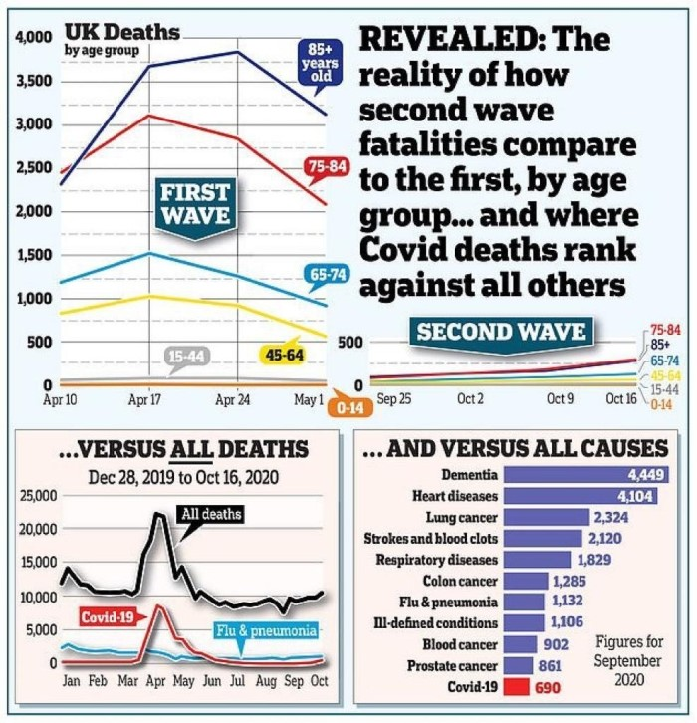
Source: https://www.dailymail.co.uk/news/article-8890811/Coronavirus-claimed-lives-just-17-victims-40-figures-elderly-risk.html
There were lockdowns for covid19 which adversely impacted diagnosis, treatments, surgeries and procedures for these other illnesses, meaning more deaths from these other illnesses, yet these other illnesses affect far more people than covid19. The governments have obviously not done a Cost-Benefit analysis for Lockdowns in Britain and Ireland and other countries.
People are dying all the time, every day, from smoking related illnesses, cancers, heart diseases, respiratory diseases, chronic diseases, chronic infections, neurological and dementia diseases, car accidents, etc. and they are dying in greater numbers than from covid19. Should we lock down the country to prevent deaths from these illnesses and accidents ? The answer is obviously ‘no’ and the answer for covid19 should be ‘no’. The Infection Fatality Rate for covid19 is stated above and is equivalent to a flu season. In fact, deaths in 2020 are less than some previous years, as seen in charts in this paper. This presents yet more evidence of the Disproportionality of Lockdowns and in this case the Disproportionality is leading to increased deaths from non covid illnesses. This point is analysed further later on in the paper in the section titled ‘I. What are the harms of lockdowns on the health of the population?’
The Chart in the next page provides the odds of a person dying of many causes and illnesses including covid19. It puts the Disproportionality of lockdowns in perspective. Ironically, the lockdowns are increasing the risk of dying of these other illnesses and diseases. Sources and References are included in the chart itself below.
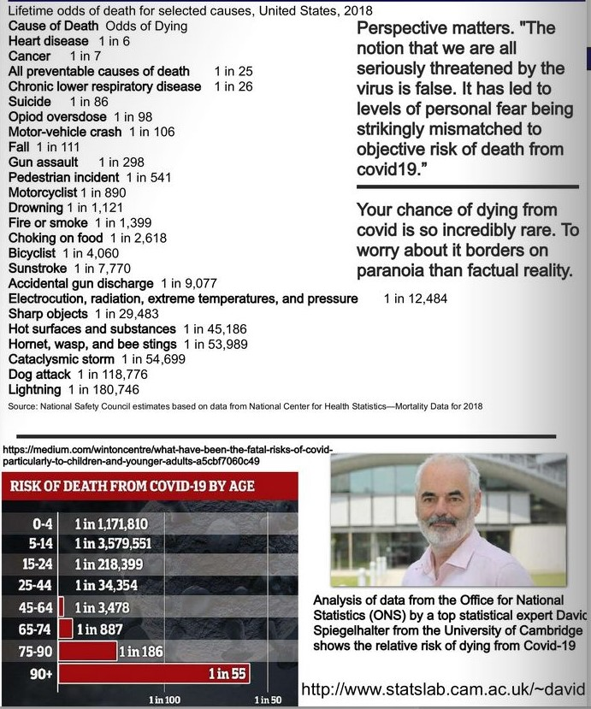

Collateral Damage caused by Lockdowns in many countries
In measuring and assessing Disproportionality its important to look at the collateral damage of lockdowns. Collateral Global whose web site is at https://collateralglobal.org consists of medical doctors, professors, scientists, immunologists, epidemiologists, statisticians, economists, lawyers and academics who are measuring and quantifying the damage done by covid19 related lockdowns in countries around the world. It includes the thousands of cancelled appointments, diagnostics, screenings, treatments, and operations for cancers, heart diseases, endocrine diseases, gastro-intestinal diseases, respiratory diseases, chronic infections, dementia diseases, etc. and the worsening of illnesses and deaths which will result from this. It also catalogues the damage done to young people in countries around the world by lockdowns including the increase in suicides, self harm, mental illnesses and drug and alcohol abuse. Their research shows increases in domestic violence, more family instability, alcohol and drug abuse, divorces, seperations, worsening physical health, mental health and emotional health due to lockdowns. The higher unemployment caused by lockdowns and its damage now and for years into the future is also included and the fact that higher unemployment leads to increased suicides and poorer health for those affected. The damage to economies and economic growth will continue to worsen this in 2021 and future years. Economic losses are also quantified. The vast amount of facts, statistics and evidence from around the world shows that lockdowns are not working and are destroying societies and economies. The web site is at https://collateralglobal.org
To reinforce the points above, Mr. David Nabarro, the European Director of WHO said in 2020, “We in the World Health Organization do not advocate lockdowns as the primary means of control of this virus.” Yet Ireland and several other countries are using lockdowns as the primary means and only means of control, with disastrous consequences.
Zero covid is impossible and unattainable due to the nature of the virus and to the fact that zero colds and flu’s have never been achieved. This point and the scientific facts are explained by Dr. David Livermore in an Expert Scientific Report in March 2021.
Page 18, HART Expert Report - https://www.hartgroup.org/wp-content/uploads/2021/03/240321-Updated-HART-review.pdf
A further test of Disproportionality involves evidence from the British Government about covid19 and its threat to public health. On March 19th, 2020 the British Government officially announced that covid19 was not a High Consequence Infectious Disease (HCID). High Consequence Infectious Disease (HCID) are the most serious type of infectious diseases, comparable to the Spanish Flu of 1918 - 20 and Ebola outbreaks. Normally a government imposes social restrictions and lockdowns for High Consequence Infectious Disease (HCID), and as covid19 is not a HCID then the lockdown in Britain was medically and legally unjustifiable. In Law, the lockdowns in Britain (and other European countries) were disproportionate as covid19 was NOT classified as a HCID by the British Government. This was particularly true for the second and third national lockdowns in Autumn and Winter 2020. View the official British Government web site at https://www.gov.uk/guidance/high-consequence-infectious-diseases-hcid#status-of-covid-19 and screenshots of same at www.data-analytica.org
Sinister Activities and the Promotion of Lockdowns
In February 2021 Gript news reported on a group of pro lockdown scientists known as the ‘Independent Scientific Advocacy Group (ISAG)’, some of whom were government advisors, and press and media advisors, who were engaged in a secret and sinister campaign “to increase insecurity, anxiety, and uncertainty” in the general public so as to frighten and terrify the Irish public and politicians and prolong the lockdown, enforce more lockdowns, and follow an impossible “zero covid” strategy. Link to news item here at https://gript.ie/look-for-ways-to-increase-insecurity-anxiety-and-uncertainty-zero-covid-document/ and https://gript.ie/zeroleaks-how-zero-covids-science-isnt-science-at-all/ and https://gript.ie/category/zeroleaks .
They were also engaged in sinister smear campaign to identify, target, ridicule, mock and ruin any scientists, doctors, politicians, etc. who disagreed with them. This manipulation of public opinion, the press and media and of politicians was very sinister, possibly criminal. The scientists in this group have not publicly declared their conflicts of interest in relation to covid19 and lockdowns and vaccines. Most of these scientists had high paid, secure State-paid jobs and/or Big Pharma jobs. The Lockdowns promoted by people like them have led to massive economic losses for businesses, workers and the government and increased deaths from non covid illnesses. This group will need be investigated by the police and other authorities and may face criminal charges and prosecutions and professional sanctions. People do not have the automatic right to destroy businesses and whole economies and the lives of people with non covid19 illnesses.

How does covid19 compare to previous pandemics in history?
As covid19 and the accompanying national lockdowns have created massive disruption and destruction to the societies and economies of countries worldwide, its important to compare covid19 to prior pandemics and epidemics. Many false reports in the press and media have claimed that the covid19 pandemic was similar to the Spanish Flu of 1918 – 1920. This is complete nonsense. The following chart below provided for Sweden compares covid19 to prior pandemics and epidemics.
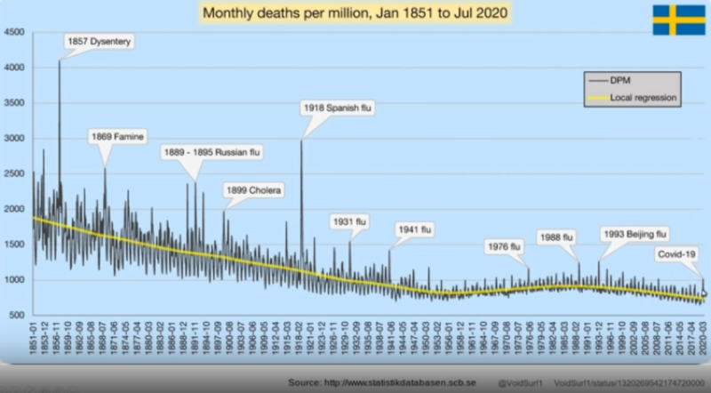
Source: http://www.statistikdatabasen.scb.se
As one can see on the chart below, the covid19 was a very minor pandemic when compared to previous pandemics in the 20th century and 19th century. The panic, paranoia and hysteria about covid19 in the press and media and in government reports was totally unjustified. Yet this panic and hysteria led to public support for national lockdowns in 2020 and 2021.
One sees flu’s involved in many of these pandemics and indeed there is a flu season every Winter for thousands of years. There were no national lockdowns for prior pandemics and epidemics which were far worse than covid19.

The Greater Good argument and Common Good argument and Public Interest term
The Greater Good argument and Common Good argument and Public Interest term is being misused to enforce lockdowns in 2020 and 2021. The great Philosophers who defined the “Common Good” over the centuries such as Aristotle, St. Thomas Aquinas, John Locke, David Hume, Thomas Jefferson, James Madison, and Jean Jacques Rousseau all believed that that no government should become the "perverted servant of special interests," whether these special interests be understood as Aristotle's "interest of the rulers," Locke's "private good," Hume's and Madison's "interested factions," or Jefferson’s “elective despotism” and “corruption and tyranny”, and Rousseau's "particular wills." Today we have a small minority of scientists, doctors, advisors, and politicians with conflicts of interest who stand to make enormous fortunes from lockdowns and vaccinations and from terrorising the people into accepting what they want. While censorship and threats against other scientists and doctors have blocked and prevented an informed public debate about lockdowns. These actions and many more detailed on this page, including loss of lives and serious injuries and massive financial losses to busineses and countries caused by the lockdowns show that lockdowns work against the Common Good and are destroying the Common Good.
The Greater Good argument and Common Good argument and Public Interest term cannot be used to justify lockdowns as the vast majority of the population, over 99%, recover and are safe, there are effective medicines for covid19, hospitals were not overwhelmed (see sections below) and the high rate of False Positives means some Winter illnesses and accidents which cause deaths for hundreds of years were mislabeled as ‘covid19’, and lockdowns are themselves the cause of increased deaths, injuries from non covid19 illnesses and massive financial losses. The evidence presented here and throughout this paper shows that lockdowns are disproportionate in science and in law, and indeed lockdowns have been destructive and went against the Common Good and the Public Interest as detailed in Section K of this paper, and this provides a valid reason for a court to strike down and cancel the lockdown law.
Section R of this paper provides a viable and effective alternative to lockdowns, namely the Great Barrington Declaration, viewable at https://gbdeclaration.org which is supported by many thousands of medical doctors and scientists worldwide.

23a Central Statistics Office, Ireland, January 25th 2021, www.cso.ie
23b Data Analytica, www.data-analytica.org/index.htm#9 , March, 2021
23c Data Analytica, www.data-analytica.org/index.htm#med , March, 2021
23d Data Analytica, www.data-analytica.org/index.htm#hosp March, 2021
D. What were the Total Deaths and Excess Mortality for 2020 and Comparison to Previous Years

In prior pandemics throughout history there were large rises in total deaths in the year or years of the pandemic and a big rise in excess mortality. And the rise in deaths would be far higher than the previous 10 - 20 years when there was no pandemic. This is a useful tool for measuring a pandemic in terms of its threat to public health, the deployment of resources and government funding for healthcare and hospitals, the need for vaccinations, the need for restrictive measures such as masks, social distancing, lockdowns, travel bans, etc. and comparison to prior pandemics.

Deaths in Ireland in 2020 and Comparison to previous years. The Data and Facts
Comparing deaths in 2020 to previous years provides further evidence that the covid19 pandemic ended in mid June 2020.
Deaths in 2020 and Comparison to previous years
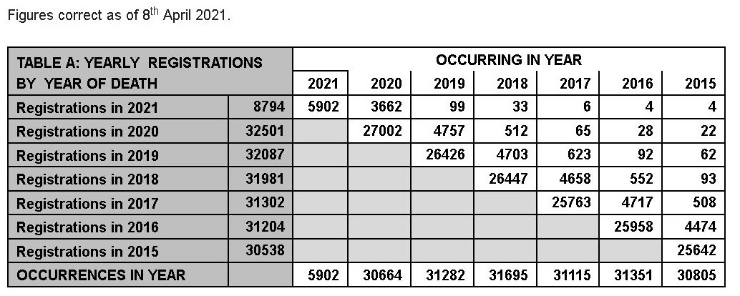
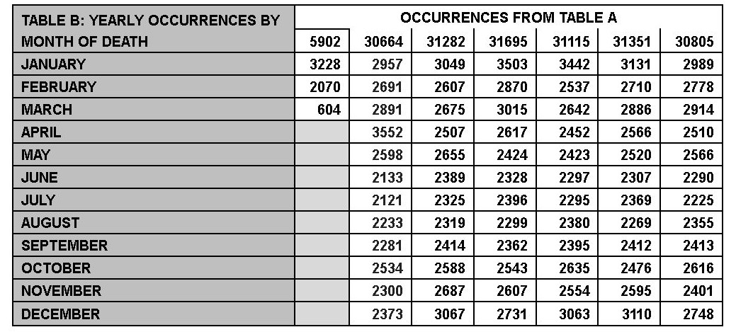
Sources: General Registration Office, April 8th 2021. These are accurate up to April 8th 2021 as it takes 3 months to register deaths.
Note: Figures are subject to change as more deaths are registered and do not represent the actual number of deaths which have actually occurred in any month. They are a close approximation as a death can take up to 3 months to be registered with the GRO. The last 3 – 5 months of 2020 will change as more 2020 deaths are registered in 2021.
Total deaths every year hover around 31,000, and this was the case in 2020. So far in April 2021, the number of deaths registered for 2020 is slightly lower than 31,000. There was no excess mortality for the year of 2020. The covid19 pandemic was over by Summer 2020 when deaths dropped significantly and remained low until the Winter season when colds, flu’s and Winter illnesses return every year. Deaths by month in 2020 are significantly less than deaths in previous years with the exception of April 2020. April was the worst month of the covid pandemic but this could be explained by a shifting of the cold and flu season in 2019 – 2020 from December – February to March - April 2020. This has occurred in previous years and decades.

2018 was the period of the Australian Flu which killed many people in Ireland across all age groups. 16,757 people died between January and June 2018 during the period of the Australian Flu while 16,822 people died during this same period in 2020. The numbers are very similar. There was no lockdown for this in 2018. Similar numbers of people have died during this period over the last 10 years and 30 years. We have got flu’s and cold seasons for many years and decades, indeed hundreds of years and we have had no national lockdowns.

Deaths in Ireland in 2020 per 1000 of population and Comparison the previous years

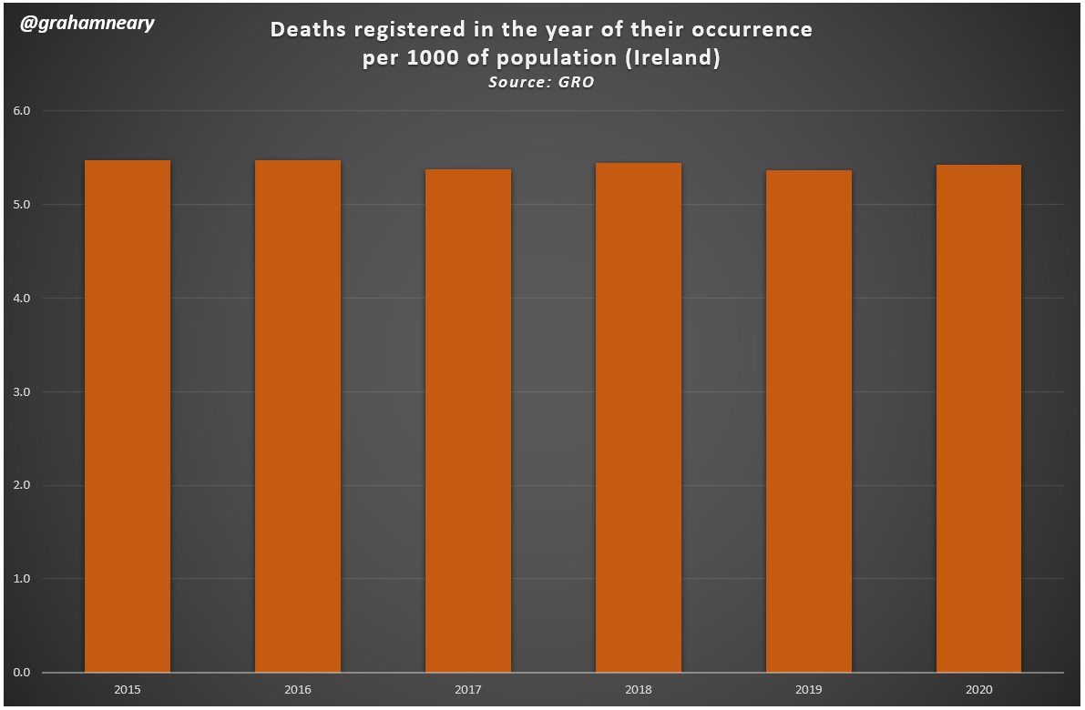
Source: Graham Neary, Statistician, and General Registration Office April 2021

Graham Neary works in the statistics field and has an excellent knowledge of stats and numbers. The excess mortality for 2020 was the same as for previous years, there was a brief spike in deaths in April 2020 and then the curve returned to the same pattern it has had for the last 10 years or more. Mr. Kieran Morrissey engineer and statistician has also compiled detailed statistics and reports of deaths and excess mortality in Ireland from RIP.ie and other official sources and has found that excess mortality in Ireland was the same as for the previous 10 years ^{19a}. Overall, excess mortality for 2020 is the same as for the previous 10 years and the research has confirmed and continues to confirm this.
I include an Expert Report by Kieran Morrisey engineer and statistician titled ‘Study of COVID-19 deaths claimed by NPHET/data.gov.ie between March 2020 and March 2021 using GRO/CSO death data combined with RIP.ie death notices’ at the end of this Section. This report is extremely important and provides strong evidence that there was no excess mortality in 2020.

.

Excess Mortality, Ireland. Comparison of 2020 to previous years.
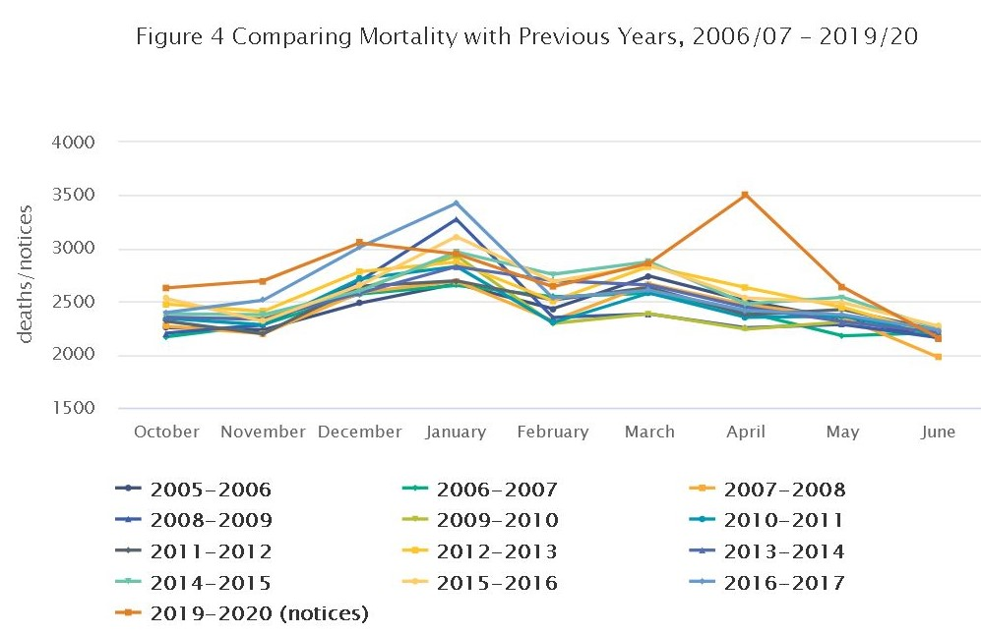
Source: CSO, Ireland, https://www.cso.ie/en/releasesandpublications/fb/b-mpds/measuringmortalityusingpublicdatasources/

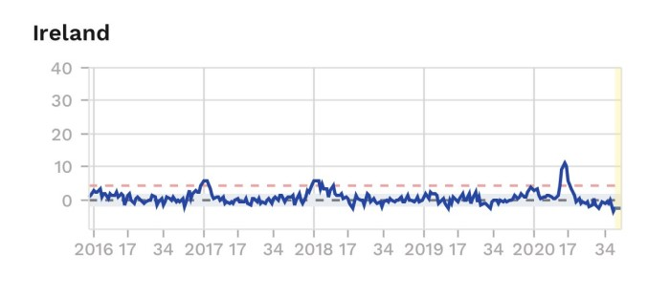
Source: CSO, Ireland
No significant increase in excess mortality in Ireland and other European countries in 2020 and 2021. Sweden had no lockdowns. See chart below. This points to a minor and short-lived pandemic in 2020 which was not as deadly and as serious as portrayed in the press and media and by government ministers and ‘advisors’.
Excess Mortality Internationally
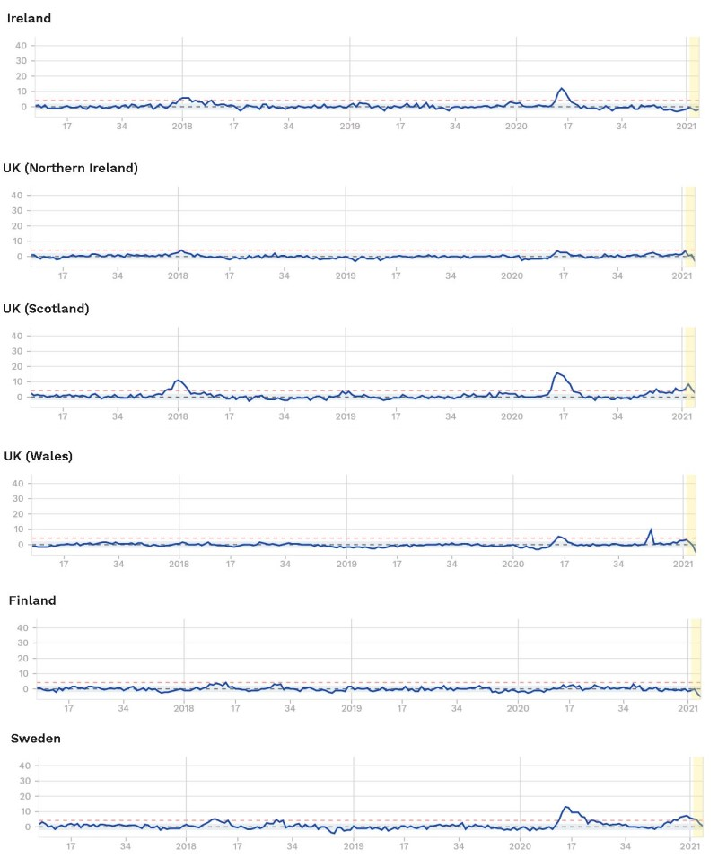
Source: https://www.euromomo.eu
According to Dr. Ivor Cummins, Euromomo has stated that Excess Mortality for Europe in 2020 was increased by 0.08% and Sweden it was 0.03% and Sweden had no lockdowns. (https://www.youtube.com/watch?v=ueYiYv53Ei8 and https://thefatemperor.com/). This is tiny and barely significant. It certainly does not suggest a deadly pandemic similar to Spanish Flu or the Black Death as promoted by the press and media and several governments and their ‘advisors’. For many decades and centuries there have been significant differences between deaths in different countries in Europe and between countries in other continents due to seasonal factors, ageing population, general health and nutrition of population, general hygiene, medical facilities and cutbacks to these facilities, cancers, diabetes, and heart disease rates, differing levels of disability, vitamin D levels, and pre-existing immunity to viruses and other germs. Lockdowns do not factor in these important differences.

In the USA, Government statistics show that the number of deaths for 2020 was 2.85 million people and is similar to deaths per year for the last 6 years. There was no massive spike in deaths in 2020.
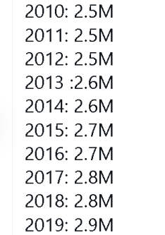
Source: CDC in the USA, https://www.cdc.gov/nchs/nvss/vsrr/covid19/index.htm
International studies confirm low excess mortality from covid19 and no big rise in annual mortality. Genevieve Briand, assistant program director of the Applied Economics master’s degree program at Johns Hopkins University, critically analyzed the effect of COVID-19 on U.S. deaths using data from the Centers for Disease Control and Prevention (CDC) in her webinar titled “COVID-19 Deaths: A Look at U.S. Data.” She found no rise in excess mortality and no large increase in annual deaths compared to the last 10 - 20 years. This is the subject of a scientific article in Johns Hopkins University - ‘A closer look at U.S. deaths due to COVID-19’, Johns Hopkins Newsletter, November 22, 2020 and is viewable at https://web.archive.org/web/20201126163323/https:/www.jhunewsletter.com/article/2020/11/a-closer-look-at-u-s-deaths-due-to-covid-19
Another published scientific paper also found no increase in excess mortality and was quite insightful - ‘All-cause mortality during COVID-19: No plague and a likely signature of mass homicide by government response’ by D. G. Rancourt, June 2020 DOI: 10.13140/RG.2.2.24350.77125. Project: Science reviews relevant to COVID-19 viewable at https://www.researchgate.net/publication/341832637_All-cause_mortality_during_COVID-19_No_plague_and_a_likely_signature_of_mass_homicide_by_government_response

A pandemic on the scale of the Spanish Flu and Black Death would see a massive increase in actual mortality for the year and in excess mortality in Ireland and many other countries. This did not occur in 2020 and 2021. The Chart on page 57 showing prior pandemics and epidemics throughout history proves this point further. In light of these important facts above, the lockdowns after May 2020 were not supported by the scientific facts and evidence and were disproportionate and unnecessary.
E. Were the Irish Hospitals overwhelmed and overcrowded and over capacity with a pandemic from March to December 2020 and for 2021 ?

We will look at deaths during the period June to December 2020. The curve on the chart flattened from June to December 2020. This is very significant and marks the period when the covid19 pandemic ended. This can be seen in terms of hospital admissions during this particular period.

Deaths from covid19 (Includes those with pre-existing illnesses with covid19, False Positives, and those specifically of covid19)
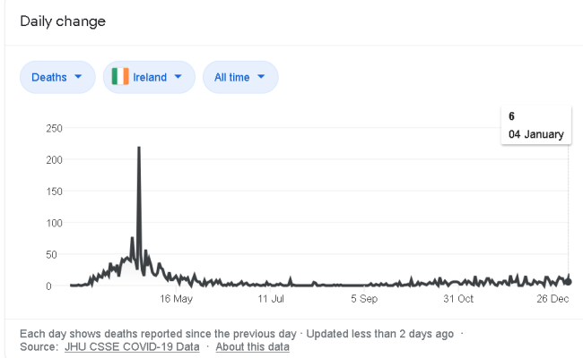
Source: https://github.com/CSSEGISandData/COVID-19

The spike in deaths for April 2020 show the effects of the covid19 pandemic in Ireland. Hospitals were under some pressure from late March to May 2020 but there was adequate capacity to deal with this. There was no need for field hospitals and none were built. The building of new emergency hospital facilities in areas of Dublin, Ireland and in Britain were abandoned by the Irish and British governments in Summer 2020. They knew they were not necessary. This provides a clue or indication that the pandemic was not as prolonged and not as deadly as they anticipated. And the evidence below confirms this.
From June to December 2021, the number of covid19 deaths dropped dramatically and there were no deaths for several days. The curve flattens on the chart above for that period. The number of covid19 cases dropped to less than 500 in hospitals and less than 50 people in ICU during that period according to HSE and government statistics - https://covid-19.geohive.ie/pages/hospitals-icu--testing
There are 12,000 hospital beds in Ireland and ICU capacity is 297 with a surge capacity of 375.
So there was plenty of hospital capacity and the hospitals were not overwhelmed and overcrowded. And the field hospitals built in Ireland 2020 were not used as there was no need for them. And the Nightingale hospitals constructed in Britain were never used and were dismantled in 2021.
These are the facts despite the hysteria in the Irish press and media. Reports from hospital staff around Ireland stated the hospitals were mostly empty during this period. This is the subject of continuing investigations and whistleblower testimonies and protected disclosures. These whistleblowers need to protect their identities as the government and senior civil servants have fired or threatened all of those people who disagreed with them. Yet the government imposed regional lockdowns, a national lockdown of levels 1 – 3, many social restrictions, travel bans, and mandatory mask wearing during this period including during the Summer months. These measures were Disproportionate.
The deaths in 2021 do not show a massive increase in deaths compared to previous years. Hospitals experienced the same level of stress from Winter illnesses, colds, flu’s and complications of old age and deaths from these, and the chronic bed shortages and ICU shortages which they have experienced for over 20 years (due to massive government cutbacks in the health sector).
October 19th 2020 was the date the second national lockdown was announced by the Irish government. As of 7pm on October 19th 2020, according to the National Public Health Emergency Team in Ireland there were:
- 298 COVID-19 patients hospitalised, a tiny percentage of all hospital beds and reserves. There is a total of 12,000 hospital beds. There was 22,000 beds in 2008 before the government cutbacks and austerity to bail out bankers, bondholders and speculators. There should be 20,000 hospital beds for Ireland's population in 2020.
- 32 patients are in ICU, a small percentage of total ICU facilities and reserves. There is a total of 280 ICU beds and this is to be increased by 17. Surge capacity is 375. Government cutbacks since 2009 had reduced the number of ICU's. There should be 700 ICU's in Ireland to cater for a population 4.8 million people.
- No deaths on October 19th 2020
Source: https://covid19ireland-geohive.hub.arcgis.com/ (October 19th, 2020)
Prior to and during the second lockdown in October, there was plenty of hospital capacity and the hospitals were not overwhelmed and overcrowded. These are the facts despite the hysteria in the Irish press and media. Reports from hospital staff around Ireland stated the hospitals were mostly empty during this period. This is the subject of continuing investigations and whistleblower testimonies.
The Chart above showing Deaths clearly shows no big increase in deaths from covid in the period October to December 2020. The reasoning for the lockdown was defective and flawed in light of the facts and evidence. One member of the Irish government admitted to these facts in October 2020, see image below.
Hospitals were mostly empty from Summer to early Winter 2020. Ex Irish Leader, Leo Varadkar, confirmed this on October 25th 2020
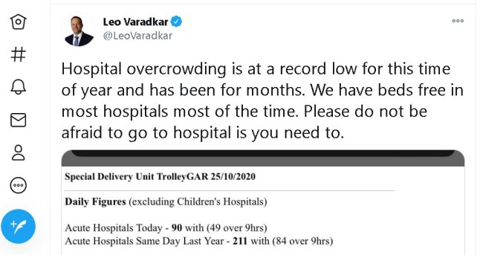
In December 2020 the Irish Winter begins and there is a big increase in Winter illnesses such as colds. Flu’s bacterial and /or viral pneumonia, and respiratory illnesses, in heart diseases, cancers, complication s of old age, suicides, and accidents every year. Hospitals become very busy during this period. This has occurred for hundreds of years in Ireland. The chart below shows an increase in deaths due to Winter illnesses and accidents some of which are covid19. The exact percentage of covid19 cases is difficult to determine due to the high rate of False Positives.
The third national lockdown was enforced on December 26th and this lockdown was further extended in January 2021 and is expected to last until June 2021.

Analysis of January 2021 in Ireland and Comparison to Previous Years. The Impact of Winter Seasonal Illnesses and Deaths every year.
Comparison of January 2021 to January 2020 and January and Winter of 2017 – 18
First week of 2020 was the ‘worst ever’ for hospital overcrowding. More than 3,000 patients went without beds as trolley numbers hit new record. Some 3,143 patients went without beds during the week, as trolley numbers hit a new daily record of 760 on both Monday and Tuesday, according to figures from the Irish Nurses and Midwives Organisation. There was no national lockdown imposed for this.
Hospital respiratory admissions reported from a network of sentinel hospitals during the 2017 – 2018 Winter season, peaked at 535 during week 1 2018, this is the highest peak level in recent years (figure 5). The peak coincided with high levels of influenza. Total emergency admissions reported from the Irish sentinel hospital network peaked during the last week in January (week 4 2018; n=2975).
According to the HPSC : The 2017 / 2018 influenza season was a severe season with a high impact on the Irish health
- Number of notified influenza cases: 11,889
- Number of confirmed influenza cases 76islabeling76: 4,713
- Number of confirmed influenza cases admitted to ICU: 191
- Number of notified influenza cases that died: 255
- Number of acute respiratory infection/influenza outbreaks: 223
There was no national lockdown imposed for this.
Sources: https://www.hpsc.ie/a-z/respiratory/influenza/seasonalinfluenza/surveillance/influenzasurveillancereports/seasonsummaries/Influenza%202017-2018%20Annual%20Summary_Final.pdf?fbclid=IwAR0spcLPoAhDyEL2fJ5yCb4Lf2Q8hWqqN2QJrrNZZ6Hmxvs7UlEpA3b49l8
https://www.irishtimes.com/news/health/first-week-of-2020-worst-ever-for-hospital-overcrowding-1.4135852?fbclid=IwAR0HDym1R81q5HUNxXOWor7b125Pnr_zlm_MjrvvLWPqeri3VaXQ3PqlV-o
January 2021 Facts
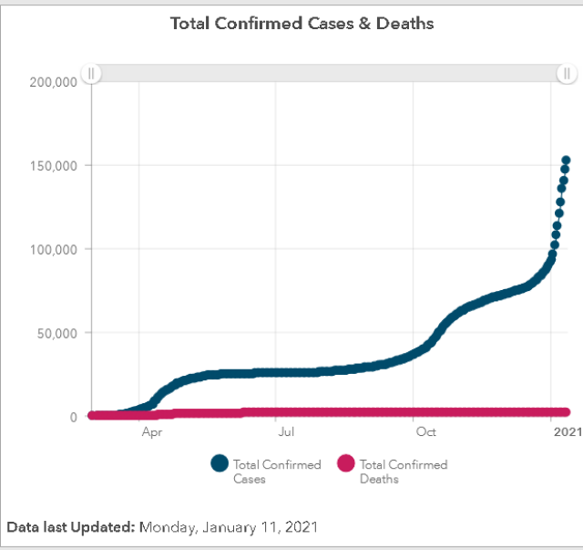
January 11th 2021, one of the ‘worst days’ of the pandemic in Ireland. Deaths remain very low while the number of cases, including False Positives continue to increase and rise to high levels. False Positives from defects in PCR testing have been verified by scientific research and WHO ^{9b} and in Section A of this paper.
Source: https://covid19ireland-geohive.hub.arcgis.com/
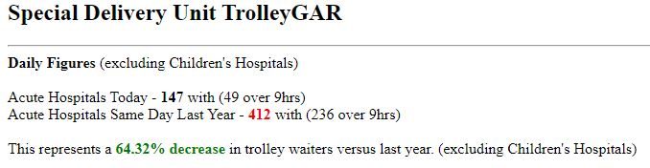Source: HSE
The number of people in trolleys in Acute Hospitals in January 2021 is less than in January 2020. Numbers are significantly lower in 2021, by a factor of 3. This provides more evidence that the covid pandemic is over. Winter seasonal illnesses and deaths have returned in January 2021 although they appear less prominent than previous years.
Source: HSE, January 6th 2021
The following statistics are from January 12th 2021. This includes all persons with Winter illnesses such as flus, colds, respiratory illnesses, bronchitis, asthma, heart diseases, circulatory disorders, neurological diseases, dementia, complications of old age, cancers, suicide attempts, and accidents who have tested positive for covid19. It also includes False Positives for covid19 and persons wrongly labelled as covid19.
Irish Hospital data for January 12th 2021
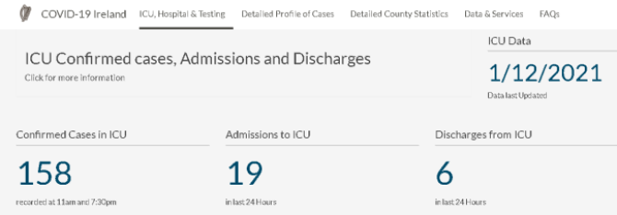
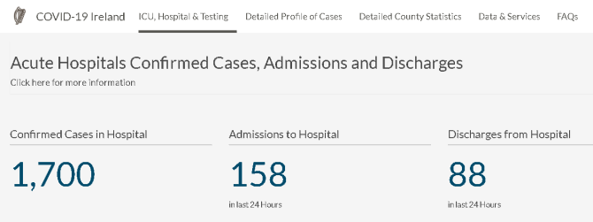
Source: https://covid19ireland-geohive.hub.arcgis.com/pages/hospitals-icu--testing HSE, Ireland.
Irish Hospital data for February 2nd 2021 (end of January and beginning of February)
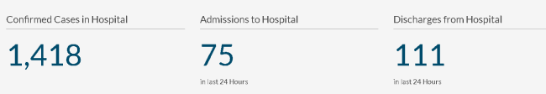
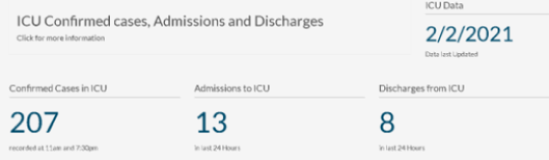
Source: https://covid19ireland-geohive.hub.arcgis.com/pages/hospitals-icu--testing
These numbers are similar to the Winter season for hospitals for previous 20 years. There is spare capacity in Irish hospitals in January 2021. Lets examine the Hospital data and capacity again. There is a total of 12,000 hospital beds. There is a total of 297 ICU beds. Surge capacity is 375. So there was spare capacity in hospitals in January and February 2021.
Government cutbacks since 2009 had reduced the number of ICU’s. There should be 700 ICU’s in Ireland to cater for a population 4.8 million people. The government has taken over private hospitals (through legal contracts) in Ireland and this has created additional beds and ICU’s since April 2020. This has temporarily increased total hospital capacity for 2020 and 2021
These are the facts despite the hysteria in the Irish press and media. Reports from hospital staff around Ireland in January 2021 stated the hospitals were just as busy as previous years for January and the Winter season of 2021. This is the subject of continuing investigations and whistleblower testimonies. Hospitals are always busy during the Winter season and this has been the case for decades and centuries. Two Galway politicians were contacted in January 2021 by Whistleblowers inside the HSE and Hospitals and they were told that the hospitals were NOT being overwhelmed in Winter 2020 and that the numbers in hospitals were similar to Winters in previous years. And they also informed them that corpses in morgues were being tested for covid19 in order to increase the number of covid cases – there is a news video mentioning this at https://www.youtube.com/watch?v=vD7iSOZMmVk. More Whistleblowers are coming forward.
The data, facts and evidence show that January 2020 and the Winter period of 2017 – 2018 were similar to Winter 2020 – 2021 in terms of hospital admissions, ICU’s, hospital overcrowding, people stranded on trolleys, and deaths. And the numbers are quite similar for the last 20 years for the Winter season. Total deaths so far for January 2021 are similar to total deaths in January for the last 20 years.
The hospitals were under severe pressure in 2020, 2021, 2018, 2017, 2016, 2015, 2014, 2010, 2000, etc. in the same way they were under severe pressure for the previous 20 years in the Winter season. Statistics show that there was some spare capacity in the Winter seasons. Though spare capacity in hospitals is determined by government health policy failures and lack of investment in hospitals over the previous 10 years. The numbers admitted to hospitals were similar to the previous 20 years. Hospitals generally get very busy in January every year due to Winter illnesses and deaths. December to the end of March is their busiest time every year, and this occasionally is spread out to April if the colds and flu season is late. As Irish testing centres and Irish hospitals were 80mislabeling most people admitted to hospital as ‘covid19’ through using PCR test cycles of 35 – 45, which give 97% False Positives, then persons with cancers, heart diseases, copd, respiratory illnesses, neurological illnesses, diabetes, chronic illnesses, accidents were all being called ‘covid19’ cases. Whole hospital wards may be housing False Positive cases who have many different diseases and illnesses, called ‘covid wards’. Many diseases and illnesses all lumped together as ‘covid19’.
Every person who goes into the hospital for any illness or accident is tested for covid19. The False Positive rate for PCR tests is 97% so most of them are being diagnosed with covid19. There is also the problem of a hospital patient who gets tested 5 or 6 times for covid19 and is positive in all tests and this is counted as 6 new cases or 6 new covid19 patients in the official statistics. This over inflates the daily and total number of cases, including the number of False Positives. This over counting in addition to False Positives can create massive increases in numbers.
Dr. Tony Holohan, the chief medical officer, made the unusual claim that symptoms of colds and flus and respiratory illnesses were all covid19 in January 2021. This is a ridiculous statement and is not supported by the scientific facts and the statistics over the last 20 years. It is important to emphasise that not all illnesses should be 80islabe ‘covid19’ and that False Positives for covid19 are playing a role in misdiagnosis and is labeling. The high number of False Positives also means that a high percentage of hospital staff tested false positive and had to take time off work, and “quarantine”. This reduced hospital staff at a time when hospitals are very busy during the Winter months and created additional stress
The deaths in January 2021 are similar to previous years due to Winter illnesses which come very year. The usual rise in deaths in Winter is depicted in the following chart for 2020-21 for Ireland.
Winter Season iIlnesses, Hospitalisations and Deaths over the Years
ICU’s and Hospitals are used more often in the Winter months due to colds, flus, respiratory illnesses, pneumonia, damp and mold in buildings, circulatory disorders, heart diseases, cancer complications, depression and mental illnesses, other illnesses, complications of old age, and accidents. Comparison to previous 20 years and to previous pandemics and epidemics is necessary in all cases and analysis.
Statistics and data over the last 20 years shows the following for Winter Illnesses:
Hospitalisations: 1,000 – 8,000
ICU on a given day: 80 – 240
Waiting in Trolleys per day: 100 – 760 (January 2020 was the worst.)
and per week: 800 – 3,100 (January 2020 was the worst.)
Hospital Beds Capacity: Ireland is among the bottom 3 EU countries in terms of bed capacity, 3 per 1000 of the population as opposed to EU average of 5 per 1000. The Irish government refused to increase the number of hospital beds and ICU’s over the previous 10 years and actually made cutbacks to existing numbers. Irish politicians have ruined the Irish hospitals and healthcare system for the 10 years prior to 2020, through government cutbacks and lack of investment. Court Orders of Performance may be necessary to force the government to resolve this issue.
Police investigations, military investigations, coroner investigations, private investigations and use of whistleblowers and protected disclosures will be required to determine the exact status of hospitals throughout 2020 and 2021, and to determine the scale of False Positives for covid19 in Ireland, the mislabeling of many illnesses as covid19, and the mislabeling of many deaths as covid19 and the conflicts of interest of government advisors. Comparisons with Winter flu seasons and epidemics for the previous 30 years will need to be determined from these whistleblower reports, protected disclosures and investigations listed above.
In summary, the available evidence and facts show that the hospitals and ICU’s were not overwhelmed, overcrowded and over capacity in 2020 and 2021. There was some spare capacity. From June to December 2020 the Irish hospitals were mostly empty. And there was plenty of time for the Irish government and HSE to increase hospital beds and ICU’s to cope for increased Winter illnesses but they didn’t do this. The hospitals were not overwhelmed. In late December 2020 and into January and February 2021 the hospitals came under stress from the Winter illnesses which they have every year for the last 20 years.
There were no lockdowns in the previous 20 years when Irish hospitals were under severe pressure due to colds, flu’s, bacterial and viral pneumonia and many other Winter illnesses. There was no need for lockdowns in 2020 and 2021. Lockdowns were not required, not needed, but government investment in hospitals and healthcare was needed.

F. Were there effective medicines for covid19 in 2020 and 2021 ?

One of the most important questions in any pandemic throughout history is ‘are there any effective medicines to treat the infection causing the pandemic ?’ The evidence and facts show that there were effective medicines for treating covid19 in 2020 and 2021 and there are documented cases of many thousands of recoveries from using them ^{24a} . In fact, most of these medicines had a success rate of 90% or more ^{24a} This has been confirmed in scientific studies worldwide and by medical doctors working in hospitals and clinics worldwide. These effective medicines for covid19 include:
- Hydroxychloroquine. And Hydroxychloroquine, AZT and Zinc combinations
- Ivermectin
- Budesonide
- Hyberbaric oxygen treatment
- Dexamethasone
- Plasma Antibody Treatment, Regeneron
- MATH+” protocol
- Avoidance of aggressive ARDS treatment / aggressive ventilator treatment
- Avoidance of ACE inhibitors and Statins.
- Use of Vitamin D, Vitamin C and Zinc to protect the immune system and is associated with reduced risk of severe covid19 and death.
- Stress Reduction can improve Immune System functions against covid19 and other viruses. This includes quality time with one’s loved ones and daily exercise, sleep, and healthy diets.
Combining certain medicines safely can also improve the recovery rate. Most of the Experts, the top medical doctors and scientists listed in the last section of this paper agree with these facts and evidence.

These medicines and vitamins are highly effective and are one of the most important reasons for ending the lockdowns, particularly in Summer and Autumn 2020 when this knowledge became known globally and covid19 numbers were very low. Scientific findings and medical findings about these medicines are provided on many reputable scientific and medical web sites and on www.data-analytica.org#med

A Dr. Vladimir Zelenko in New York successfully used Hydroxychloroquine to treat 699 covid19 patients and there was a100% success rate in Spring 2020. News article here at https://techstartups.com/2020/03/28/dr-vladimir-zelenko-now-treated-699-coronavirus-patients-100-success-using-hydroxychloroquine-sulfate-zinc-z-pak-update/
Professor Didier Raoult in France successfully treated 20 covid patients Hydroxychloroquine and published a paper on this which is available here at https://www.mediterranee-infection.com/wp-content/uploads/2020/03/Hydroxychloroquine_final_DOI_IJAA.pdf
Dr. Stella Immanuel a medical doctor in the USA had success with Hydroxychloroquine in 350 covid19 patients, a 100% success rate ^{24d}. Harvey Risch, MD, PhD who heads the Yale University School of Epidemiology recommends Hydroxychloroquine. He authored “The Key to Defeating Covid-19 Already Exists. We Need to Start Using It” which was published in Newsweek Magazine July 23rd, 2020.
In Ireland, Dr. Patrick Morrissey, a highly experienced medical doctor, can vouch for the beneficial effects of Hydroxychloroquine. He treated over three dozen covid patients with Hydroxychloroquine /Zn/VitD/VitC+ to very good effect and had 100% success rates. This is first hand experience of the benefit of a therapeutic suppressed by the Irish health service.
Dr. Anthony Fauci of the NIH in the USA, one of the top government advisors stated chloroquine (which is contained in Hydroxychloroquine) was effective and safe for treating SARS in 2005. See picture below.

Covid19 also called ‘SARS-CoV2’ is a variant of the SARS virus The fact that there were effective medicines for treating covid19 meant that lockdowns were unnecessary and disproportionate in 2020 and 2021. There were other factors at play here which need to be examined.
Sinister attempts to deny people effective medicines for covid19
Hydroxychloroquine is listed in these effective medicines above. It should be pointed out that sinister attempts were made to falsely state that Hydroxychloroquine was not useful, not effective and may be dangerous in the treatment of SARS-CoV2 also called ‘covid19’ in 2020. This false paper and false rumour was exposed in 2020 and a paper retracted from the Lancet journal ^{24b} . Also, deliberate attempts were made to discredit Hydroxychloroquine through the administration of excessive and lethal doses of it to patients in trials. This was done corruptly and fraudulently to discredit Hydroxychloroquine and stop it’s use in treating covid19 ; this corruption was also exposed ^{24c} Even Dr. Anthony Fauci contradicted himself and his own findings n 2005 by incorrectly stating that there was no evidence for the effectiveness of Hydroxychloroquine or Chloroquine in 2020 (see picture above). One must factor in the fact that Fauci was a strong supporter of lockdowns and he had financial interests in vaccine companies and Big Pharma. Conflicts of interest have played a key role internationally in this covid saga.

Conflicts of Interest
Many attempts were made to diminish, mock, undermine and block the use of these effective medicines mentioned above and also Vitamin D and Zinc, despite scientific and medical evidence of their efficacy, effectiveness and safety for covid19 in 2020 and for viral illnesses in many previous years and decades. Some of those who most strongly supported the lockdowns also tried to block the administration of these medicines in countries around the world. There are some countries where these effective medicines are banned by the government and health authorities, and doctors and nurses have been fired from their jobs and made the subject of criminal investigations for using these effective medicines. This is an outrageous abuse of power. This suggests an anti scientific and anti medical approach to covid19, and a bias in favour of lockdowns and other anti democratic measures. All types of “experts” and “advisors” to governments have many reasons for recommending lockdowns and creating desperation for their new ‘cures’, while not declaring their own conflicts of interest, grants commissions and other financial inducements, investments in PPE, vaccine and new drug promotion motives, and political / ideological motives. Denying people effective and essential medicine for an illness is a criminal offence in most countries and will be the subject of criminal investigations.

24a www.data-analytica.org/index.htm#med
24b The Lancet, June 2020, https://www.thelancet.com/journals/lancet/article/PIIS0140-6736(20)31324-6/fulltext
https://www.google.com/search?&q=Hydroxychloroquine+false+paper
24c COVID-19 & Public Health Totalitarianism: Untoward Effects on Individuals, Institutions and Society By Peter R. Breggin, MD. https://www.stopworldcontrol.com/downloads/en/legal/science/legal-report.pdf and https://www.ageofautism.com/2020/06/who-solidarity-and-uk-recovery-clinical-trials-of-hydroxychloroquine-using-potentially-fatal-doses.html and https://www.stopworldcontrol.com/full/
24d https://www.godreports.com/2020/07/african-american-doctor-treated-350-covid-patients-hasnt-lost-one/
G. Was there pre-existing immunity to coronaviruses developed over many years and centuries which conferred protection for most people against covid19

Scientific research is showing that there is an average recovery rate of 99.77% for covid19. For people under 70 the recovery rate is 99.95%. This death rate is the same as a flu season. Scientists now believe this high level of protection against covid19 is due to due to pre-existing immunity to coronaviruses developed over hundreds of years fighting the colds and flu’s caused by coronaviruses and that human immune systems have a memory of the structure and the individual parts of coronaviruses, and covid19 is a coronavirus. And this memory is used by the immune system to recognize and kill coronaviruses, including covid19. A pre-existing immunity to coronviruses may confer a certain level of immunity to covid19 for a majority of people.
Scientific studies listed below provide evidence of this. Antibodies and T cell memory against coronaviruses developed over hundreds of years, and other arms of the immune system such as T cells, lymphocytes, NK cells and macrophages, IgA, IgG, have been recognising and killing coronaviruses for milennia. Those people who recovered already have antibodies to and T cell memory of the virus and do not need vaccines. Recovered patients have T cell memory against coronaviruses and interact with other arms of the immune system such as T cells, lymphocytes, NK cells and macrophages which have been recognising and killing coronaviruses for a long time.
Here are important scientific papers and findings concerning pre-existing immunity against covid19 and other coronaviruses which humans have had for centuries.
- https://science.sciencemag.org/content/early/2020/10/27/science.abd7728.full
- https://www.nih.gov/news-events/nih-research-matters/potent-antibodies-found-people-recovered-covid-19 NIH, 2020
- Covid-19: Do many people have pre-existing immunity? Doshi, British Medical Journal, 2020
- Different pattern of pre-existing SARS-COV-2 specific T cell immunity in SARS-recovered and uninfected individuals, Bert et al. 2020 https://www.biorxiv.org/content/10.1101/2020.05.26.115832v1.full.pdf
- Immunological memory to SARS-CoV-2 assessed for up to eight months after infection, Mateus et al. 2020
- SARS-CoV-2-specific T cell immunity in cases of COVID-19 and SARS, and uninfected controls Bert et al. 2020

An important study in Japan revealed a high level of pre-existing immunity to covid19.
Scientific Paper: Dynamic Change of COVID-19 Seroprevalence among Asymptomatic Population in Tokyo during the Second Wave by Sawako Hibino, Kazutaka Hayashida, Andrew C Ahn, Yasutaka Hayashida.
doi: https://doi.org/10.1101/2020.09.21.20198796. https://www.medrxiv.org/content/10.1101/2020.09.21.20198796v1
and
Tokyo citizens may have developed COVID-19 herd immunity, say researchers
News Medical, September 24, 2020. https://www.news-medical.net/news/20200924/Tokyo-citizens-may-have-developed-COVID-19-herd-immunity-say-researchers.aspx
- Targets of T Cell Responses to SARS-CoV-2 Coronavirus in Humans with COVID-19 Disease and Unexposed Individuals, Grifoni et al. 2020, https://www.cell.com/cell/fulltext/S0092-8674(20)30610-3#.XtUNRAVlzFA.twitter
- Early induction of functional SARS-CoV-2-specific T cells associates with rapid viral clearance and mild disease in COVID-19 patients, Tan et al. 2021 https://www.sciencedirect.com/science/article/pii/S2211124721000413
- Covid-19 Immune Signatures Reveal Stable Antiviral T-Cell Function Despite Declining Humoral Responses, Dragon et al. 2020 https://www.researchgate.net/publication/343882507_Covid19_Immune_Signatures_Reveal_Stable_Antiviral_T Cell_Function_Despite_Declining_Humoral_Responses
- Antibody Status and Incidence of SARS-CoV-2 Infection in Health Care Workers Lumley et. al. 2020
- T cells found in COVID-19 patients ‘bode well’ for long-term immunity. Science Mag, May 2020, https://www.sciencemag.org/news/2020/05/t-cells-found-covid-19-patients-bode-well-long-term-immunity
- Covid infection shown to provide as much immunity as vaccines The Financial Times, January 2021
- ‘Can a cold give you coronavirus immunity? Some forms of common respiratory illness might help build protection from Covid-19... and it could last up to 17 YEARS, scientists say’
The Daily Mail, June 12, 2020 https://www.dailymail.co.uk/news/article-8412807/Can-cold-coronavirus-immunity.html
- Some Forms of Common Cold May Give COVID-19 Immunity Lasting up to 17 Years, New Research Suggests, The Science Times, June 2020, https://www.sciencetimes.com/articles/26038/20200612/common-cold-give-covid-19-immunity-lasting-up-17-years.htm
- STUDIES: 60% of people naturally RESISTANT to SARS-COV2, Off Guardian, June 2020. https://off-guardian.org/2020/06/12/study-80-of-people-naturally-resistant-to-coronavirus/
- Articles by Dr. Michael Yeadon, Former Pfizer Chief Science Officer and published scientist
'Lies, Damned Lies and Health Statistics – the Deadly Danger of False Positives' explains the defects in PCR tests for covid19. There are false positives for covid19 in over 80% of cases.
"Pandemic is Over" - Former Pfizer Chief Science Officer Says "Second Wave" Faked On False-Positive COVID Tests.
The PCR False Positive Pseudo-Epidemic by Dr. Michael Yeadon
What SAGE Has Got Wrong by Dr. Michael Yeadon
According to many authors, this suggests there's "cross-reactive T cell recognition between circulating 'common cold' coronaviruses and covid19." In other words, if you've recovered from a common cold caused by a particular coronavirus, your immune system may activate when you encounter covid19, thus rendering you resistant to COVID-19. A high percentage of the population had this pre-existing immunity to covid19 and other coronaviruses. These points were reinforced in March 2021 by Dr. Geert Vanden Bossche, a leading scientist involved in drug development and vaccine development for decades, who stated that most of humanity already had pre-existing immunity to coronaviruses and that T cells played a major role in killing covid19 in 2020 and 2021 ^{24e} . He advocated for a greater use of T cells and NK cells in future vaccine research development. Immunity to coronaviruses may depend on the strength of the immune systems of a whole population, and this may depend on Vitamin D and C and Zinc levels, nutrition and antioxidant status and inflammatory markers, fat and refined sugar intake, T-cell cross immunity and accumulated herd immunity over time, percentage of population over 70, stress levels and cortisol and inflammatory markers, physical exercise per capita, diabetes, body mass of populations which vary between nations. Some nations are extremely unhealthy and have appalling immune systems, and they are more vulnerable to epidemics and pandemics.

Most of humanity already had pre-existing immunity to covid19 and other coronaviruses prior to 2020, involving a few arms of the immune system. The enforcement of lockdowns on peoples and nations when the majority of the people had pre-existing immunity to covid19 as evidenced by scientific research and the very low death rate was and still is unjustified and disproportionate.

24e https://dryburgh.com/geert-vanden-bossche-open-letter-to-who-halt-all-covid-19-mass-vaccination/
Interview of Dr. Geert Vanden Bossche https://www.bitchute.com/video/hHuA7GRzH93P/
H. How common is the spread of the SARS-CoV-2 virus by individuals who are infected, but display no symptoms? how common is asymptomatic transmission ?

Much of the infrastructure of COVID-19 lockdown policies is premised on the idea that the SARS-CoV-2 virus can spread from infected people who display no symptoms that are typical of COVID-19 infection (that is, asymptomatic individuals) to uninfected individuals. If asymptomatic or pre-symptomatic disease spread is uncommon, lockdown policies could be replaced with much less onerous policies, such as symptom checking in public venues and public health advice for people with symptoms to stay home and avoid public places, with little effect on infection transmission rates.

According to a comprehensive survey of the literature on reported cases through early June 2020, about 20% of COVID-19 cases are asymptomatic.²⁴ Seroprevalence studies tend to report a larger fraction of infections (often not identified as cases) as asymptomatic.²⁵ In any case, asymptomatic viral carriers clearly make up a large fraction of COVID-19 cases and infections, so a good understanding of how likely they are to transmit the disease to others should play an important role in the determination of COVID-19 infection control policies.

The scientific evidence now strongly suggests that COVID-19 infected individuals who are asymptomatic are more than an order of magnitude less likely to spread the disease to even close contacts than symptomatic COVID-19 patients. A meta-analysis of 54 studies from around the world found that within households – where none of the safeguards that restaurants are required to apply are typically applied – symptomatic patients passed on the disease to household members in 18% of instances, while asymptomatic patients passed on the disease to household members in 0.7% of instances.²⁶
A separate, smaller meta-analysis similarly found that asymptomatic patients are much less likely to infect others than symptomatic patients.²⁷
- Buitrago-Garcia D, Egli-Gany D, Counotte MJ, Hossmann S, Imeri H, Ipekci AM, Salanti G, Low N. Occurrence and transmission potential of asymptomatic and presymptomatic SARS-CoV-2 infections: A living systematic review and meta-analysis. PloS Med. 2020 Sep 22;17(9):e1003346. Doi: 10.1371/journal.pmed.1003346. PMID: 32960881; PMCID: PMC7508369.
- Bendavid, E., Mulaney, B., Sood, N., Shah, S., Ling, E., Bromley-Dulfano, R., Lai, C., Weissberg, Z., Saavedra, R., Tedrow, J., Tversky, D., Bogan, A., Kupiec, T., Eichner, D., Gupta, R., Ioannidis, J., & Bhattacharya, J. (2020). COVID-19 Antibody Seroprevalence in Santa Clara County, California. medRxiv, 2020.04.14.20062463. https://doi.org/10.1101/2020.04.14.20062463

A large study of 10 million residents of Wuhan, China, all tested for the presence of the virus, found a total of 300 cases, all asymptomatic. A comprehensive contact tracing effort identified 1,174 close contacts of these patients, none of whom tested positive for the virus.²⁸ This is consistent with a vanishingly low level of asymptomatic spread of the disease. While theoretical modeling work from earlier in the epidemic (including some of my own published research²⁹) predicts some level of asymptomatic disease spread, the empirical evidence at this point later in the epidemic strongly shows very little evidence that this is an important empirical reality.
By contrast with asymptomatic patients, symptomatic patients are very likely to infect others with the virus during extended interactions, especially in the initial period after they develop symptoms. A careful review of 79 studies on the infectivity of COVID-19 patients found the symptomatic patients are infectious for only the first eight days after symptom onset, with no evidence of live virus detected beyond day 9 of illness.³⁰

Other important studies have also found that asymptomatic transmission is not a major factor and may have very little or no impact. The following studies confirm this:
Hao-Yuan Cheng, MD, MSc et al., Contact Tracing Assessment of COVID-19 Transmission Dynamics in Taiwan and Risk at Different Exposure Periods Before and After Symptom Onset, JAMA Intern Med Vol. 180(9), May 1, 2020, https://www.ncbi.nlm.nih.gov/pmc/articles/PMC7195694/;
Shin Young Park et al., Coronavirus Disease Outbreak in Call Center, South Korea, Emerg Infect Dis Vol. 26(8), Apr. 23, 2020, https://wwwnc.cdc.gov/eid/article/26/8/20-1274_article.
Mercedes Yanes-Lane et al., Proportion of asymptomatic infection among COVID-19 positive persons and their transmission potential: A systematic review and meta-analysis, PLoS One, Nov. 3, 2020, https://doi.org/10.1371/journal.pone.0241536.

- (Madewell ZJ, Yang Y, Longini IM, Halloran ME, Dean NE. Household Transmission of SARS-CoV-2: A Systematic Review and Meta-analysis. JAMA Netw Open. 2020;3(12):e2031756. doi:10.1001/jamanetworkopen.2020.31756)
- Buitrago-Garcia D, Egli-Gany D, Counotte MJ, Hossmann S, Imeri H, Ipekci AM, Salanti G, Low N. Occurrence and transmission potential of asymptomatic and presymptomatic SARS-CoV-2 infections: A living systematic review and meta-analysis. PLoS Med. 2020 Sep 22;17(9):e1003346. doi: 10.1371/journal.pmed.1003346. PMID: 32960881; PMCID: PMC7508369.
The WHO has admitted that asymptomatic transmission of covid19 was very rare: https://edition.cnn.com/2020/06/08/health/coronavirus-asymptomatic-spread-who-bn/index.html
Professor Hendrik Streeck of the University of Bonn is the leading virologist of Germany. He led a study in the most affected area in Heinsberg, Germany. He found no evidence for asymptomatic transmission. https://www.businessinsider.in/science/news/germanys-had-more-than-113000-coronavirus-cases-but-fewer-than-3000-deaths-scientists-are-hoping-to-unlock-why-/articleshow/75074478.cms
And other scientific studies show that there is no viral spread in the open air - https://www.medrxiv.org/content/10.1101/2020.04.04.20053058v1

For centuries Science has held that symptomatic persons spread disease and were infectious for so many days, yet in 2020 this was changed to suggest that asymptomatic persons are major spreaders of disease. This asymptomatic spreader theory has been complicated by defective PCR tests and a high rate of False Positives where healthy people with no symptoms are wrongly presumed to be ill and infected. These False Positives form a significant percentage of the so called "asymptomatic spreaders".

In summary, asymptomatic individuals are an order of magnitude less likely to infect others than symptomatic individuals, even in intimate settings such as people living in the same household where people are much less likely to follow social distancing and masking practices that they follow outside the household. Spread of the disease in less intimate settings by asymptomatic individuals – including religious services, in-person restaurant visits, gyms, and other public settings – are likely to be even less likely than in the household. The clear implication of this scientific fact is that many intrusive lockdown policies (including church and business capacity limitations and closures) could be replaced with less intrusive symptom checking requirements, with little or no detriment to infection control outcomes.

- (Cao, S., Gan, Y., Wang, C. et al. Post-lockdown SARS-CoV-2 nucleic acid screening in nearly ten million residents of Wuhan, China. Nat Commun 11, 5917 (2020). https://doi.org/10.1038/s41467-020-19802-w)
- Peirlinck M, Linka K, Costabal FS, Bhattacharya J, Bendavid E, Ioannidis J, Kuhl E (2020), “Visualizing the Invisible: The Effect of Asymptotic Transmission on the Outbreak Dynamics of COVID-19” Computer Methods in Applied Mechanics and Engineering. 372: 1 Dec. 2020, 113410. https://doi.org/10.1016/j.cma.2020.113410.
- Cevik M, Tate M, Lloyd O et al. SARS-CoV-2, SARS-CoV, and MERS-CoV viral load dynamics, duration of viral shedding, and infectiousness: a systematic review and meta-analysis. The Lancet Microbe. Nov. 19, 2020. DOI:https://doi.org/10.1016/S2666-5247(20)30172-5
I. What are the principles govern good health policy and public health practice?

The WHO had a plan for dealing with global pandemics in 2019 and this was rejected and not used in 2020 by WHO and health authorities in many countries. The WHO plan named ‘Non-pharmaceutical public health measures for mitigating the risk and impact of epidemic and pandemic influenza’ is available for viewing at https://thefatemperor.com/wp-content/uploads/2020/11/WHO-Pandemic-Guidelines-2019.pdf . The complete rejection of this WHO plan in 2020 and 2021 needs to be investigated as it led to unnecessary lockdowns and massive economic losses and health losses for many countries.
The principles of good public health³¹ and health policy practice predate the epidemic. While the topic is voluminous, there are a few principles that are particularly relevant to COVID-19 policy making, including the following guidelines for decision makers:

- Consider both the costs and benefits of alternative policies, choosing policies that appropriately balance the two.

- Appropriately account for uncertainty in the projected costs and benefits of policy options.

- Account for the strength of the scientific evidence.

- Be constrained in policy making by democratic norms and ethical principles.

- Choose policies that treat people in society equitably, and in particular eschew policies that disproportionately favor richer members of society over poorer members.

Sound health policy decision making requires a careful evaluation of both the costs and benefits over both the long and short term. The nature of these costs and benefits considered should be broadly considered, including physical costs (such as enhanced risk of mortality and morbidity from all sources), psychological harms (such as increased rates of depression and suicidality), as well as the economic damage (such as increased joblessness, closed businesses, and reduced income).

The costs and benefits of every potential policy involves some degree of uncertainty, including lockdowns. In the face of uncertainty, public health decision making should be based on the best available evidence regarding the most likely outcomes from the imposition of the policy. Public health decision making should eschew decision making based on worst-case or best-case assumptions about the outcomes that may happen if alternate policies are adopted. It is particularly bad practice to make decisions that assume worst case scenarios regarding the costs of a policy and best-case scenarios regarding the benefits of a policy, or vice versa. So, for instance, it is poor public health practice to assume that lockdowns, if implemented will have a dramatic effect on disease transmission and mortality with no consideration of the harms associated with lockdowns.³²

In addition to the costs and benefits, public health policy must consider the strength of the scientific evidence regarding the measure in achieving the aims it proposes. Of course, without solid scientific evidence in favor of a policy – especially one with enormous costs – its imposition by a government on a population would be unethical. The greater the potential harms from the policy on some part of the population, the greater the evidentiary standard required to establish its necessity.

Finally, equity is a key principle of public health. Public health officials must consider whether the harms of a policy like lockdowns fall disproportionately on the poor, on minority populations, or on others who are of low socio-economic status. Similarly, policies that accrue benefits disproportionately to the rich, to majority populations, and to people of high socio-economic status should be redesigned to comport with the requirement for equity in public health decision making.

In summary, sound public health practice adheres to key principles aimed at grounding policy in good science, respecting human rights and democratic norms, appropriately accounting for costs and benefits of policies and uncertainty in outcomes, treating people equitably, as well as other principles not discussed here.

- Public Health Leadership Society (2002) Principles of the Ethical Practice of Public Health. American Public Health Association. https://www.apha.org/-/media/files/pdf/membergroups/ethics/ethics_brochure.ashx
- In Manitoba, Chief Public Health Officer Dr. Brent Roussin adopted the position in November 2020 that lockdowns would stop the spread of Covid-19 and save lives: “We need to turn these numbers around and we need to turn them around now. . . . [T]hese new restrictions will help halt the spread of this virus, to protect Manitobans, and to ensure that our healthcare system can continue to function…“These next few weeks will be difficult for many. And we know that. But this sacrifice over this time (sic) will save lives.” Dr. Brent Roussin, 2020-11-10 Press Conference, Video at 23:10 and 31:16 https://news.gov.mb.ca/news/index.html?item=49737.

J. Are the lockdowns necessary to protect the health and well-being of the general population? Were Lockdowns a failure and where is the scientific evidence?

Since the available epidemiological literature often tends to group many of the items in the list above under the moniker of “lockdown” or “non-pharmaceutical intervention (NPI)” we will consider the evidence regarding the items together based on the criteria for good public health practice we discussed above.

Theoretical Considerations. The theoretical models used to justify lockdowns – compartment or SEIR models – do not predict a decrease in the total number of infected people but shift in the timing of infections.

Compartment models work by envisioning a population exposed to a new pathogen like the SARS-CoV-2 virus. In the simplest versions of these models, everyone in the population is initially susceptible to infection. The epidemic starts with one person being infected and in turn infecting other people in the pool of susceptible people. Many infected people recover from the disease and – because of immunity induced by infection – are no longer susceptible. Over time, the population of susceptible people diminishes to the point where a newly infected person infects one or fewer people, and the epidemic declines. In models like this, which are in common use to forecast the COVID-19 epidemic, lockdowns play a role of dampening the number of interactions between susceptible people and infected people, slowing the growth of the epidemic. However, unless the number of infections is reduced to zero – a result clearly not in evidence in the COVID-19 epidemic – the disease continues to spread in the population. The clear theoretical implication from these models is that lockdowns delay infections into the future, rather than prevent them from occurring altogether.³³ But society-wide lockdowns are not a tool of disease eradication, and in fact have never in history eradicated a disease. This “benefit” – a theoretical delay in the incidence of cases – should be considered against the harms from lockdowns, some of which are described below.
What is the evidence that these theoretical models provide accurate forecasts of the future path of the pandemic? Unfortunately, their track record is poor. According to a comprehensive evaluation of the performance of these models by an international group of statisticians and mathematicians, their poor performance stems from a wide variety of problems, including:³⁴
- Chikina M and Pegden W (2020) A Call to Honesty in Pandemic Modeling. Medium. https://medium.com/@wpegden/a-call-to-honesty-in-pandemic-modeling-5c156686a64b
- Ioannidis JPA, Cripps S, Tanner MA. Forecasting for COVID-19 has failed. Int J Forecast. 2020 Aug 25. doi: 10.1016/j.ijforecast.2020.08.004. Epub ahead of print. PMID: 32863495; PMCID: PMC7447267.

Poor data input, wrong modeling assumptions, high sensitivity of estimates, lack of incorporation of epidemiological features, poor past evidence on effects of available interventions, lack of transparency, errors, lack of determinacy, looking at only one or a few dimensions of the problem at hand, lack of expertise in crucial disciplines, groupthink and bandwagon effects and selective reporting are some of the causes of these failures.

Given this poor track record in prediction, extreme caution should be exercised by public health decision makers in using compartment models to forecast the future direction of the pandemic and in predicting the effects of policy interventions such as lockdowns on COVID-19 outcomes such as mortality and hospitalization.³⁵
The Imperial College London model which was used internationally to justify Lockdowns has been proven wrong. The Irish Model was and still is based on this.
The Imperial College London model of covid-19 by Ferguson has informed the policies of the US, UK, Irish and other European governments, and the WHO. Imperial College London model was used to justify national lockdowns and martial law. This model is widely accepted worldwide as being wrong in it’s forecasts and predictions in 2020 and it was wrong by several orders of magnitude. Ferguson who proposed the Imperial College London model has admitted that he was wrong and that the model is wrong and many top scientists, doctors and epidemiologists have also found this model to be wrong. The predictive models failed to factor in
- pre-existing immunity to coronaviruses including covid19. And acquired immunity from being infected with the particular virus. | - the high percentage of False Positives for covid19 or any other pandemic virus / bacteria | - the virulence and transmissibility of a virus. Unproven & Unjustified fears of Asymptomatic spread.
- the percentage of population over 70 with 2 or more illnesses which can kill or severely weaken. And Percentage of population over 80. | - levels of obesity and diabetes in a population & sections of population with weakened immunity | - Vitamin D levels and Zinc levels in a population. Seasonal factors involved in viral illnesses
- the availability of medicines which were over 90% effective and any sinister attempts to deny access to them | - conflicts of interest of government advisors and Model creators | - hysteria in the press and media which fuel panic
- Safe and Effective vaccines which are fully tested and approved. Vaccine deaths should not be counted as virus deaths. | - dumping ill and infectious patients into nursing homes | - bad data, wrong variables,  errors and omissions wrong assumptions, poor quality forecasting methods
The Models were wrong and useless yet they were used by governments to enforce lockdowns and to arrest people, fine them, jail them, and deprive them of Constitutional rights and Human Rights. Ferguson had a long history of many false predictions going back to 2001 ^{35a} , and this has continued with his predictions for the British government and SAGE and indirectly for Ireland during the covid19 outbreak which led to the enforcement of lockdowns.

Empirical Literature on Lockdown Benefits?
In the case of lockdowns and social distancing interventions, there is no existing randomized study – the gold standard study type in clinical therapeutics and public health interventions – that has evaluated the efficacy or costs of these measures. Scientific experts have argued for the necessity and feasibility of such randomized evaluation of restricting schools, universities, and workplaces, banning public gatherings, and the like.³⁶ If one were to view these lockdowns and activity restrictions as a medical intervention, it would be unethical to implement them in the absence of randomized evidence in support of their efficacy.

In the absence of such evidence, scientists and public health officials tend to rely on studies that are less rigorous than randomized trials in establishing causal links between the intervention and outcomes, including event studies and other observational studies. In the case of the lockdowns, the evidence from these sources is decidedly mixed. Evidence from the draconian lockdown order in China – including home and centralized quarantine, severe travel restrictions, cordon sanitaire, mandated centralized symptom reporting, and other interventions inconsistent with democratic norms – suggests that lockdowns can “temporarily” reduce spread of the virus.³⁷ Evidence from the early days of the epidemic (March and early April 2020) in the US found that states that imposed strict stay-at-home orders had a slower growth in the epidemic that states that did not over that short period of time.³⁸
The problem with these event studies is that they cannot be used to forecast the effect of imposing less strict lockdowns (such as restrictions on businesses and gatherings). Focused as they are on quarantine or stay-at-home orders and the draconian policies imposed during the early epidemic in China, they represent a best case for the effectiveness of lockdowns. More importantly, they only measure the effect of lockdown on the speed of disease spread in the short run and should not be used to forecast the effect of lockdown on long run epidemic outcomes, since the theoretical literature strongly cautions against it. Recall that in those models, lockdowns push cases into the future; they do not prevent them altogether.

In fact, there are many possible reasons why the number of cases might change over time outside of lockdowns, and these should be accounted for in any accurate estimation of lockdown effects. Perhaps most importantly, these simple event studies do not account for the environmental, epidemiological, and economic factors that impact disease spread, imputing changes in the track of the epidemic almost entirely to policy interventions.
There are many possible reasons why the number of cases might change over time outside of lockdowns, and these should be accounted for in any accurate estimation of lockdown effects. For instance, there is evidence that COVID-19 infection rates are increased during cold weather seasons.^{39, 40} It is striking that the recent sharp rise in COVID-19 cases in California corresponds with colder weather, despite the continuing lockdowns. Even authors who favor lockdowns as a policy option in summarizing this evidence agree that seasonality plays an important role in case spread:⁴¹
“A convincing argument that weather influences COVID-19 can be formulated in three parts:
(1) experimental data suggest SARS-CoV-2 persistence on surfaces or in the air is sensitive to temperature, humidity, and ultraviolet light;
(2) other environmentally sensitive respiratory viruses are seasonal, and more common in winter; and therefore,
(3) climatic effects could be protective over space (hot, dry places might have less transmission) and time (summer might see reduced transmission compared to winter).”

This is not to say that other factors play no role, but rather that seasonality should be accounted for in any analysis of case spread. Studies decomposing lockdown effects should also account for the fact that, even in the absence of policy interventions, people change their behavior to protect themselves from disease risk if they perceive the danger from infection to be high.⁴² The best studies, which account for environmental, epidemiological, and economic factors alongside policy interventions conclude that the mortality from COVID-19 infection in different regions is not primarily driven by policy decisions like lockdowns, but rather by other factors specific to each region.⁴³ A comprehensive international cross-country study, analyzing data from the first eight months of the pandemic, conclude that:⁴⁴
Are the lockdowns necessary Countries that already experienced a stagnation or regression of life expectancy, with high income and non-communicable disease rates, had the highest price to pay. This burden was not alleviated by more stringent public decisions. Inherent factors have predetermined the Covid-19 mortality: understanding them may improve prevention strategies by increasing population resilience through better physical fitness and immunity…The death rate appears not to be linked with the responses of governments.
In other words, countries that had a population predisposed to poor COVID-19 infection outcomes, especially countries that had an older population, tended to have worse outcomes irrespective of whatever lockdown policies they implemented.
The WHO recommendations for pandemics in 2019 did not recommend the lockdown of countries
The failure of lockdowns is further reinforced by the World Health Organisation (WHO) themselves in their report 'Nonpharmaceutical Interventions for Pandemic Influenza, National and Community Measures' from 2006, which is on the official American Government Health website, the writers of which include current members of SAGE, British Government 'advisors'. This report criticises forced isolation and quarantine branding these measures "ineffective and impractical". It also states that "Legal authority and procedures for implementing interventions should be understood in advance and should respect cultural differences and human rights." The WHO recommendations for pandemics in 2019 did not recommend the lockdown of countries The failure of lockdowns is further reinforced by the World Health Organisation (WHO) themselves in their report 'Nonpharmaceutical Interventions for Pandemic Influenza, National and Community Measures' from 2006, which is on the official American Government Health website, the writers of which include current members of SAGE, Government 'advisors'. This report criticises forced isolation and quarantine branding these measures "ineffective and impractical". It also states that "Legal authority and procedures for implementing interventions should be understood in advance and should respect cultural differences and human rights." Crucially the report states that at Phase 6 of a Pandemic, when a Pandemic is officially declared (WHO declared it to be a Pandemic on 11th March 2020), measures such as tracing and quarantine should not be attempted. This means that according to the WHO themselves neither the UK or the rest of the world should have been put in 'lockdown'. It states "Patient isolation and tracing and quarantine of contacts should cease, as such measures will no longer be feasible or useful." The WHO document is available at https://www.ncbi.nlm.nih.gov/pmc/articles/PMC3291415/
The Failure of Lockdowns : The Scientific Evidence
There was no lockdown in Sweden, Taiwan, South Korea, Japan, Florida and a few states in the USA, Cambodia, Burundi, East Timor, Turkmenistan, Belarus, Estonia, Finland, Iceland, Latvia, Malawi, Tanzania, Nicaragua, Ururguay and a few states in Brazil, and they experienced similar or less rates of death from covid19 than countries or states in lockdown. There are many factors affecting covid19 fatality rates outside of mere lockdown considerations. Factors such as seasonality, Winter or Summer, percentage of population over 70 with 2 or more illnesses, the use of effective medicines for covid19 or the banning or deprivation of such, Vitamin D status, obesity levels, ultraviolet levels in the country, percentage of the population over 70 with 2 or more pre-existing illnesses, prior exposure to viruses and immunity built up over decades, the general health, fitness and diet of the population, the nursing home policies, the status of the hospitals and healthcare system, etc.. For example Japan had no
lockdowns but had the lowest mortality rate for covid19 in the world, yet governments are not analysing the reasons for this, including the high amount of Vitamin D in the blood of Japanese citizens, they wear masks regularly, and their healthy diet and lifestyle and accompanying low obesity rates and their willingness to use effective medicines for covid19. The evidence shows that these many factors above played a more important role than lockdowns. The covid19 proved to be seasonal in both lockdown and non lockdown countries, with an increase in cases and deaths during the Winter of 2020 – 2021, as is the case with viral infections such as colds and flu’s during the Winter season every year. The question is whether lockdowns worked to control the virus in a way that is scientifically verifiable. Based on the following scientific studies, over 30 in total, the answer is no and for a variety of reasons: bad data, no correlations, no causal demonstration, contradictions, anomalous exceptions, and so on. Listing of research provided below.
Listing of published scientific papers showing the Failure of Lockdowns

- https://thefatemperor.com/published-papers-and-data-on-lockdown-weak-efficacy-and-lockdown-huge-harms/ and a synopsis of these scientific papers on https://www.aier.org/article/lockdowns-do-not-control-the-coronavirus-the-evidence/
- Assessing Mandatory Stay‐at‐Home and Business Closure Effects on the Spread of COVID‐19
By Eran Bendavid Christopher Oh, Jay Bhattacharya, John P.A. Ioannidis, European Journal of Clinical Investigation, January 5th 2021
- Comparison between lockdown countries and no lockdown countries
The Case against Lockdowns by Philippe Lemoine is a scientific analysis of this difference using statistics, charts and evidence - https://cspicenter.org/blog/waronscience/the-case-against-lockdowns/
- “Overview of the Evidence” is an official report published by the Health Advisory and Recovery Team (HART) in Britain in March 2021. This is a large team of scientists, medical doctors, professors and health professionals based in Britain. The Report is viewable at https://www.hartgroup.org/wp-content/uploads/2021/03/HART-REVIEW.pdf
It details the failure of lockdowns and the destructive effects of the lockdown on the physical health, mental health and emotional health of the nation and the vast financial losses and economic damage to the nation. Quotation from document
‘ The data is in: lockdowns serve no useful purpose and cause catastrophic societal and economic harms. They must never be repeated in this country.’

- No Correlation between the Stringency of Lockdowns and Death rates
This looked at lockdowns and non lockdowns in many countries in 2020. There is an obvious lack of correlation in the following graph by Pandata
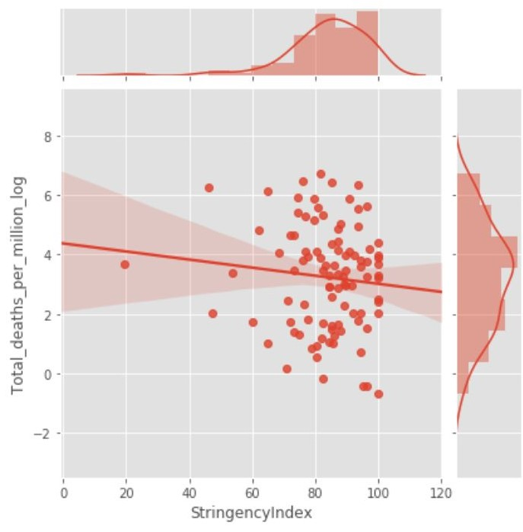
Source: https://pandata.org/wp-content/uploads/2020/07/Exploring-inter-country-variation.pdf
Pandata has supplied a vast amount of statistics, data and facts to prove that lockdowns did not work and that covid19 posed the same risk as a flu season which we experience every few years. https://www.pandata.org/
- A scientific study of 160 countries involving lockdowns and non lockdowns showed that lockdowns had no effect on reducing death rates from covid19 but caused many other health, economic and social problems. Lockdowns were ineffective and counter-productive.
Covid-19 Mortality: A Matter of Vulnerability Among Nations Facing Limited Margins of Adaptation
Marc et al.. Front. Public Health, 19 November 2020 | https://doi.org/10.3389/fpubh.2020.604339
- An Interdisciplinary Approach to analyzing the failure of Lockdowns is provided in this scientific paper
‘COVID-19 Lockdown Policies: An Interdisciplinary Review’, by Dr. Oliver Robinson, https://papers.ssrn.com/sol3/papers.cfm?abstract_id=3782395. It examines hundreds of studies across the world. An excellent video Lecture at https://www.youtube.com/watch?v=JtK-4B4N_OI
- SARS-CoV-2 waves in Europe: A 2-stratum SEIRS model solution
Levan Djaparidze, Federico Lois, 2020, medRxiv 2020.10.09.20210146;
- COVID-19: Rethinking the Lockdown Groupthink, by Ari R Joffe MD, FRCPC
Affiliation: Department of Pediatrics, Division of Critical Care Medicine, University of Alberta and Stollery Children’s Hospital, Edmonton, Alberta, Canada.
- The following scientific debate on RTE in October 2020 shows that lockdowns and a zero covid19 policy are a medical and economic disaster and are Disproportionate in science, medicine and in law. Professor John Lee, a retired Pathologist debated Tomas Ryan a lecturer in TCD, Dublin. Professor John Lee clearly won the debate and used the science and facts and evidence to do so.
Video of Debate - https://www.youtube.com/watch?v=auzaGbhKafE
- A large CDC study completed in March 2021 concluded that mandatory mask wearing and other restrictive social measures was associated with a 1.8% decrease in covid19 transmission. While no mask wearing and no restrictive social measures was associated with a 1.2 % increase in covid19 transmission. These are miniscule and insignificant changes, which point to the fact that covid19 is not as contagious and dangerous as commonly believed. Published paper below.
Association of State-Issued Mask Mandates and Allowing On-Premises Restaurant Dining with County-Level COVID-19 Case and Death Growth Rates — United States, March 1–December 31, 2020.
Guy et al. March 2021 https://www.cdc.gov/mmwr/volumes/70/wr/mm7010e3.htm
- Stay-at-home policy is a case of exception fallacy: an internet-based ecological study. Savaris, R.F., Pumi, G., Dalzochio, J. et al. Sci Rep 11, 5313 (2021). https://doi.org/10.1038/s41598-021-84092-1
- Did The Shutdowns Save Lives? A Year Later, Statistical Analysis Suggests Not, by Chuck DeVore, March 2021, https://thefederalist.com/2021/03/12/did-the-shutdowns-save-lives-a-year-later-statistical-analysis-suggests-not
- In a May 20th, 2020, Bloomberg article titled “The Results of Europe’s Lockdown Experiment Are In,” data journalist Elaine He shared several visuals based on work done by the University of Oxford’s Blavatnik School of Government, which tracked a range of government stringency measures across Europe. They found no correlation between lockdowns and significantly reduced mortality rates - https://www.bloomberg.com/graphics/2020-opinion-coronavirus-europe-lockdown-excess-deaths-recession/
- An important Israeli study which used mobility data has confirmed that lockdowns were ineffective. COVID-19 pandemic-related lockdown: response time is more important than its strictness
Loewenthal et al.. October 2020, EMBO Mol Med (2020)12:e13171 https://doi.org/10.15252/emmm.202013171

- Florida Governor Ron DeSantis held a public health roundtable at the Florida State Capitol on March 18th 2021 and invited top international experts including scientists, medical doctors and professors of medicine to testify. This meeting detailed the failure of lockdowns in the USA and worldwide. Video of meeting - https://www.youtube.com/watch?v=-V7ZqnoKdUQ
- Coping With COVID-19: Learning from Past Pandemics to Avoid Pitfalls and Panic. Daniel, T. Halperin
- Urgent Report on Pandemics and Freedom. American Institute for Economic Research, (2020)
- COVID Catastrophe: Consequences of Societal Shutdowns. Maine Policy Institute, (2020)
- Unreported Truths about COVID-19 and Lockdowns. Alex Berenson, 2020
- Chin V, Ioannidis J, Tanner M, Cripps S. (2020) Effects of Non-Pharmaceutical Interventions on COVID-19: A Tale of Three Models. medRxiv. https://www.medrxiv.org/content/10.1101/2020.07.22.20160341v2
^{35a} Sage’s covert coup Part Two – Project Fear https://www.conservativewoman.co.uk/sages-covert-coup-part-two-project-fear/
- Cristea, I. A., Naudet, F., & Ioannidis, J. P. A. (2020). Preserving equipoise and performing randomized trials for COVID-19 social distancing interventions. Epidemiology and Psychiatric
Sciences. https://doi.org/10.1017/S2045796020000992
- Pan A, Liu L, Wang C, et al. Association of Public Health Interventions With the Epidemiology of the COVID-19 Outbreak in Wuhan, China. JAMA. 2020;323(19):1915–1923. doi:10.1001/jama.2020.6130

- Mark N Lurie, Joe Silva, Rachel R Yorlets, Jun Tao, Philip A Chan, Coronavirus Disease 2019 Epidemic Doubling Time in the United States Before and During Stay-at-Home Restrictions, The Journal of Infectious Diseases, Volume 222, Issue 10, 15 November 2020, Pages 1601–1606, https://doi.org/10.1093/infdis/jiaa491; The article also had a correction appended. Mark N Lurie, Joe Silva, Rachel R Yorlets, Jun Tao, Philip A Chan, Corrigendum to: COVID-19 Epidemic Doubling Time in the United States Before and During Stay-at-Home Restrictions, The Journal of Infectious Diseases, Volume 222, Issue 10, 15 November 2020, Page 1758, https://doi.org/10.1093/infdis/jiaa506
- Araujo MB and Naimi B (2020) Spread of SARS-CoV-2 Coronavirus Likely Constrained by Climate. medRxiv. https://www.medrxiv.org/content/10.1101/2020.03.12.20034728v3.article-info
- Sajadi, Mohammad M. and Habibzadeh, Parham and Vintzileos, Augustin and Shokouhi, Shervin and Miralles-Wilhelm, Fernando and Amoroso, Anthony, Temperature, Humidity and Latitude Analysis to Predict Potential Spread and Seasonality for COVID-19 (March 5, 2020). Available at SSRN: https://ssrn.com/abstract=3550308 or http://dx.doi.org/10.2139/ssrn.3550308
- Carson CJ, Gomez ACR, Shweta B, and Ryan SJ (2020) “Misconceptions about Weather and Seasonality Must not Misguide COVID-19 Response” Nature Communications 11: 4312. https://doi.org/10.1038/s41467-020-18150-z
- Yoo BK, Kasajima M, Bhattacharya J. (2020) “Public Avoidance and the Epidemiology of novel H1N1 Influenza A.” National Bureau of Economic Research Working Paper #15752. DOI 10.3386/w15752. https://www.nber.org/papers/w15752
- Atkeson A, Kopecky K, Zha T. (2020) “Four Stylized Facts about COVID-19” National Bureau of Economic Research Working Paper #27719. DOI 10.3386/w27719. https://www.nber.org/papers/w27719
- De Larochelambert Q, Marc A, Antero J, Le Bourg E, and Toussaint JF. (2020) Covid-19 Mortality: A Matter of Vulnerability Among Nations Facing Limited Margins of Adaptation. Front. Public Health, 19 November 2020 |
K. What are the harms of lockdowns on the health of the population? Do these harms damage or destroy the Common Good, the Greater Good, the Public Interest?

While the evidence on the benefits of lockdowns is equivocal, the harms of the lockdowns are manifold and devastating. The effects on the health of populations, in particular, warrants careful attention, since they can be compared directly against the harms from COVID-19 infection. The COVID-19 lockdowns have often featured the cessation of elective and other medical services to keep hospital and health care systems available for COVID-19 patients. Naturally, patients who skip medical services will suffer adverse health consequences as a result. The empirical evidence internationally supporting these ideas includes documentation for plummeting childhood vaccination rates⁴⁵, worse cardiovascular disease outcomes (in part because patients delayed necessary cardiac care)⁴⁶, less cancer screening⁴⁷ ⁴⁸ and deteriorating mental health⁴⁹ ⁵⁰ ⁵¹.

According to leading doctors and healthcare staff in Ireland, thousands of hospital appointments, screenings, diagnosis, treatments and surgeries for
- Cancers
- heart diseases
- diabetes
- neurological diseases and dementia
- respiratory illnesses
- chronic infections
- gastrointestinal damage and diseases
- endocrine diseases
- mental illnesses including those at increased risk of suicide and self harm
- chronic diseases many of which are degenerative over time

were cancelled in 2020 and into 2021 due to covid19. This was true for all age groups, including the most vulnerable. This was due to the lockdowns and other social restrictions in 2020 and 2021. Many of these appointments are time critical and involve vital screenings, early diagnosis, and surgeries and delays will lead to deaths. This will cause an increase in deaths from these illnesses, diseases and injuries over 2020 and 2021, 2022, 2023, 2024, etc.. More people are projected to die from missing these medical appointments and treatments for these illnesses than from covid19 The data and the scientific evidence supports this - Covid Recovery : A Scientific Approach group formed in Ireland in November 2020, and includes 67 doctors and 100 scientists published a White Paper detailing deaths from the lockdown itself, see paper below
COVID-19 Alternative Strategy – A Case for Health and Socioeconomic Wellbeing

For example, 200,000 first-time hospital appointments were cancelled due to the lockdowns. And in addition to this, tens of thousands of repeat appointments have been cancelled due to the lockdowns. The population of Ireland is 4.8 million so these numbers are significant. These facts reported in the Irish Examiner newspaper on 25th January 2021 - https://www.irishexaminer.com/news/arid-40213250.html
The front page of the Irish Independent newspaper on August 6th 2020 had a headline and article about the thousands of screenings, diagnostics and treatments for cancers, heart diseases, lung diseases, neurological diseases and other diseases and illnesses which were cancelled from March to August 2020 in Ireland. This has vastly increased waiting lists, waiting times and caused a worsening of diseases and illnesses across Ireland. Medical doctors and scientists, epidemiologists, and healthcare professionals all admit that this will lead to many deaths. Lockdowns may constitute manslaughter, grievous bodily harm and even murder. See article below.

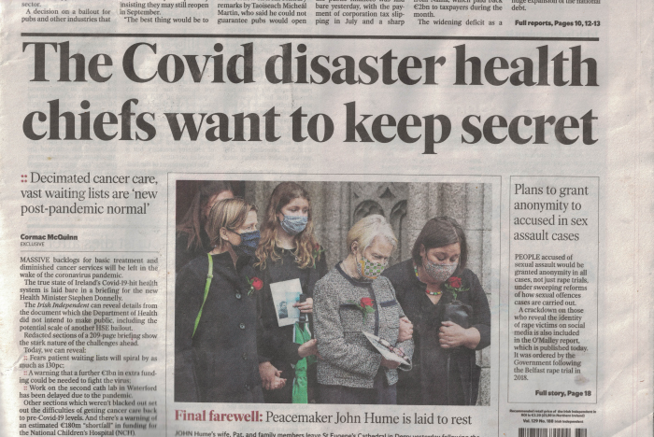
Diminished cancer services and fears of 130pc increase in waiting lists: The Covid disaster health chiefs want to keep secret
Irish Independent newspaper, August 6th 2020

The following submission from the Irish Cancer Society to the Irish Parliament in 2020 outlines the great difficulties imposed by covid19 and lockdowns on cancer diagnosis and treatment in Ireland - ‘Oireachtas Special Committee on COVID-19 Response’ by Irish Cancer Society, available at https://thefatemperor.com/wp-content/uploads/2020/11/2020-09-30_submission-averil-power-chief-executive-irish-cancer-society-scc19r-r-0419_en.pdf . Dr. Ivor Cummins has compiled reports of the harms caused by lockdowns in Ireland and many other countries on https://thefatemperor.com/published-papers-and-data-on-lockdown-weak-efficacy-and-lockdown-huge-harms/

How do covid-19 deaths compare to deaths from heart attacks, cancers, respiratory illnesses, neurological and dementia diseases, accidents, cerebrovascular diseases and alzheimers disease for 2020 ? and are all of these now being mislabeled covid19 deaths ? The following chart which appeared in the British Press and Media in October 2020 shows the situation in Britain which is similar to that in Ireland and other western European countries.
Source: https://www.dailymail.co.uk/news/article-8890811/Coronavirus-claimed-lives-just-17-victims-40-figures-elderly-risk.html
Some 4.59 million people were waiting to begin treatment at the end of January 2021, according to NHS England. It is the highest since records began. The number waiting more than a year was 304,044 in January 2021 - the highest for any month since January 2008. In comparison, the number in January 2020 was just 1,643. Source: https://news.sky.com/story/covid-19-number-of-people-waiting-a-year-for-hospital-treatment-in-england-soars-amid-coronavirus-crisis-12242590 .
There was a lockdown for covid19 which adversely impacted diagnosis, treatments, surgeries and procedures for these other illnesses, meaning more deaths from these other illnesses, yet these other illnesses affect far more people than covid19. More people will die from the effects of lockdowns than from covid19. The governments have obviously not done a Cost-Benefit analysis for Lockdowns in Britain and Ireland and other countries.
People are dying all the time, every day, from smoking related illnesses, cancers, heart diseases, respiratory diseases, chronic diseases, chronic infections, gastro-intestinal illnesses, neurological and dementia diseases, work and car accidents, etc. and they are dying in greater numbers than from covid19. Should we lock down the country to prevent deaths from these illnesses ? The answer is obviously ‘no’ and the answer for covid19 should be ‘no’. The Infection Fatality Rate for covid19 is stated above and is equivalent to a flu season. In fact, deaths in 2020 are less than some previous years, as seen in charts above.
Collateral Damage caused by Lockdowns in many countries. Quantification of Losses.
Collateral Global whose web site is at https://collateralglobal.org consists of medical doctors, professors, scientists, immunologists, epidemiologists, statisticians, economists, lawyers and academics who are measuring and quantifying the damage done by covid19 related lockdowns in countries around the world. It includes the thousands of cancelled appointments, diagnostics, screenings, treatments, and operations for cancers, heart diseases, endocrine diseases, gastro-intestinal diseases, respiratory diseases, chronic infections, dementia diseases, etc. and the worsening of illnesses and deaths which will result from this. It also catalogues the damage done to young people in countries around the world by lockdowns including the increase in suicides, self harm, mental illnesses and drug and alcohol abuse. Their research shows increases in domestic violence, more family instability, alcohol and drug abuse, divorces, seperations, worsening physical health, mental health and emotional health due to lockdowns. The higher unemployment caused by lockdowns and its damage now and for years into the future is also included and the fact that higher unemployment leads to increased suicides and poorer health for those affected. The damage to economies and economic growth will continue to worsen this in 2021 and future years. Economic losses are also quantified. The vast amount of facts, statistics and evidence from around the world shows that lockdowns are not working and are destroying societies and economies. The web site is at https://collateralglobal.org
In the UK two financial analysts and experts, Tim Knox and Jim McConalogue, have outline d the cost per year of life saved and the massive financial and economic losses to the UK economy caused by the lockdowns since march 2020. Ireland would have similar losses per population. Their web site and paper is available at https://www.civitas.org.uk/publications/what-price-lockdown/
Paper: https://www.civitas.org.uk/content/files/The-cost-of-the-cure-30-November.pdf
They found that the cost per year of life saved (QALY) ranges from nearly three times more than what the NHS is usually prepared to pay to over 80 times more.
Sector by sector, the Working Paper identifies economic losses of:
- over £70 billion for manufacturers;
- £40 billion for the construction industry;
- £35 billion for retailers;
- £69 billion for small businesses;
- £30 billion for hotels and restaurants;
- £42 billion for airline-enabled international travel costs;
- £7 billion for pubs;
- £21 billion for rail transport;
- £22 billion for car production and;
- £29 billion for the arts and entertainment industries.
Other costs include:
- Public sector net debt is expected to increase by £473 billion in 2020-21;
- GDP has fallen by 11.3% in 2020;
- Unemployment is expected to increase by between 450,000 and 2.45 million above pre-pandemic levels;
- 20,000 loss of lives could be lost from delayed treatment for cancer and other diseases;
- 16,900 additional domestic violence cases (on 2019) were recorded between March and June 2020;
- Significant increases in depression (64% recording common depressive symptoms), anxiety (69% report increases) and loneliness (reports of loneliness parents of under-fives up by 1.4 million)
- Significant increases in substance abuse including high-risk drinking among adults up by 3.7 million, 20% increase in opiate addictions, 39% increase in number of relapses among addicts;
- A 25% to 30% reduction in learning among primary and secondary pupils, respectively.
Other studies confirm a similar scale of losses for Britain, ‘the Pandemic measures are costing £500 million a day in lost output, while adding £1 billion a day to the national debt…..The NHS waiting list has soared to a record high of nearly 4.6 million…..Pubs and restaurants are losing an estimated £1.7billion a week. The Dail Mail, March 21, 2021. https://www.dailymail.co.uk/news/article-9386889/The-shattering-price-lockdown-health-economy-revealed-year-Covid-restrictions.html . Ireland has similar losses when adjusted for population.
Other Cost-Benefit analysis studies also show massive losses and costs caused by Lockdowns. ⁵⁴
An Interdisciplinary approach to analyzing the harms of Lockdowns is provided in this scientific paper
COVID-19 Lockdown Policies: An Interdisciplinary Review, Dr. Oliver Robinson, https://papers.ssrn.com/sol3/papers.cfm?abstract_id=3782395. It examines hundreds of studies across the world. An excellent video Lecture at https://www.youtube.com/watch?v=JtK-4B4N_OI
“Overview of the Evidence” is an official report published by the Health Advisory and Recovery Team (HART) in Britain in March 2021. This is a large team of scientists, medical doctors, professors and health professionals based in Britain. The Report is viewable at https://www.hartgroup.org/wp-content/uploads/2021/03/HART-REVIEW.pdf
It details the failure of lockdowns and the destructive effects of the lockdown on the physical health, mental health and emotional health of the nation and the vast financial losses and economic damage to the nation. Quotation from Report
‘ The data is in: lockdowns serve no useful purpose and cause catastrophic societal and economic harms. They must never be repeated in this country.’

In addition to the physical health harms from lockdown, international studies and research shows there has been immense psychological harm. The social isolation induced by lockdown has led to a sharp rise in alcohol and drug abuse in Ireland and Britain and this is projected to worsen as these two countries move into severe recession as a result of covid19 and the lockdowns ^{55, 56,} . The correlates to the effects of these lockdowns internationally ⁵⁷ . There was also an increase in mental illnesses and suicides and self harm in Ireland in 2020 caused by the lockdowns and their wider social and economic effects, similar to the "deaths of despair" that occurred in the wake of the 2008 Great Recession.⁵⁸ For children, the cessation of in-person schooling since the spring has led to "catastrophic" learning losses, with severe projected adverse consequences for affected students' life spans. According to a US CDC estimate, one in four young adults seriously considered suicide this past June.⁶² Among 25 to 44-year-olds, the US CDC reports a 26% increase in excess all-cause mortality relative to past years, though fewer than 5% of 2020 deaths have been due to COVID-19.^{63, 64} An important legal report by Dr. Peter Breggin, a medical doctor and psychiatrist titled “COVID-19 & Public Health Totalitarianism: Untoward Effects on Individuals, Institutions and Society” was filed in a federal court in Ohio, USA, on August 31, 2020, and it exposed the vast damage done to mental health, emotional health and physical health caused by lockdowns. Studies from the UK in 2020 show lockdowns had the following effects:
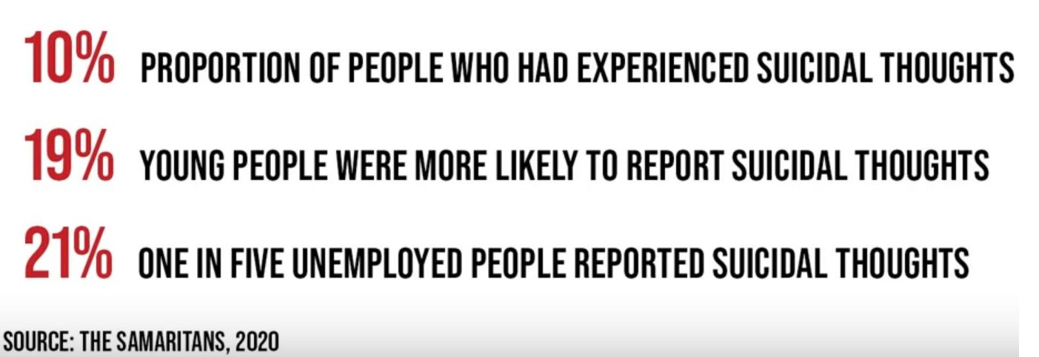
There has been a large increase in domestic violence in families and homes in Ireland during the lockdown as many people have lost their jobs, children are at home due to closed schools and people are forced to stay for longer together in confined environments ^{64a} . In Ireland there was a 5km travel ban which prevented people from going more than 5km from their home. Over 2,000 women were forced to flee family homes and seek shelter during the lockdowns in Ireland in 2020. This causes lasting damage to families particularly children. There was an 88% increase in domestic violence cases in Ireland in 2020, which was due to the lockdowns ^{64b}
- CDC (2020) Effects of the COVID-19 Pandemic on Routine Pediatric Vaccine Ordering and Administration — United States, 2020. MMWR. 69(19): 591-3. https://www.cdc.gov/mmwr/volumes/69/wr/mm6919e2.htm
- Ball S, Banerjee A, Berry C, et alMonitoring indirect impact of COVID-19 pandemic on services for cardiovascular diseases in the UKHeart Published Online First: 05 October 2020. doi: 10.1136/heartjnl-2020-317870
- Rutter MD, Brookes M, Lee TJ, et alImpact of the COVID-19 pandemic on UK endoscopic activity and cancer detection: a National Endoscopy Database AnalysisGut Published Online First: 20 July 2020. doi: 10.1136/gutjnl-2020-322179
- https://www.bbc.com/news/health-53300784, UK scientists warned in July that delayed cancer diagnosis and treatment due to lockdown measures could cause at least 7,000 additional deaths in the UK alone, and as many as 35,000 deaths in a worst-case scenario. If the lockdowns had the same impact in Canada, a population just less than half of the UK, 3,500 to 17,500 deaths could have occurred.
- Vizard T, Davis J, White E, Beynon B (2020) Coronavirus and depression in adults, Great Britain: June 2020. Office for National Statistics, UK. https://www.ons.gov.uk/peoplepopulationandcommunity/wellbeing/articles/coronavirusanddepressioninadultsgreatb ritain/june2020
- United Nations. Policy Brief: COVID-19 and the Need for Action on Mental Health, 13 May 2020. New York, New York: United Nations Sustainable Development Group, https://unsdg.un.org/resources/policy-brief-covid-19-and-need-action-mental-health
- Centre for Addiction and Mental Health, Mental Health in Canada, Covid-19 and Beyond: CAMH Policy Advice, July 2020, http://www.camh.ca/-/media/files/pdfs---public-policy-submissions/covid-and-mh-policy-paper-pdf.pdf
- . Null
- . Null
- https://onlinelibrary.wiley.com/doi/full/10.1111/ijcp.13674
- COVID-19 - drug and alcohol surveys; evidence collection - https://www.drugsandalcohol.ie/31949/
- Rise in number of people seeking treatment for serious alcohol abuse - https://www.rte.ie/news/2020/0727/1155901-alcohol-addiction-ireland/
Why drug dealing and drug use will increase after Covid-19 - https://www.rte.ie/brainstorm/2020/0901/1162507-drug-dealing-consumption-ireland-recession-coronavirus/
- American Medical Association (2020) Issue Brief: Reports of Increases in Opioid- and Other Drug Related Overdose and Other Concerns During COVID Pandemic. AMA Advocacy Resource Center. Oct. 31, 2020. https://www.ama-assn.org/system/files/2020-11/issue-brief-increases-in-opioid-related-overdose.pdf
- Ireland facing a ‘tsunami’ of mental health problems - https://www.irishtimes.com/news/health/gp-describes-terrible-problem-of-suicide-among-young-people-1.4426625?mode=sample&auth-failed=1&pw-origin=https%3A%2F%2Fwww.irishtimes.com%2Fnews%2Fhealth%2Fgp-describes-terrible-problem-of-suicide-among-young-people-1.4426625 and
https://www.cambridge.org/core/journals/irish-journal-of-psychological-medicine/article/covid19-and-its-effect-on-emergency-presentations-to-a-tertiary-hospital-with-selfharm-in-ireland/EE607C7634CFAF7E03AEF7E7FA3DB425
https://hselibrary.ie/what-is-the-impact-of-the-covid-19-pandemic-on-suicide-rates/
https://www.irishtimes.com/news/health/gp-describes-terrible-problem-of-suicide-among-young-people-1.4426625?mode=sample&auth-failed=1&pw-origin=https%3A%2F%2Fwww.irishtimes.com%2Fnews%2Fhealth%2Fgp-describes-terrible-problem-of-suicide-among-young-people-1.4426625
https://www.thejournal.ie/mental-health-pandemic-psychological-society-5179679-Aug2020/
http://www.suicideireland.com/mental-health-and-suicide-related-news/
https://collateralglobal.org/suicide
- Alzheimer’s Impact Movement (2020) The 2020 COVID-19 Pandemic and Dementia: Deaths Above Average. https://www.scribd.com/document/483085777/Dementia-Deaths-Above-Average-State-by-State-Table
- Center for Research on Education Outcomes (2020) Estimates of Learning Loss in the 2019-2020 School Year. CREO Stanford University. October 2020. https://credo.stanford.edu/sites/g/files/sbiybj6481/f/short_brief_on_learning_loss_final_v.3.pdf
- Christakis DA, Van Cleve W, Zimmerman FJ. Estimation of US Children’s Educational Attainment and Years of
Life Lost Associated With Primary School Closures During the Coronavirus Disease 2019 Pandemic. JAMA Netw Open. 2020;3(11):e2028786. doi:10.1001/jamanetworkopen.2020.28786
As a result of lockdowns, the world economy lost $10 - 11 trillion or over 7% of global GDP in 2020 ^{64c} , and the final loss in terms of GDP is projected to be $28 trillion over the coming decade according to top economic forecasts ^{64c}. The Irish economy that is the non IT and Pharmaceuticals sectors shrunk by over 15% in 2020, national GDP fell by 3%, unemployment reached 20 - 25% in 2020, the government deficit increased to 19 billion euros and the national debt has risen to over 240 billion euros. Ireland is now bankrupt in 2021. Economists, investors and academics all agree that the lockdowns have caused economic recessions worldwide and these recessions or depressions will continue after the lockdown due to the depletion of incomes, customer numbers, spending and consumption and productive investment growth and the high debt levels. Also higher government deficits and national debt levels resulting from the lockdowns will lead to government austerity policies after the lockdowns. All of this has increased unemployment and will lead to continuing high levels of unemployment.
Studies in Ireland show that relative to employment, unemployment was associated with a 2–3-fold increased risk of male suicide and undetermined death but generally a 4 – 6-fold increased risk in women ^{65c} . Other studies found that being unemployed was associated with a twofold to threefold increased relative risk of death by suicide, compared with being employed ^{65a} Mattei and Pistoresi ^{65b} found a continuing deep-rooted effect over 18 years where a 1% increase in long-term unemployment increased the suicide rate by 0.83%. There are many scientific studies showing a relationship between higher unemployment levels and rising suicide rates ^{65d} . The lockdowns and their effects will worsen this. Two recently published scientific papers corroborate this, "’Long Term Impact of the Covid19 Unemployment Shock on Life Expectancy and Mortality Rates’ by Bianchi at al. (2021). This was published by the National Bureau of Economic Research in the U.S. It's summary finding is that this event of covid19 and lockdowns and it’s economic destruction is 2 to 5 times worse than a usual unemployment shock and that it will result in an increase in mortality of 3.0% and a 0.5% drop in life expectancy translating into an extra 890,000 deaths over the coming 15 years in the U.S. A second paper by Casey B. Mulligan again for the NBER titled " Deaths of Despair and the Incidence of Excess Mortality in 2020" shows a 10 to 60% percent increase in deaths linked to suicide, alcohol or opioids.
This is certainly not serving the Common Good and the Public Interest.

Scientific experts calculate that the equivalent of 560,000 lives will be lost as a result of the lockdowns in Britain. This will be the result of a fall in GDP of 9% or more, a deep recession, more bankruptcies of businesses and individuals, higher unemployment levels, higher suicide levels, higher poverty levels and worsening health for many more millions of people, more drug and alcohol abuse, cutbacks to healthcare and hospitals as a result of massive national debt levels and declining tax revenues, and thousands of cancelled appointments in hospitals due to lockdowns which will lead to many thousands of deaths. There are several news articles about this.
https://www.dailymail.co.uk/news/article-8925425/Lockdown-claim-equivalent-560-000-lives-health-impact-recession-cause.html
https://www.spectator.co.uk/article/is-the-cost-of-another-lockdown-too-high-
In Ireland the number of lives lost would be similar to Britain, when measured per population.
A recent study⁶⁵ in European Psychiatry analyzed the psychological harms of the lockdowns in
Switzerland and attempted to quantify citizens’ years of life lost as a result. The authors focused on deaths caused by “suicide, depression, alcohol use disorder, childhood trauma due to domestic violence, changes in marital status, and social isolation.” The authors find that the 2.1% of the population who suffered from one of these conditions would suffer nearly 9.8 years of life lost in expectation as a consequence of just a three-month lockdown. They emphasize that that their estimate is likely to be an underestimate because many of the outcomes they analyze will persist even after the lockdown ends. The authors conclude,
The literature suggests that increased duration of confinement is associated with worse outcomes for psychological health of those confined. While some of the stress-related problems ensuing from confinement may remit, an important portion of this damage may prove to be hard or impossible to reverse and the affected individuals may experience ongoing suffering. Our projection suggests that the Swiss population will incur a substantial increase in mortality as a consequence of confinement-related psychosocial stress, which should be considered in forming public health responses to the pandemic.
Research by Dr. Breggin which was used in US courts confirms a vast amount of damage to mental health, emotional health and physical health from Lockdowns ^{70a}. While the lockdowns result in direct harms for the health of populations where they are implemented, they also have devastating indirect consequences as a result of a collapse in worldwide economic outcomes, with a particularly large and negative effect on poor countries.⁶⁶ This economic harm translates directly into health harm, as large populations are no longer able to feed themselves due to poverty. The UN estimates that an additional 130 million poor people will be at risk of starvation as a consequence of the economic collapse caused by the lockdowns– predicting a famine of “biblical” proportions.⁶⁷ Estimates suggest that an additional 400,000 people will die from inadequate tuberculosis treatment as a consequence of diversion of resources away from TB identification and treatment.⁶⁸ Vaccination campaigns in rich and poor countries that address diseases like diphtheria and polio have been suspended due to the lockdowns.⁶⁹
According to Oxfam, the COVID-19 response is likely to throw another half a billion people into poverty. This would be the first time since 1990 that poverty increased and could be severe enough to put some countries back to where they were three decades ago ^{68a} . There were 1.4 million additional TB deaths, 500k additional HIV deaths, 385k additional malaria deaths due to lockdown ^{68b}
According to a recent editorial in the journal Nature, COVID-19 is “fuelling a resurgence of AIDS, malaria, and tuberculosis” around the world.⁷⁰ The evidence and facts clearly show that the harms caused by lockdowns damage or destroy the Common Good, the Greater Good, the Public Interest in Ireland and in other countries around the world. And that this damage will be long term.
- Czeisler MÉ , Lane RI, Petrosky E, et al. Mental Health, Substance Use, and Suicidal Ideation During the COVID-19 Pandemic — United States, June 24–30, 2020. MMWR Morb Mortal Wkly Rep 2020;69:1049–1057. DOI: http://dx.doi.org/10.15585/mmwr.mm6932a1
- Rossen LM, Branum AM, Ahmad FB, Sutton P, Anderson RN. Excess Deaths Associated with COVID-19, by Age and Race and Ethnicity — United States, January 26–October 3, 2020. MMWR Morb Mortal Wkly Rep 2020;69:1522–1527. DOI: http://dx.doi.org/10.15585/mmwr.mm6942e2
- CDC (2020) Provisional COVID-19 Death Counts by Sex, Age, and State. https://data.cdc.gov/NCHS/Provisional-COVID-19-Death-Counts-by-Sex-Age-and-S/9bhg-hcku
64a https://www.irishtimes.com/news/social-affairs/covid-19-sharp-increase-in-women-and-children-fleeing-domestic-violence-1.4404850
64b 88% increase in domestic violence cases in 2020 - https://waterford-news.ie/2021/02/10/88-increase-in-domestic-violence-cases-in-2020/
64c https://duckduckgo.com/?q=global+economy+cost+of+covid&t=hd&va=o&ia=web and
IMF, https://www.theguardian.com/business/2020/oct/13/imf-covid-cost-world-economic-outlook
⁶⁵ Dominik A. Moser, Jennifer Glaus, Sophia Frangou and Daniel S. Schechter, “Years of Life Lost Due to the Psychosocial Consequences of Covid-19 Mitigation Strategies Based on Swiss Data” 19 May 2020, European Psychiatry, 63(1), e58, 1–7, https://doi.org/10.1192/j.eurpsy.2020.56
65a https://www.ncbi.nlm.nih.gov/pmc/articles/PMC1732539/
65b Mattei G, Pistoresi B. Unemployment and suicide in Italy: evidence of a long-run association mitigated by public unemployment spending. Eur J Health Eco. (2019) 20: 569–77. doi: 10.1007/s10198-018-1018-7
65c Suicide and employment status during Ireland’s Celtic Tiger economy https://academic.oup.com/eurpub/article/21/2/209/495670
65d https://scholar.google.ch/scholar?q=link+between+unemployment+and+suicide&hl=en&as_sdt=0&as_vis=1&oi=scholart
- Bhattacharya J and Packalen M (2020) Focused COVID-19 Restrictions will Save Lives in Poor Countries. Financial Post. July 3, 2020. https://financialpost.com/opinion/focused-covid-19-restrictions-will-save-lives-in-poor-countries
- Dowsett C (2020) As famines of ‘biblical proportion’ loom, Security Council urged to ‘act fast’. UN News. April
21, 2020. https://news.un.org/en/story/2020/04/1062272
- McKie R (2020) Covid set to cause 400,000 surge in TB deaths as medics diverted. The Guardian. Nov. 8, 2020. https://www.theguardian.com/world/2020/nov/08/covid-set-to-cause-400000-surge-in-tb-deaths-as-medics-diverted
68a BBC, 2020, Coronavirus: World risks ‘biblical’ famines due to pandemic – UN, BBC News. https://www.bbc.com/news/world-52373888
68b Strohecker K., 2020, Coronavirus crisis could plunge half a billion people into poverty: Oxfam, Reuters. https://www.reuters.com/article/us-health-coronavirus-poverty/coronavirus-crisis-could-plunge-half-a-billion-people-into-poverty-oxfam-idUSKCN21R0E7
- GAVI (2020) At least 80 million children at risk of disease as COVID-19 disrupts vaccination efforts, warn Gavi, WHO and UNICEF. May 22, 2020. https://www.gavi.org/news/media-room/least-80-million-children-risk-disease-covid-19-disrupts-vaccination-efforts

L. Are the harms of the lockdowns equitably distributed?

The harms of lockdowns are unequally distributed. In the US, for instance, economists have found that only 37% of jobs in the US can be performed wholly on-line, and high-paying jobs are overrepresented among that set.⁷¹ By declaring janitors, store clerks, meat packers, postal workers, and other blue-collar workers as "essential" workers in most states, regardless of whether they qualify as high COVID mortality risk, the lockdowns have failed to shield the vulnerable in these occupations. The same is true in Ireland as well. Ireland has had an unemployment rate of 21% in 2020 when covid unemployment payments are included in the figures, one of the highest in the EU ^{70b} . The impact of this unemployment has fallen most severely on younger and less well-educated workers and on minorities.

Worldwide, the economic dislocation from the lockdowns has increased the number of households where young adults who have lost their jobs co-reside with vulnerable older parents,⁷⁴ which may increase the risk of COVID-related death.⁷⁵ Lockdowns thus fail the test of imposing costs and conferring benefits equitably.⁷⁶
The physical harms of lockdowns in terms of worsening of health and increased deaths from non
covid19 illnesses and diseases are discussed in points above. These mainly affect the more vulnerable
sections of society, the poor, the elderly, minorities, women, the disabled and the unemployed. They
are and will continue to be disproportionately affected by lockdowns with serious consequences for
their lives.

- Nature (2020) How to stop COVID-19 fuelling a resurgence of AIDS, malaria and tuberculosis. Nature 584: 169. August 12, 2020. doi: https://doi.org/10.1038/d41586-020-02334-0
70a “COVID-19 & Public Health Totalitarianism: Untoward Effects on Individuals, Institutions and Society” was filed by Dr. Peter Breggin in a federal court in Ohio, USA, on August 31, 2020
70b CSO, Ireland, https://www.cso.ie/en/releasesandpublications/er/mue/monthlyunemploymentdecember2020/
- Dingel JI and Neiman B (2020) How Many Jobs Can Be Done at Home? National Bureau of Economic Research Working Paper #26948. April 2020
- Goldsetein L (2020) We’re Number One! Highest Unemployment Rate in the G7. Toronto Sun. Sept. 30, 2020. https://torontosun.com/opinion/columnists/goldstein-were-number-one-highest-unemployment-rate-in-the-g7
- Beland LP, Brodeur A, Mikola D, and Wright T. (2020) Here’s how the coronavirus is affecting Canada’s labour market. The Conversation. May 13, 2020. https://theconversation.com/heres-how-the-coronavirus-is-affecting-canadas-labour-market-137749
- Evandrou M, Falkingham J, Qin M, and Vlachantoni A (2020) Changing Living Arrangements, Family Dynamics and Stress During Lockdown: Evidence from Four Birth Cohorts in the UK. University of Southampton Eprint Soton. https://eprints.soton.ac.uk/443865/1/family_dynamics_during_covid_19_final.pdf
M. What is the magnitude of the risk children pose in disease spread? Is there any rationale for lockdown related restrictions on children?

The overwhelming weight of scientific data suggests that the risk of transmission of the virus from younger people aged 18 and below to older people is small or negligible, and the risk of transmission from people 18 to 25 to older people is small relative to the risk of transmission from people older than 25 to others older than 25.

The most important evidence on childhood spread of the disease comes from a study conducted in Iceland and published in the New England Journal of Medicine.⁷⁷ The data for this study comes from Iceland’s systematic screening of its population to check for the virus. This is the most important study on this topic because it is the only study that definitively establishes the direction of spread of the virus from contact to contact. The study reports on both a population-representative sample and a sample of people who were tested because of the presence of symptoms consistent with COVID-19 infection. The study team isolated SARS-CoV-2 virus samples from every positive case, sequenced the genome of the virus for every case and tracked the mutation patterns in the virus. This analysis, along with contact tracing data, allowed the study team to identify definitively who passed the virus to whom. There have been hundreds of minor mutations of the virus identified, which typically do not alter the function of the virus much, but which provide a unique fingerprint, of sorts, that makes it possible to tell whether two patients could possibly have passed the virus to one another. From this analysis, the senior author of the study, Dr. Kari Stefansson, concluded⁷⁸ that “[E]ven if children do get infected, they are less likely to transmit the disease to others than adults. We have not found a single instance of a child infecting parents. There is amazing diversity in the way in which we react to the virus.”

Although the Iceland study is the only definitive study, there are a number of other studies that use contact tracing methods to investigate the role of children in disease spread. The bulk of such studies conclude that children play a small role, consistent with the Iceland data. A French study,⁷⁹ conducted by scientists at the L’Institut Pasteur, examined data from late April 2020 on schoolteachers, students, and their parents in Crepy-en-Valois in France. The schools in France were closed from the end of January on, at first because of a February holiday and then the late February lockdown. The authors found three cases among kids in January using antibody tests but found no evidence of virus spread to other kids or teachers from those early cases. Any spread between the end of January and the end of April (when the authors collected samples) must have occurred during the lockdown. The kids who tested antibody positive at the end of April, because of the circumstances of the lockdown, must have become positive from a source other than their school. The main contacts of the young children were their parents, of whom 61% were positive, which is consistent with parent to child spread. Also consistent is the fact that only 6.9% of parents tested positive in April for the virus among the kids who were antibody negative. The authors’ main conclusion⁸⁰ from these facts is that parents were the source of infections in school children; children were not the source. This finding mirrors the conclusion from the Icelandic study that the disease spreads less easily from children to adults than it does from adults to adults.
Researchers in Ireland conducted a similar study⁸¹ which analyzed 1,160 children and adults in Ireland who were physically present in a school at some time between March 1st and March 13th where a COVID-19 case was identified. (Schools were closed in Ireland on March 12th). The authors found 3 children (all between 10 and 15 years old) and 3 adults who had COVID-19 infections. Their study followed students and families after the school closures to see if there was any evidence of disease spread from these identified cases. All six patients had confirmed cases of COVID-19 disease but were found to have contracted the virus from contacts outside of the school setting. Despite identifying a total of 722 contacts, the study authors reported finding no instance of an infected child infecting another child. The infected adults, by contrast, had many fewer contacts – 102 – but did pass on the infection to a few adult contacts.

- Fenoll AA & Grossbard S (2020) Intergenerational residence patterns and Covid-19 fatalities in the EU and the US, Economics & Human Biology, 39. https://doi.org/10.1016/j.ehb.2020.100934.
- Kulldorff M and Gupta S. (2020) Canada's COVID-19 strategy is an assault on the working class. Toronto Sun. Nov. 29, 2020. https://torontosun.com/opinion/columnists/opinion-canadas-covid-19-strategy-is-an-assault-on-the-working-class
- Daniel F. Gudbjartsson, Ph.D., Agnar Helgason, Ph.D., et al., Spread of SARS-CoV-2 in the Icelandic Population, The New England Journal of Medicine, https://www.nejm.org/doi/full/10.1056/NEJMoa2006100 (June 11, 2020).
- Roger Highfield, Coronavirus: Hunting Down COVID-10, Science Museum Group,
https://www.sciencemuseumgroup.org.uk/blog/hunting-down-covid-19/ (April 27, 2020).
⁷⁹ Arnaud Fontanet, MD, DrPH, Rebecca Grant, et al., SARS-CoV-2 Infection in Primary Schools in Northern France: A Retrospective Cohort Study in an Area of High Transmission, Institut Pasteur, https://www.pasteur.fr/fr/file/35404/download (last visited July 9, 2020).
A report⁸² by the ministry of health in the Netherlands, based on contact tracing data, finds almost no disease spread by infected patients 20 and under at all, and only limited spread by adults 20-25 to others outside their own age category. The authors of the study concluded: “Data from the Netherlands also confirms the current understanding: that children play a minor role in the spread of the novel coronavirus. The virus is mainly spread between adults and from adult family members to children. The spread of COVID-19 among children or from children to adults is less common.”

A German⁸³ study reports a strikingly similar finding on the likelihood of pediatric disease spread. The German Society for Pediatric Infectious Diseases collected on all children and adolescents admitted to a hospital for COVID-19 treatment between mid-March and early May 2020 – 128 patients in all, admitted to 66 different hospitals. The authors were able to find the source of infection for 38% of these patients, which turned out to be a parent 85% of the time. Though the authors document a limitation of small sample size, they conclude that “In contrast to other epidemic viral respiratory infections, the primary source of infection with SARS-CoV-2 appears not to be other children.” The authors reported a single death among these 128 pediatric patients.

- COVID-19 In Primary Schools: No Significant Transmission among Children or From Students to Teachers,
Institut Pasteur, https://www.pasteur.fr/en/press-area/press-documents/covid-19-primary-schools-no-significant-transmission-among-children-students-teachers (June 23, 2020).
- Laura Heavey, Geraldine Casey, et al., No Evidence of Secondary Transmission of COVID-19 from Children Attending School in Ireland, 2020, Eurosurveillance, https://www.eurosurveillance.org/content/10.2807/1560-7917.ES.2020.25.21.2000903#html_fulltext (May 28, 2020).
- Children and COVID-19, National Institute for Public Health and the Environment, https://www.rivm.nl/en/novel-coronavirus-covid-19/children-and-covid-19 (July 2, 2020).
- Armann, J. P., Diffloth, N., Simon, A., Doenhardt, M., Hufnagel, M., Trotter, A., Schneider, D., Hübner, J., & Berner, R. (2020). Hospital Admission in Children and Adolescents With COVID-19. Deutsches Arzteblatt international, 117(21), 373–374. https://doi.org/10.3238/arztebl.2020.0373

One of the largest studies in the world on coronavirus in schools, carried out in 100 institutions in the UK, recently confirmed that “there is very little evidence that the virus is transmitted” in schools.⁸⁴ Indeed, the president of the Royal College of Pediatrics and Child Health and a member of the government advisory group Sage confirmed that “there is very little evidence that the virus is transmitted in schools” based on this extensive study.

A study of 23 family disease clusters in Greece, published on Aug. 7th in the Journal of Medical Virology, found that in 91% of the clusters, an adult was the first person to be infected. Their contact tracing effort attempted to clarify the direction of disease spread by careful questioning about the relative timing of the development of symptoms. They found no evidence of either child to adult spread, or even of child to child spread. They concluded that “[w]hile children become infected by SARS‐CoV‐2, they do not appear to transmit infection to others.

Furthermore, children more frequently have an asymptomatic or mild course compared to adults.”⁸⁵

A study by the Federal Office of Public Health of Switzerland analyzed 793 cases reported by Swiss doctors in late July 2020.⁸⁶ The reports included the place where each patient most likely contracted the infection. The most common source of infection was at home, with 27.2% tracing their disease there. School, by contrast, consisted of only 0.3% of the infections; exactly two of the 793 cases could be tracked to a school. There are some limitations though of this study: first, it is a contact tracing study without genetic sequencing verification so the usual caveat applies; and second, the report provides no details about the age of the cases, so it is not possible to separately glean the disease acquisition frequencies for children and adults; and third, only summer schools were in session during this time period. Nevertheless, the results strongly suggest that schools are a minor source of community spread of the infection.

A recent South Korean contact tracing study⁸⁷ was cited in the New York Times as providing evidence that “Older Children Spread the Coronavirus Just as Much as Adults.” Contrary to the interpretation of the NYT headline, the pattern of evidence reported in the study does not imply that older children spread the coronavirus as much as adults. A follow-on paper on South Korean case study, reanalyzing the same data set, the same patients, and published in the Archives of Disease in Childhood, clarified the direction of transmission of disease by focusing only on cases without “shared exposure” to a positive case.⁸⁸

The idea in this reanalysis paper is to exclude from consideration situations where two people who are infected share a third contact who is also infected, since it is possible that third contact infected both the original two people. Using this method, the authors found a single case (out of 107 pediatric index cases and 248 household members who also tested positive) of a child passing on the disease to another household member – another child. They find no instances of a child passing the disease to an adult.

This reanalysis of the South Korean paper is instructive, and the lesson should be clear. Correlation studies and anecdotes that do not distinguish the direction of spread of disease provide no information whatsoever about the safety (or lack thereof) of school reopening. In every single instance, when a more careful analysis that identifies the direction of spread (such as this South Korean study) is conducted, the analysis finds that children pose a negligible risk of spreading the disease to adults, both at school and at home.

There are other contact tracing-based studies that have attempted to reach conclusions about the role of children in spreading the epidemic that suffer from the same problem as the original South Korean study referenced above. For instance, a pre-print study from the Italian province of Trento⁸⁹ reported on 2,812 cases who reported 6,690 contacts. Though there were only 14 children among these cases, the authors nevertheless conclude that they transmitted the disease at a high rate, infecting 11 of their 49 contacts, nearly all within the same household.

- Sian Griffiths, Pupils pose little risk of spreading COVID, The Sunday Times (Aug. 9, 2020), available at https://www.thetimes.co.uk/article/pupils-pose-no-risk-of-spreading-covid-27q6zfd9l.
- Helena C. Maltezou Rengina Vorou Kalliopi Papadima, et al. (2020) “Transmission dynamics of SARS‐CoV‐2 within families with children in Greece: a study of 23 clusters” Journal of Medical Virology, https://doi.org/10.1002/jmv.26394 (accessed August 12, 2020).
- Office fédéral de la santé publique OFSP (2020) “Rectificatif : les lieux de contamination sont les contextes familiaux et non les boîtes de nuit” Aug. 2, 2020. available at https://www.bag.admin.ch/bag/fr/home/das-bag/aktuell/news/news-02-08-2020.html
- Park YJ, Choe YJ, Park O, Park SY, Kim YM, Kim J, et al. “Contact tracing during coronavirus disease outbreak, South Korea, 2020,” Emerg Infect Dis. (Oct. 2020), available at https://doi.org/10.3201/eid2610.201315 (accessed online July 27, 2020),
- Kim J, Choe YJ, Lee J, et al., Role of children in household transmission of COVID-19, ARCHIVES OF DISEASE IN
CHILDHOOD (August 7, 2020), available at doi: 10.1136/archdischild-2020-319910
This represents only a small fraction of cases and contacts the authors analyzed, so numerically it is incorrect to conclude that children played a key role in the spread of the epidemic. Furthermore, unlike the Icelandic study, the Italian study cannot distinguish a child infecting a contact from the contact infecting the child. To my knowledge, nearly every contact-tracing based study of the role of children in the epidemic – with the Icelandic study and reanalysis of the South Korean study cited above as notable exceptions – suffers from this same problem.

A recent report, published in the Journal of Pediatrics and entitled “Pediatric SARS-CoV-2:

Clinical Presentation, Infectivity, and Immune Responses”, measured the concentration of the

SARS-CoV-2 virus in the nasopharynx of children who showed symptoms consistent with COVID-19 infection.⁹⁰ The report found that the viral load in pediatric patients with symptoms (typically mild symptoms) was higher than adult hospitalized patients with severe COVID-19 disease. This is consistent with reports from earlier in the epidemic, which found similarly high viral loads in children.⁹¹ Many news media reports of the Journal of Pediatrics study extrapolated beyond the results of the study, with alarming headlines saying that children are“silent spreaders” of SARS-CoV-2.⁹²

These media reports are misleading because the presence of virus in the nasopharynx is not synonymous with the transmissibility of the virus. The PCR test which checks for the presence of the virus registers false positive results in the presence of non-viable, non-infectious, viral particles.^{93,94,95} So even a high viral load is not evidence of infectivity.⁹⁶ The Journal of Pediatrics study itself appropriately lists the fact that their study does not assess the transmissibility of the virus as a limitation of the study. The only way to check for infectivity is to conduct a careful study of actual transmission of the virus, of the sort reported in the Icelandic contact tracing/viral mutation analysis referenced earlier.⁹⁷

- Pirous Fateh-Moghadam, Laura Battisti, Silvia Molinaro, Steno Fontanari, Gabriele Dallago, Nancy Binkin,
Mariagrazia Zuccali (2020) “Contact tracing during Phase I of the COVID-19 pandemic in the Province of Trento, Italy: key findings and recommendations” medRxiv preprint, DOI: https://doi.org/10.1101/2020.07.16.20127357. (accessed online Aug. 6, 2020)
- Lael Yonker et al. (2020) “Pediatric SARS-CoV-2: Clinical Presentation, Infectivity, and Immune Responses.”
The Journal of Pediatrics DOI: 10.1016/j.jpeds.2020.08.037 https://www.jpeds.com/article/S0022-3476(20)31023-4/fulltext
- Terry C Jones et al. (2020) “An Analysis of SARS-CoV-2 Viral Load by Patient Age” medRxiv.
doi:https://doi.org/10.1101/2020.06.08.20125484. https://www.medrxiv.org/content/10.1101/2020.06.08.20125484v1
- Science Daily (2020) “Researchers show children are silent spreaders of virus that causes COVID-19” Press release, August 20, 2020. https://www.sciencedaily.com/releases/2020/08/200820102442.htm
- Kucirka LM, Lauer SA, Laeyendecker O, et al. (2020) Variation in False-Negative Rate of Reverse Transcriptase Polymerase Chain Reaction–Based SARS-CoV-2 Tests by Time Since Exposure. Annals of Internal Medicine. https://doi.org/10.7326/M20-1495
- Lan L, Xu D, Ye G, et al. (2020) Positive RT-PCR Test Results in Patients Recovered From COVID-19. JAMA. 2020;323(15):1502–1503. doi:10.1001/jama.2020.2783
- Cohen AN, Kessel B (2020) False positives in reverse transcription PCR testing for SARS-CoV-2. medRxiv 2020.04.26.20080911; doi: https://doi.org/10.1101/2020.04.26.20080911. Accessed 7/22/2020.
- Gavin Joynt and William Wu (2020) “Understanding COVID-19: what does viral RNA load really mean?” Lancet
Infectious Diseases 20(6): P635-6. DOI:https://doi.org/10.1016/S1473-3099(20)30237-1 https://www.thelancet.com/journals/laninf/article/PIIS1473-3099(20)30237-1/fulltext
- Daniel F. Gudbjartsson, Ph.D., Agnar Helgason, Ph.D., et al., Spread of SARS-CoV-2 in the Icelandic Population, The New England Journal of Medicine, https://www.nejm.org/doi/full/10.1056/NEJMoa2006100 (June 11, 2020).

Another approach to this topic involves analyzing the effect of actual school closures on the spread of the epidemic within a country. If children play a role as a key vector of the epidemic, then one would expect that countries that closed schools would see a significant effect of this policy on disease spread. In fact, the opposite is the case. Studies from around the world that have examined school closures (including Japan⁹⁸, New South Wales⁹⁹, and Sweden/Finland¹⁰⁰) find little or no effect of school closure on disease spread. The studies encompass closures of both elementary schools and high schools. A study¹⁰¹ analyzing the Swedish experience concluded that there was there was no additional risk to elderly people cohabiting with school age children up to age 16, despite the fact that Swedish schools were kept open throughout the epidemic. A systematic review of this evidence¹⁰² concluded that even though it may be possible for children to be infected with the virus and even transmit it, “[o]pening up schools and kindergartens is unlikely to impact COVID-19 mortality rates in older people.”

- Kentaro Iwata, Asako Doi, and Chisato Miyakoshi (2020) “Was school closure effective in mitigating coronavirus disease 2019 (COVID-19)? Time series analysis using Bayesian inference” International Journal of Infectious Diseases. DOI: https://doi.org/10.1016/j.ijid.2020.07.052 (accessed online Aug. 6, 2020).
- Kristine Macartney, Helen Quinn, Alexis Pillsbury, et al. (2020) “Transmission of SARS-CoV-2 in Australian Educational Settings: A Prospective Cohort Study” The Lancet Child & Adolescent Health. DOI: https://doi.org/10.1016/S2352-4642(20)30251-0 (accessed online Aug. 6, 2020)
- Public Health Agency of Sweden (2020) “COVID-19 in Schoolchildren: A Comparison between Finland and Sweden” https://www.folkhalsomyndigheten.se/contentassets/c1b78bffbfde4a7899eb0d8ffdb57b09/covid-19-school-aged-children.pdf (accessed online Aug. 6, 2020)
- Brandén, Maria; Aradhya, Siddartha; Kolk, Martin; Härkönen, Juho; Drefahl, Sven; Malmberg, Bo; et al. (2020): Residential Context and COVID-19 Mortality among the Elderly in Stockholm: A population-based, observational study. Stockholm Research Reports in Demography. Preprint. https://doi.org/10.17045/sthlmuni.12612947.v1 (accessed online Aug. 6, 2020)
- Jonas Ludvigsson (2020) “Children are Unlikely to be the Main Drivers of the COVID-19 Pandemic – A
Systematic Review” Acta Paediatrica, DOI: 10.1111/apa.15371 (accessed online Aug. 6, 2020).

One purported counterexample to this evidence that has received widespread attention involves the reopening of school in Israel in the early summer.¹⁰³ While the Israeli opening of schools is cited as a counter-example to the many other studies showing the negligible risk of transmitting COVID-19 by children, the Israeli reports suggest it was a unique circumstance, with children crowded into a small closed space and few precautions taken against disease spread. The New York Times story cited above provides an illustrative anecdote of symptomatic teachers passing the virus to their students. And the primary source of disease spread at the Gymnasia Rehavia high school was a single symptomatic teacher infecting colleagues and students. Contemporary reports, which emphasize the success of Israel in controlling the epidemic, suggest that Israelis reduced adherence to other mitigation measures as well. The cases that arose in Israeli schools are more likely a reflection of pre-existing community spread of the virus than a cause.

Thus, with no careful study to back it, and several lines of evidence that complicate any causal inference, the role of school opening in the resurgence of COVID-19 cases in Israel is not established. If there is a lesson to be learned, it is that schools can be opened safely for in-person learning if reasonable precautions – specific to the circumstances of each school – are taken. In the Israeli case, as with much of the anecdotal evidence cited, no viral sequencing analysis was conducted to verify the direction of disease spread. A report in Science emphasizes that no causal connection should be inferred from the correlation between Israeli school openings and the rise in cases there: “In Israel, infections among children increased steadily after schools opened. That paralleled a rise in cases nationwide, but it’s not clear whether the country’s rising caseload contributed to the increase within schools or vice versa.”

A large study of 1,900 children attending an urban summer schools in Barcelona, Spain over a five-week period found only 39 new index cases (30 pediatric).¹⁰⁴ The setting was chosen because the investigators viewed it as a model for what to expect from school openings in the fall. These kids had 253 contacts in total, of whom, only 12 developed an infection – a secondary attack rate of 4.7%. The low secondary attack rate was similar for children of all ages attending the programs, ranging up to 17 years-old. The investigators attributed the success in controlling the spread of the disease to frequent hand washing by the children and to organizing the children into “bubbles” so that the kids interacted with the same group of children all day long.

A recent and comprehensive official report by Public Health England of the role of English schools, which were reopened on June 1, 2020 despite high community case numbers, in spreading the pandemic.¹⁰⁵ The author of this report found that cases and outbreaks were
“uncommon across all educational settings” and that “[s]taff members had an increased risk of SARS-CoV-2 infections compared to students in any educational setting, and the majority of cases linked to outbreaks were in staff.” In response to this study, UK education minister Gavin Williamson said “The latest research, which is expected to be published later this year – one of the largest studies on the coronavirus in schools in the world – makes it clear there is little evidence that the virus is transmitted at school.”¹⁰⁶
The overwhelming bulk of scientific studies that have examined the topic – including the best studies, which take pains to distinguish correlation from causation – find that children play a limited role in spreading COVID-19 infection to adults and that children themselves face minimal risk of poor outcomes if they should become infected.

In summary, Irish responses to the epidemic have included many limitations on the activities of children, including but not limited to closures of schools, limitations to in class teaching, restrictions on Bible camps and Bible studies, suspension or limitations of sports and activities, and limitations to contacts with friends. Given the evidence cited here, these policies are inconsistent with the principle that public health decisions must be grounded in good scientific evidence.

- Isabel Kershner and Pan Belluck (2020) “When COVID Subsided, Israel Reopened Its Schools. It Didn’t Go Well.” New York Times. Aug. 4, 2020. https://www.nytimes.com/2020/08/04/world/middleeast/coronavirus-israel-schools-reopen.html (Accessed online Aug. 6, 2020)
- Oriel Guell (2020) Major coronavirus study in Spanish summer camps shows low transmission among children. El Pais. (Aug. 26, 2020) available at https://english.elpais.com/society/2020-08-26/major-coronavirus-study-in-spanish-summer-camps-shows-low-transmission-among-children.html
- Sharif Ismail et al. (2020) “SARS-CoV-2 infection and transmission in educational settings:
cross-sectional analysis of clusters and outbreaks in England” Public Health England, Aug. 12, 2020 https://assets.publishing.service.gov.uk/government/uploads/system/uploads/attachment_data/file/911267/School_O utbreaks_Analysis.pdf
- Peter Walker (2020) “Little Evidence COVID Spreads in Schools, says Gavin Williamson” The Guardian, Aug. 10, 2020. https://www.theguardian.com/world/2020/aug/10/little-evidence-covid-spreads-in-schools-says-gavin-williamson

N. Do Restrictions on the Activities of Young Adults Play an Important Role in Disease Spread? Do Young adults face particular harms from the lockdown restrictions?

Unlike children, young adults who are infected – especially early in infection – spread disease as efficiently older adults. However, they are harmed by infection much less than older adults. Young adults face a very low mortality risk from COVID-19 infection – an infection survival rate of 99.98% for people aged 20-49, according the US CDC.¹⁰⁷

By contrast, young adults face enormous harm from lockdowns. Indicators of psychological harm have also increased sharply in prevalence in this group. According to a US CDC survey, one in four young adults aged 18 to 24 seriously considered suicide.¹⁰⁸ Similarly, Ireland has reported an increase in suicides and self harm in 2020 during the lockdowns and this is projected to worsen in 2021, 2022, 2023 and further years ¹⁰⁹ . Other harms include lost educational opportunities with colleges and universities shutting down or providing only online classes and catastrophically high unemployment and economic dislocation from international studies ¹¹⁰

- COVID- 19 Pandemic Planning Scenarios, Centers for Disease Control and Prevention,
https://www.cdc.gov/coronavirus/2019-ncov/hep/planning-scenarios.html.
- Czeisler MÉ , Lane RI, Petrosky E, et al. Mental Health, Substance Use, and Suicidal Ideation During the COVID-19 Pandemic — United States, June 24–30, 2020. MMWR Morb Mortal Wkly Rep 2020;69:1049–1057. DOI: http://dx.doi.org/10.15585/mmwr.mm6932a1external icon
- https://www.irishexaminer.com/news/arid-40063418.html
https://www.cambridge.org/core/journals/irish-journal-of-psychological-medicine/article/covid19-and-its-effect-on-emergency-presentations-to-a-tertiary-hospital-with-selfharm-in-ireland/EE607C7634CFAF7E03AEF7E7FA3DB425
https://hselibrary.ie/what-is-the-impact-of-the-covid-19-pandemic-on-suicide-rates/
https://www.irishtimes.com/news/health/gp-describes-terrible-problem-of-suicide-among-young-people-1.4426625?mode=sample&auth-failed=1&pw-origin=https%3A%2F%2Fwww.irishtimes.com%2Fnews%2Fhealth%2Fgp-describes-terrible-problem-of-suicide-among-young-people-1.4426625
https://www.thejournal.ie/mental-health-pandemic-psychological-society-5179679-Aug2020/
http://www.suicideireland.com/mental-health-and-suicide-related-news/
https://www.brookings.edu/research/the-human-costs-of-the-pandemic-is-it-time-to-prioritize-well-being/
https://collateralglobal.org/suicide
Ironically, international research shows the lockdowns themselves have thus increased the risk of COVID-19 faced by older populations by increasing the number of households where young adults who have lost their jobs co-reside with vulnerable older parents¹¹¹, which increases the risk of COVID-related death.¹¹²

For young adults then, the harms from lockdowns are substantially greater than the harms from COVID. Viewed as a medical treatment, lockdowns imposed on younger populations violates the ethical principle that medical actions should do no harm to the patient. Unlike, chemotherapy for cancer, which induces a short-term harm to a patient in exchanges for a potential longer-term benefit, lockdowns cause long lasting harm to young adults with little to no long-lasting benefit.

Collateral Damage caused by Lockdowns in many countries
Collateral Global whose web site is at https://collateralglobal.org consists of medical doctors, professors, scientists, immunologists, epidemiologists, statisticians, economists, lawyers and academics who are measuring and quantifying the damage done by covid19 related lockdowns in countries around the world. It includes the thousands of cancelled appointments, diagnostics, screenings, treatments, and operations for cancers, heart diseases, endocrine diseases, gastro-intestinal diseases, respiratory diseases, chronic infections, dementia diseases, etc. and the worsening of illnesses and deaths which will result from this. It also catalogues the damage done to young people in countries around the world by lockdowns including the increase in suicides, self harm, mental illnesses and drug and alcohol abuse. Their research shows increases in domestic violence, more family instability, alcohol and drug abuse, divorces, seperations, worsening physical health, mental health and emotional health due to lockdowns. The higher unemployment caused by lockdowns and its damage now and for years into the future is also included and the fact that higher unemployment leads to increased suicides and poorer health for those affected. The damage to economies and economic growth will continue to worsen this in 2021 and future years. Economic losses are also quantified. The vast amount of facts, statistics and evidence from around the world shows that lockdowns are not working and are destroying societies and economies. The web site is at https://collateralglobal.org

¹¹⁰ Sharp A. (2020) Youth unemployment rate spikes amid pandemic. Canada’s National Observer. May 8, 2020. https://www.nationalobserver.com/2020/05/08/news/youth-unemployment-rate-spikes-amid-pandemic
- Evandrou M, Falkingham J, Qin M, and Vlachantoni A (2020) Changing Living Arrangements, Family Dynamics and Stress During Lockdown: Evidence from Four Birth Cohorts in the UK. University of Southampton Eprint Soton. https://eprints.soton.ac.uk/443865/1/family_dynamics_during_covid_19_final.pdf
- Fenoll AA & Grossbard S (2020) Intergenerational residence patterns and Covid-19 fatalities in the EU and the US, Economics & Human Biology, 39. https://doi.org/10.1016/j.ehb.2020.100934.
O. Can religious services be held safely? Are there particular benefits that derive from communal singing?

Religious activity is essential to a meaningful life for many Irish, and the free exercise of religion is guaranteed under article 44 of the Irish Constitution. There is also a Constitutional separation of church and state, the state is not supposed to interfere in the church and vice versa. It is unacceptable that the state has been forcing the churches to remain closed. Irish police have called to the houses of priests and warned them not to hold masses and religious services.

Because assembly for religious practice is so important to so many, rather than recommending that religious assembly be canceled during the pandemic, the World Health Organization has provided guidance for religious assembly in the context of COVID-19.¹¹³ The US CDC provides similar guidance and is instructive in the international context.

The CDC guidance for communities of faith starts by recognizing the particular importance that religious communities should be permitted to gather for worship.¹¹⁴ The CDC document cites the US First Amendment right to the free exercise of religion and reminds state and local authorities to account for this right in decision making about permitting religious communities to meet. Similar guarantees are present in the Irish Constitution, as these involve fundamental human rights.

The recommendations in the CDC guidance include: (1) communication with local public health authorities regarding in person service plans; (2) protection for staff who are at higher risk for severe illness, including older staff members and those with underlying medical conditions; (3) encouragement of the congregation and staff to engage in hygienic hand washing practices; (4) encourage the congregation and staff to wear masks when social distancing is difficult, (5) promote six-foot social distancing during worship and reduce physical contact (shaking hands, hugging); (6) disinfection and cleaning of the worship space before and after each service; (7) minimize sharing of worship materials and shared food; (8) encourage staff and congregants with symptoms consistent with COVID-19 infection or at high mortality risk given infection (e.g. elderly congregants and those with relevant comorbid conditions) to stay home; and (9) post signs and messages to communicate information about practices that can lead to disease spread. The CDC document is pointedly silent on singing during worship and does not make any explicit recommendations regarding communal singing. These guidelines require social distancing, which can reduce the likelihood of disease spread, but do not require a limitation to a fixed number of people in a service regardless of the size of the church, which has no scientific justification.

By following these guidelines, churches, mosques, synagogues, and other religious assemblies can safely hold indoor worship services, with minimal effect on the spread of COVID-19 disease.

The overwhelming evidence that church attendance provides psychological benefits for attendees should be considered against the cost of a marginal increase in disease spread (a harm that can be mitigated by following safety protocols). A comprehensive meta-analysis of the literature found evidence of improved mental health from religiosity (typically defined to encompass church attendance).¹¹⁵ This is consistent with the broader literature on the psychological benefits of membership in voluntary associations as way to alleviate psychological distress.¹¹⁶
The evidence suggesting psychological benefits of church attendance (including reductions in rates of depression) are particularly strong for adolescents.¹¹⁷ Church attendance reduces stress and allostatic load (a term indicating stress endured over a long period of time),¹¹⁸ which can cause both psychological and physical harms, including higher incidence of chronic disease and higher mortality.¹¹⁹ There is also evidence in the medical literature regarding the particular psychological benefits provided by communal singing in the process of worship.¹²⁰

- World Health Organization (2020) Practical Considerations and Recommendations for Religious Leaders and Faith-Based Communities in the Context of COVID-19. https://www.who.int/publications/i/item/practical-considerations-and-recommendations-for-religious-leaders-and-faith-based-communities-in-the-context-of-covid-19
- US Centers for Disease Control (2020) Considerations for Communities of Faith. https://www.cdc.gov/coronavirus/2019-ncov/community/faith-based.html
- Hackney, C. H., & Sanders, G. S. (2003). Religiosity and Mental Health: A Meta-Analysis of Recent Studies. Journal for the Scientific Study of Religion, 42(1), 43–55. https://doi.org/10.1111/1468-5906.t01-1-00160
- Rietschlin, J. (1998). Voluntary Association Membership and Psychological Distress. Journal of Health and Social Behavior, 39(4), 348–355. https://doi.org/10.2307/2676343
Communal singing provides a sense of belonging and connectedness that is crucially important in the life of many believers, with measurable effects on mental health.^{121,122,123}

Of course, the spiritual benefits of in-person religious observance are personal to every member of the religious communities and should not be discounted even if they are not discretely measurable in terms of health benefits. For many believers, faith provides purpose in life.

Court precedents have been set in the USA and in Scotland. In the USA, the US Supreme Court has ruled that the closing of the churches in New York state under lockdown laws is unConstitutional and illegal, and this law has been struck down. Churches in New York are free to open up again for religious services. Religious freedom is protected US under the Constitution.
Splitting 5 to 4, Supreme Court Backs Religious Challenge to Cuomo’s Virus Shutdown Order, New York Times, November 26th 2020
In Scotland, a court ruled that the closure of churches under Scotland’s lockdown laws was unlawful and breaches important rights. This ruling in March 2021 means that churches in Scotland are free to open up for religious services.
Source: https://news.sky.com/story/scottish-church-lockdown-worship-ban-unlawful-court-rules-12255414

- Demir, M., & Urberg, K. A. (2004). Church attendance and well‐being among adolescents. Journal of Beliefs and
Values, 25(1), 63–68. https://doi.org/10.1080/1361767042000198951
- Bruce, M. A., Martins, D., Duru, K., Beech, B. M., Sims, M., Harawa, N., Vargas, R., Kermah, D., Nicholas, S. B., Brown, A., & Norris, K. C. (2017). Church attendance, allostatic load and mortality in middle aged adults. PLOS ONE, 12(5), e0177618. https://doi.org/10.1371/journal.pone.0177618
- Juster, R. P., McEwen, B. S., & Lupien, S. J. (2010). Allostatic load biomarkers of chronic stress and impact on health and cognition. In Neuroscience and Biobehavioral Reviews (Vol. 35, Issue 1, pp. 2–16). Pergamon. https://doi.org/10.1016/j.neubiorev.2009.10.002
- Shakespeare T & Whieldon A (2017) Sing Your Heart Out: community singing as part of mental health recovery. Medical Humanities, 44(3) http://dx.doi.org/10.1136/medhum-2017-011195
- Clift S , Hancox G , Morrison I , et al . Choral singing and psychological wellbeing: quantitative and qualitative findings from English choirs in a cross-national survey. J Applied Arts & Health 2010;1:19– 34.doi:10.1386/jaah.1.1.19/1
- Clift S , Morrison I . Group singing fosters mental health and wellbeing: findings from the East Kent ’singing for health' network project. Mental Health and Social Inclusion 2011;15:88–97.doi:10.1108/20428301111140930
- Livesey L , Morrison I , Clift S , et al . Benefits of choral singing for social and mental wellbeing: qualitative findings from a cross‐national survey of choir members. J Public Ment Health 2012;11:10– 26.doi:10.1108/17465721211207275
P. Can restaurants and bars be opened safely to customers? Are there particular benefits that derive from eating in community?

Ireland is the home to a vibrant restaurant and food service industry, including countless eateries, bars, and cafes. It is an important industry that provides entrepreneurial and employment opportunities that benefit the people of Ireland in many ways, including providing psychologically important opportunities to eat together with friends and family. These facilities remain closed throughout Ireland. These closure orders are not scientifically justified.

It is important to look at international studies and practices in this area. Western developed countries such as Ireland share a lot in common with similar countries. We will examine the experience of Canada and the USA below.

If restaurants, bars, etc. adhere to basic safety protocols promulgated by public health agencies throughout Canada (the protocols in summer/fall 2020 in Alberta are a typical example¹²⁴), they can operate with in-person service safely. The recommendations include the following (among other items not listed here): (1) discourage patrons from congregating together while waiting for seating; (2) limit party size at tables and require a 2 metre distance between each dining party; (3) provide for physical barriers between tables when 2 metre distance is impossible; (4) use contactless payments and avoid cash payments where possible; (5) clean menus between uses or use paper menus; (6) avoid singing, or provide physical distancing between singers and patrons; (7) all employees must wear acceptable face covering at all times;
(8) frequent sanitizing of surfaces, (9) encourage symptom checking of potential patrons and do not serve patrons who have symptoms consistent with COVID-19 disease.

In New York City, where a similar set of recommendations was in place for restaurants and bars, restaurants which were permitted to operate for in-person dining (until a new closure order¹²⁵ was put in place effective Dec. 14, 2020), a detailed contact tracing report found that restaurants and bars in New York City only account for 1.4% of the COVID spread. In that study, private gatherings at home account for 74% of the COVID spread.¹²⁶

This finding should not be surprising. The evidence on the sharply lower frequency of disease spread by asymptomatic individuals means that the vast majority of people visiting a restaurant pose no risk whatsoever for spreading the disease to fellow restaurant patrons, even if they happen to carry the virus. The main set of people who pose a risk of disease spread are symptomatic patients during the first eight days of infection. Requiring a symptom check at the restaurant door is a much less onerous imposition than banning in-person dining altogether and will have about the same impact on disease spread.

Against these data regarding the negligible risks of COVID-19 transmission in indoor dining (in a restaurant following guidelines) should be considered the substantial evidence that social eating provides significant and tangible psychological and physiological benefits for diners that are lost through the imposition of such scientifically and epidemiologically unjustified blanket and untargeted bans. Those who eat socially more often feel happier and are more satisfied with life, are more trusting of others, are more engaged with their local communities, and have more friends they can depend on for support; path analysis suggests that the causal connection runs from eating together to bondedness rather than the other way around.¹²⁷ And a comprehensive survey of 17,612 men and 19,581 women over the age of 65 found that eating alone has been linked to a higher incidence of depression and suicide among adults, particularly those who live alone.¹²⁸ Eliminating the possibility of indoor dining, no matter the precautions taken, reduces or eliminates these important benefits.

- Alberta Public Health (2020) COVID-19 Information: Guidance for restaurants, cafes, pubs, and bars. September 2020.
- Klein C. (2020) New York City Indoor Dining Will Shut Down Again. Intelligencer. Dec. 11, 2020. https://nymag.com/intelligencer/2020/12/new-york-city-indoor-dining-to-shut-down-again-over-covid-19.html
- Adams E and Warerkar T (2020) Restaurants and Bars Account for 1.4 Percent of COVID-19 Spread in New York. Dec. 11, 2020. https://ny.eater.com/2020/12/11/22169841/restaurants-and-bars-coronavirus-spread-data-new-york
- (Dunbar, Breaking Bread: the Functions of Social Eating, Adaptive Human Behavior and Physiology (available at https://link.springer.com/article/10.1007/s40750-017-0061-4)).
- Tani, et al, Eating alone and depression in older men and women by cohabitation status: the JAGES longitudinal survey, Age Ageing 44(6) 1019-1026 (2015) (available at https://www.ncbi.nlm.nih.gov/pmc/articles/PMC4621239/).
Q. Can gyms, martial arts studios, and other venues offering opportunities for physical activities open with minimal risk of disease spread? Are there particular benefits to health that derive from access to such facilities?

Gyms, martial arts studios, dance studios, and other venues offering opportunities physical activities are important to many Irish as a way of staying physically fit and healthy and building strong immune systems. Despite the importance of these venues to public health, they have been closed down under the lockdown laws in 2020 and 2021. These laws are unjustified.

To my knowledge the public health authorities in Ireland have provided no studies – based on contact tracing or other data – to document that gyms and other such venues pose a risk of disease spread. There is data that suggests that physical fitness centers play a limited role in disease spread.¹³⁰ In a study published in Nature analyzing the association between mobility of populations, super-spreader events and disease risk, the authors conclude that restricting occupancy in public venues is the best approach to limiting the risk of disease spread, while lockdowns aimed at general mobility restrictions work less well.¹³¹ They find that fitness centers do not pose a very high risk of disease spread relative to other public venues.

Second, guidelines disseminated by public health agencies around Ireland provide discrete steps that fitness centers can take to reduce the risk of spread of the disease at these centers.¹³² These steps include physical distancing requirements, physical barriers, ventilation requirements, symptom checking, cleaning requirements, and face masks when physical distancing is impossible. Given the findings in the scientific literature, these requirements – if implemented appropriately – are sufficient to limit the probability of disease spread at fitness centers.

Third, closing fitness centers reduces the ability of the population to engage in activities that maintain physical fitness, and thus increase the risk of poor outcomes if a COVID-19 infection were to occur. For example, obesity is a risk factor for mortality from COVID-19 infection. Regular exercise is essential for patients with type 2 diabetes¹³³ or cardiovascular disease¹³⁴ to maintain their health. Exercise also provides people with anxiety, depression, and stress-related disorders with an important avenue to address these problems.^{135, 136} The negligible benefits of closing fitness centers in terms of slowing disease spread should be balanced against the health benefits of these centers for people who frequent them.

In summary, if fitness centers take standard precautions as recommended by Canadian public health agencies (symptom checking, good ventilation, physical barriers, etc.) the risk of COVID-19 disease spread from their operation is small. The most comprehensive studies confirm that fitness centers play a small role in disease spread. And finally, there are considerable harms to health – both physical and psychological health – from reducing the availability of venues for physical fitness for the population.

- UK Office for National Statistics (2020) Which occupations have the highest potential exposure to the coronavirus (COVID-19)? May 11, 2020. https://www.ons.gov.uk/employmentandlabourmarket/peopleinwork/employmentandemployeetypes/articles/whicho ccupationshavethehighestpotentialexposuretothecoronaviruscovid19/2020-05-11
- Chang S, Pierson E, Koh PW, Gerardin J, Redbird B, Grusky D, Leskovec J. Mobility network models of COVID-19 explain inequities and inform reopening. Nature. 2020 Nov 10. doi: 10.1038/s41586-020-2923-3. Epub ahead of print. PMID: 33171481.
- HSE Guidelines for covid19 https://www2.hse.ie/coronavirus/
- Kirwan JP, Sacks J, Nieuwoudt S. The essential role of exercise in the management of type 2 diabetes. Cleve Clin J Med. 2017 Jul;84(7 Suppl 1):S15-S21. doi: 10.3949/ccjm.84.s1.03. PMID: 28708479; PMCID: PMC5846677.
- Nystoriak MA and Bhatnagar A (2020) Cardiovascular Effects and Benefits of Exercise. Front. Cardiovasc. Med., 28 September 2018 | https://doi.org/10.3389/fcvm.2018.00135
- Craft, Lynette L., and Frank M. Perna. “The Benefits of Exercise for the Clinically Depressed.” Primary care companion to the Journal of clinical psychiatry vol. 6,3 (2004): 104-111. doi:10.4088/pcc.v06n0301

R. Alternatives to Lockdowns. Do other measures exist that would achieve the goal of the government to protect the population from Covid-19, but that would have less or no impairments on the freedoms and liberties of the population? If yes, what are they?

Yes. The Great Barrington Declaration, of which I am a primary coauthor, describes an alternate policy of focused protection. This policy would lead to less COVID-related death and less non-COVID related deaths than the current government policy. The co-authors of the Declaration include Prof. Martin Kulldorff of Harvard University and Prof. Sunetra Gupta of Oxford University. Over 12,000 epidemiologists and public health professionals, and 35,000 medical professionals have co-signed the declaration. The text of the Great Barrington Declaration is copied immediately below.¹³⁷

“As infectious disease epidemiologists and public health scientists we have grave concerns about the damaging physical and mental health impacts of the prevailing COVID-19 policies, and recommend an approach we call Focused Protection.

Coming from both the left and right, and around the world, we have devoted our careers to protecting people. Current lockdown policies are producing devastating effects on short and long-term public health. The results (to name a few) include lower childhood vaccination rates, worsening cardiovascular disease outcomes, fewer cancer screenings and deteriorating mental health – leading to greater excess mortality in years to come, with the working class and younger members of society carrying the heaviest burden. Keeping students out of school is a grave injustice.

Keeping these measures in place until a vaccine is available will cause irreparable damage, with the underprivileged disproportionately harmed.

Fortunately, our understanding of the virus is growing. We know that vulnerability to death from COVID-19 is more than a thousand-fold higher in the old and infirm than the young. Indeed, for children, COVID-19 is less dangerous than many other harms, including influenza.

As immunity builds in the population, the risk of infection to all – including the vulnerable – falls. We know that all populations will eventually reach herd immunity – i.e. the point at which the rate of new infections is stable – and that this can be assisted by (but is not dependent upon) a vaccine. Our goal should therefore be to minimize mortality and social harm until we reach herd immunity.

The most compassionate approach that balances the risks and benefits of reaching herd immunity, is to allow those who are at minimal risk of death to live their lives normally to build up immunity to the virus through natural infection, while better protecting those who are at highest risk. We call this Focused Protection.

Adopting measures to protect the vulnerable should be the central aim of public health responses to COVID-19. By way of example, nursing homes should use staff with acquired immunity and perform frequent testing of other staff and all visitors. Staff rotation should be minimized. Retired people living at home should have groceries and other essentials delivered to their home. When possible, they should meet family members outside rather than inside. A comprehensive and detailed list of measures, including approaches to multi-generational households, can be implemented, and is well within the scope and capability of public health professionals.

- Stubbs B, Vancampfort D, Rosenbaum S, Firth J, Cosco T, Veronese N, Salum GA, Schuch FB. An examination of the anxiolytic effects of exercise for people with anxiety and stress-related disorders: A meta-analysis. Psychiatry Res. 2017 Mar;249:102-108. doi: 10.1016/j.psychres.2016.12.020. Epub 2017 Jan 6. PMID: 28088704.
- Bhattacharya J, Gupta S, Kulldorff M (2020) Great Barrington Declaration. https://gbdeclaration.org
- Kulldorff M and Gupta S (2020) Canada's COVID-19 strategy is an assault on the working class. Toronto Sun. Nov. 29, 2020. https://torontosun.com/opinion/columnists/opinion-canadas-covid-19-strategy-is-an-assault-on-the-working-class
- Kwiatkowski M, Nadolny TL, Priest J, Stucka M (2020) ‘A National Disgrace’: 40,600 deaths tied to US Nursing Homes. USA Today. June 1, 2020. https://www.usatoday.com/story/news/investigations/2020/06/01/coronavirus-nursing-home-deaths-top-40-600/5273075002/
- Baumgarth N, Nikolich-Zugich J, Lee FEH, Bhattacharya D. (2020) Antibody Responses to SARS-CoV-2: Let’s Stick to Known Knowns.

Those who are not vulnerable should immediately be allowed to resume life as normal. Simple hygiene measures, such as hand washing and staying home when sick should be practiced by everyone to reduce the herd immunity threshold. Schools and universities should be open for in-person teaching. Extracurricular activities, such as sports, should be resumed. Young low-risk adults should work normally, rather than from home. Restaurants and other businesses should open. Arts, music, sport and other cultural activities should resume. People who are more at risk may participate if they wish, while society as a whole enjoys the protection conferred upon the vulnerable by those who have built up herd immunity.”

The Great Barrington Declaration provides concrete suggestions for a strategy of focused protection. This includes a (non-comprehensive) suite of policies aimed at protecting people who are particularly vulnerable (e.g. the elderly) to mortality from COVID-19 infection. These policies differ depending on the particular living situation of vulnerable people. The current policies have failed to protect the vulnerable, as is evidenced by the large fraction of the COVID-19 deaths among the elderly in Ireland. International studies show there have been many unnecessary deaths, and especially among the urban working class and poor ¹³⁸ Concrete examples of these failures include:
- Requiring older “essential” workers and members of the working class that cannot afford not to work to be put in work situations where they may be exposed to the virus.
- Failure to protect nursing home residents from exposure to the virus from staff members, visitors, new admissions, and other residents.¹³⁹
- No provision for elderly people living in multi-generational homes to be shielded should a family member be exposed to the virus.

Focused protection of the vulnerable provides a better alternative to lockdown to protect the vulnerable. Below, in Section R, I outline ideas for focused protection.

In summary, the Great Barrington Declaration offers a policy alternative to lockdowns that reduces COVID-19 related mortality among the vulnerable via overwhelming resources devoted to focused protection where they live. For the non-vulnerable, the lifting of lockdowns provides an enormous benefit for physical and psychological health – including mortality risk – that offsets the harm from potential COVID-19 infection.

S. Is there immunity obtained after being infected and cured from Covid-19?

The scientific evidence is overwhelming that there is lasting immunity after SARS-CoV-2 infection among people who recover from the infection.

First, SARS-CoV-2 is a coronavirus and humans have been exposed to coronaviruses for millenia. Immunologists reviewing this evidence of immunity after coronavirus infection argue that we should use this knowledge to set prior expectations about human immune response to SARS-CoV-2 infection, and these priors suggest a robust and long-lasting immune response. In the Journal of Immunology, immunologist Nicole Baumgarth and her colleagues write:¹⁴⁰

“[W]e argue that the normal cadence by which we discuss science with our colleagues failed to properly convey likelihoods of the immune response to SARS-CoV-2 to the public and the media. As a result, biologically implausible outcomes were given equal weight as the principles set by decades of viral immunology. Unsurprisingly, questionable results and alarmist news media articles have filled the void. We suggest an emphasis on setting expectations based on prior findings while avoiding the overused approach of assuming nothing. After reviewing Ab-mediated immunity after coronavirus and other acute viral infections, we posit that, with few exceptions, the development of protective humoral immunity of more than a year is the norm. Immunity to SARS-CoV-2 is likely to follow the same pattern.”
The direct evidence in favor of a robust and long-lasting immune response is also overwhelming. In a paper published in the journal Immunity, immunologist Deepta Bhattacharya (no relation) and his colleagues show that recovered COVID-19 patients show “durable antibody production for at least 5-7 months after infection.”¹⁴¹ Several other studies, published in prominent immunology journals, confirm this report and show that the vast majority of people who are infected produce specific antibodies in response to the infection, which confer immunity or substantial protection against reinfection.^{142, 143}

Over time, as is the normal course of an infection, the specific antibodies to SARS-CoV-2 infection fade. The immune memory persists in dormant or resting cells, called memory cells, who do not actively secrete antibodies, but nevertheless continue to provide lasting protection against SARS-CoV-2 infection. This is entirely consistent with a typical immune response to a challenge by a virus like SARS-CoV-2. Viral infections are most often addressed through CD8 T cells, which do not produce antibodies, but rather directly eliminate virus-infected cells to shortcut viral replication. Indeed, SARS-CoV-2 specific CD4 and CD8 T cells have been detected in convalescent patients.¹⁴⁴

This T-cell mediated immunity is also long lasting. A preprint study released last month documents this fact, and the title of the piece summarizes its result: “Robust SARS-CoV-2 specific T-cell Immunity is Maintained at Six Months Following Primary Infection.”¹⁴⁵ Another pre-print released last month identifies long-lasting protection after SARS-CoV-2 infection from memory B-cells, which can produce specific antibodies in response to reinfection by the virus.¹⁴⁶

Finally, it is apparently the case that many individuals who have not been infected by SARS-CoV-2 possess T-cells that recognize it and can neutralize cells infected by the virus. The hypothesized mechanism involves infection by other coronaviruses, which share some molecular structural properties with SARS-CoV-2. A separate study published in Nature found both CD4 and CD8 T cells which provide recognize (and hence attack) regions of the SARS-CoV-2 virus in both convalescent patients and patients who had previously been infected with other coronaviruses including SARS-CoV-1, seventeen years after infection.¹⁴⁷ Summarizing this evidence, Francis Collins (Director of the National Institutes of Health) writes:
Much of the study on the immune response to SARS-CoV-2, the novel coronavirus that causes COVID-19, has focused on the production of antibodies. But, in fact, immune cells known as memory T cells also play an important role in the ability of our immune systems to protect us against many viral infections, including—it now appears—COVID-19…This might potentially explain why some people seem to fend off the virus and may be less susceptible to becoming severely ill with COVID-19.

All these conclusions are well reflected in the fact that that despite millions of people infected worldwide to date after 10 months living with the virus, we have seen only a handful of patients who re-tested positive after being discharged, all of whom showed no evidence of being contagious and all presented milder symptoms. Scientific evidence strongly suggests that recovery from SARS-Cov-2 infection will provide lasting protection against reinfection, either complete immunity or protection that makes a severe reinfection extremely unlikely.

- Ripperger TJ et al. (2020) Orthogonal SARS-CoV-2 Serological Assays Enable Surveillance of Low-Prevalence Communities and Reveal Durable Humoral Immunity. Immunity 53, 925–933. Nov. 17, 2020. https://doi.org/10.1016/j.immuni.2020.10.004
- Ni, Ling, et al. (2020) "Detection of SARS-CoV-2-specific humoral and cellular immunity in COVID-19 convalescent individuals." Immunity. https://doi.org/10.1016/j.immuni.2020.04.023
- Moderbacher CR et al. "Antigen-specific adaptive immunity to SARS-CoV-2 in acute COVID-19 and associations with age and disease severity." Cell 183.4 (2020): 996-1012. DOI:https://doi.org/10.1016/j.cell.2020.09.038
- Ibid.
- Zuo J et al. (2020) Robust SARS-CoV-2-specific T-cell immunity is maintained at 6 months following primary infection. medRxiv. doi: https://doi.org/10.1101/2020.11.01.362319
- Dan JM et al. (2020) Immunological memory to SARS-CoV-2 assessed for greater than six months after infection. medRxiv. doi: https://doi.org/10.1101/2020.11.15.383323
- Le Bert, N., Tan, A.T., Kunasegaran, K. et al. (2020) SARS-CoV-2-specific T cell immunity in cases of COVID-
- and SARS, and uninfected controls. Nature 584, 457–462. https://doi.org/10.1038/s41586-020-2550-z

T. What is herd immunity? What is the most effective way to reduce harm until endemic equilibrium?

Herd immunity – also known as community immunity and endemic equilibrium – occurs when enough people have immunity so that most infected people cannot find new uninfected people to infect, leading to the end of the epidemic/pandemic. This means that the epidemic/pandemic will end before everyone is infected, although it will continue in endemic form with low rates of infections. Herd immunity is a scientifically proven phenomenon. Sooner or later, herd immunity will be reached either through natural infection or through a combination of vaccinations and natural infection.

To protect the vulnerable elderly living in nursing homes and other care settings, a focused protection strategy would include frequent testing of nursing home staff members who are not already immune, testing of visitors, and less staff rotation so that residents only interact with a limited number of staff people. Rapid antigen tests could be used to avoid the problem of a delay between sample collection and the development of test results and to reduce the possibility of functional false positive results in PCR testing. COVID-19 infected individuals should not be sent to nursing homes, and all new residents should be tested. Sequestering of care home residents who have COVID-19 is also important.

To protect older people living at home, during high transmission times, older people should be offered home delivery of groceries and other essentials. When seeing friends and relatives, it is best to do it outdoors. Testing should be available for relatives and friends who want to visit.

Free N95 masks should be provided for when they cannot avoid potential exposure.

Focused protection requires protecting protect older people still in the work force. People in their 60s are at somewhat high risk, and many are still in the workforce. Those that can work from home should be allowed to do so. For example, teachers in their 60s could teach online courses, or help fellow teachers with grading exams, essays and homework. Those that cannot work from home
should be funded to take a 3 to 6-month sabbatical. In addition, workplace disability laws should require employers to provide reasonable accommodations to protect high COVID-19 risk workers without losing their jobs.
Focused protection requires protecting elderly people living in multigenerational homes. University closures and the economic displacement caused by lockdowns has led millions of young adults to live with older parents, increasing regular close interactions across generations. We know that older people living with working-age adults have higher COVID-19 risk than older people living with other older people. There is no further excess risk if also living with children though. This is the toughest challenge, and family specific solutions must be found. If the working-age household members can work from home, they can isolate together. If that is not possible, the older family member might temporarily be able to live with an older friend or sibling, with whom they can self-isolate together during the height of community transmission. As a last resort, empty hotel rooms could be used for temporary housing.

Focused protection also requires protecting younger people with chronic conditions like diabetes, severe asthma, or obesity that place them at higher mortality risk should they become infected. The focused protection plan for these individuals is the same as that for the elderly and will vary depending upon their living circumstance.

The deployment of a safe and effective SARS-CoV-2 vaccine – if people who are most vulnerable are prioritized for inoculation -- offers an opportunity for near perfect focused protection. For this population, the harms from COVID-19 infection are far greater than the possible harms from vaccination.

Effective focused protection reduces the number of people who will need hospitalization for COVID-19 infection, since hospitalization risk, like mortality risk, rises sharply with patient age.¹⁴⁸ Thus, if effective focused protection is implemented, the probability of overcrowded hospital systems is greatly reduced.¹⁴⁹
Lockdowns actually extend the time that the vulnerable are at risk of infection. By delaying infections into the future, lockdowns delay the establishment of herd immunity in a population. Focused protection of the vulnerable is possible but without an effective vaccination campaign, requires vigilance which cannot be maintained forever.

In summary, replacing a lockdown policy with a policy of focused protection of the vulnerable would greatly reduce the lockdown harms for less vulnerable populations, while protecting the vulnerable from COVID-19 risk. The concrete suggestions outlined here are not comprehensive, and with the advent of a safe and effective vaccine in December 2020, there should be no controversy over whether this policy is possible. It is a failure of public health officials in Ireland that they have not engaged in developing strategies like those listed here. Reducing the risk of harm to the vulnerable and non-vulnerable alike from infectious (COVID-19 related) and non-infectious (lockdown related) causes should be the goal of public health policy. An aim that focuses solely on slowing disease spread – lockdown – ultimately increases both COVID-19 related and lockdown harms relative to a policy of focused protection.

- US Centers for Disease Control (2020) COVID-19 Hospitalization and Death by Age. Aug. 18, 2020. https://www.cdc.gov/coronavirus/2019-ncov/covid-data/investigations-discovery/hospitalization-death-by-age.html

- Chikina M, Pegden W. Modeling strict age-targeted mitigation strategies for COVID-19. PLoS One. 2020 Jul 24;15(7):e0236237. doi: 10.1371/journal.pone.0236237. PMID: 32706809; PMCID: PMC7380601.

U. What are the effects of lockdowns on Human Rights, Constitutional Rights, Natural Law Rights, Democratic Rights, and the Right to Scientific Freedom and Inquiry?
By Ed Shanahan, Barrister in Ireland and David Egan, Human Rights worker and Data Analyst

Ireland is a democracy and has a Constitution and EU and UN human rights obligations and Natural Law obligations. The lockdowns have breached many of these rights. In previous sections in this paper, I pointed out how lockdowns were Disproportionate, and were causing massive and widespread harms in Irish society, and were damaging or destroying the Common Good, the Greater Good and the Public Interest.
In the Netherlands, a court ruled that the curfew and lockdown there was unConstitutional and illegal on Tuesday 16h February, 2021. This ended the curfew there. This was a major victory for Democracy and Freedom in the Netherlands. This can serve as a court precedent for other European countries.
Another important court precedent was set in Germany where a regional lockdown was declared unConstitutional in January 2021. This precedent can be used in other European courts. Decisions in Germany are important due to their great efforts to avoid repeating nazi Germany. And this has important lessons for other courts and countries around Europe.
‘Catastrophically wrong’: German court declares regional lockdown UNCONSTITUTIONAL in ‘politically explosive’ decision RT.com

In Britain court cases are proceeding against the lockdowns.
https://lockdownsceptics.org/2021/02/15/latest-news-286/#judicial-reviews-against-the-government
https://christianconcern.com/ccpressreleases/scottish-church-leaders-launch-legal-action-over-unlawful-closures-and-criminalisation-of-public-worship

In the USA, court cases are being taken throughout the USA against the lockdowns
https://www.constitutionallawgroup.us/

The US Supreme Court has ruled that the closing of the churches in New York state under lockdown laws is unConstitutional and illegal, and this law has been struck down. Religious freedom is protected US under the Constitution. News report below.
Splitting 5 to 4, Supreme Court Backs Religious Challenge to Cuomo’s Virus Shutdown Order
New York Times, November 26th 2020
I have been informed by legal professionals in Ireland that the lockdowns are breaching important fundamental rights of the Irish people. This will be tested in the national courts and international courts. This needs to be taken into consideration in this paper.

Constitutional rights, Legal rights, Natural Law rights and Human Rights being breached by the lockdowns which are Disproportionate in Law
(1) Natural Law is the highest form of law and is recognised as such in the Irish Constitution and in several court cases. Natural Law predates and is superior to Constitutional law and to positive law created by politicians such as the lockdown law. Natural Law includes our inalienable rights and imprescriptible rights, which are rights we are all born with, and which cannot be denied to us by laws created by politicians. The government cannot take away inalienable and imprescriptible rights, whether through lockdown laws or any other laws. These inalienable and imprescriptible rights include the right to freedom of travel, to bodily integrity, to life and liberty, to freedom of religion, to freedom of speech, freedom of the press and freedom of expression, to due process under law, to a fair hearing and a fair trial, to freedom to earn an honest living, freedom of assembly and freedom of conscience. These cannot be blocked, perverted or undermined by police or DPP personnel, and any attempt to do so is a serious breach of the Natural Law and a crime. The English Constitution, Irish Constitution and many other Constitutions have affirmed the pre-existence and supremacy of Natural Law.
Blackstone, the famous judge, jurist and legal writer says that:
'this law of nature, being coeval with mankind and dictated by God himself, is of course superior in obligation to any other. It is binding over all the globe, in all countries, and at all times: no human laws are of any validity, if contrary to this; and such of them as are valid derive all their force, and all their authority, mediately or immediately, from this original'
The US Declaration of Independence in 1776 derived it's authority from Natural law, and contains references to Natural Law. The Irish Proclamation of Independence in 1916 and the formation of the first Dail (Irish parliament), the first Constitution of the Dail 1919-21, the Declaration of Irish Independence by the Dail and the Democratic Programme of the First Dail all derived their authority from Natural Law and used it to justify themselves. Constitutions have tried to codify some of the Natural law, such as the Bill of Rights and the First Amendment to the Constitution in the USA and the first Constitution of the Dail 1919-21, the Free State Constitution of 1922, and the 1937 Constitution in Ireland. The US Declaration of Independence in 1776 declared that the Laws of Nature and of God give nations and peoples their democratic rights, human rights and freedoms. And that these rights are inalienable.
Natural Rights are widely seen and interpreted as Universal and apply to all of humanity. The UN Declaration of Human Rights refers to Natural Law in it's preamble and attempted to codify some of the Natural Law. Article 40.3 of the Irish constitution refers to and accounts for the recognition of unenumerated rights, which derive from the Natural Law. For approximately 40 years, as a result of these unenumerated rights, the Irish courts have engaged in a process of enumerating constitutional rights, often by reference to the Natural Law.
The Natural Law has been upheld in courts in Europe and North America for over 250 years. In Ireland, Natural Law, in the form of fundamental rights and unenumerated rights, has been upheld many times in the courts. Examples include McGee v. The Attorney General, Ryan v Attorney General, Cox v Ireland, Kennedy v Ireland, Attorney General v X, The State (Healy) v Donoghue, State (Trimbole) v Governor of Mountjoy Prison, A. v The Governor of Arbour Hill Prison, McKinley v Minister for Defence, G v An Bord Uchtála, NHV v Minister for Justice, Byrne v Ireland, AM v Refugee Appeals Tribunal, Merriman v Fingal County Council, Carter v Minister for Education and Skills
In McGee v. The Attorney General, Justice Walsh acknowledged that natural rights are not created by law but that the Constitution confirms their existence and gives them protection. The Constitution itself concedes their existence:
'Articles 40, 41, 42 and 44 of the Constitution all fall within that section of the Constitution which is titled “Fundamental Rights.” Articles 41, 42 and 43 emphatically reject the theory that there are no rights without laws, no rights contrary to the law and no rights anterior to the law. They indicate that justice is placed above the law and acknowledge that natural rights, or human rights, are not created by law but that the Constitution confirms their existence and gives them protection. The individual has natural and human rights over which the State has no authority; and the family, as the natural primary and fundamental unit group of society, has rights as such which the State cannot control. ... Both in its preamble and in Article 6, the Constitution acknowledges God as the ultimate source of all authority.
The natural or human rights to which I have referred earlier in this judgment are part of what is generally called the natural law. There are many to argue that natural law may be regarded only as an ethical concept and as such is a re-affirmation of the ethical content of law in its ideal of justice. The natural law as a theological concept is the law of God promulgated by reason and is the ultimate governor of all the laws of men. In view of the acknowledgment of Christianity in the preamble and in view of the reference to God in Article 6 of the Constitution, it must be accepted that the Constitution intended the natural human rights I have mentioned as being in the latter category rather than simply an acknowledgment of the ethical content of law in its ideal of justice.'
In McGee v Attorney General, Justice Walsh also took the view that
' In this country it falls finally upon the judges to interpret the constitution and in doing so determine... the rights which are superior or antecedent to positive law or which are imprescriptible and inalienable '
In Ryan v Attorney General [1965] IR 294, Justice Kenny said:
“Natural law is both anterior and superior to positive law or man made law. There are many personal rights of the citizen which follow from the Christian and democratic nature of the State which are not mentioned in Art 40 at all.”
This view was adopted and expanded in State (Healy) v Donoghue where Justice Gannon noted, the existence of Natural Law rights:
“Which are anterior to and do not merely derive from the Constitution.”
Mr. Justice Costello made an important point about Natural Law several years after the McGee v. The Attorney General case:
' It has more than once been judicially observed that it can clearly be inferred that the Constitution rejects legal positivism as a basis for the protection of fundamental rights and suggests instead a theory of natural law from which those rights can be derived. '
Source: “Natural Law, the Constitution and the Courts” in Lynch and Meenan eds, Essays in Memory of Alexis Fitzgerald(The Incorporated Law Society of Ireland, 1987) 105, at 109.
In AM v Refugee Appeals Tribunal, Justice McDermott stated:
' Freedom of individual conscience underpins many of the democratic values and fundamental rights of the Constitution. The right to vote, to participate as a candidate in any form of election, the rights to freedom of expression, association and assembly and religious freedom are all dependent on the freely exercised will and conscience of the individual. Though it is not recognised as a separate fundamental right under the Constitution, it is clearly part of the constitutional fabric and, as such, is, I am satisfied, an unenumerated right guaranteed by Article 40.3 of the Constitution '
In NHV v Minister for Justice, Justice Donnell stated:
' a right to work at least in the sense of a freedom to work or seek employment is a part of the human personality and accordingly the Article 40.1 requirement that individuals as human persons are required be held equal before the law, means that those aspects of the right which are part of human personality'
In Merriman v Fingal County Council, the High Court (Barrett J) made reference to a number of international conventions, including the Aarhus Convention and the European Convention on Human Rights, in identifying an unenumerated ‘right to an environment consistent with human dignity and the well-being of citizens at large’. Similarly, in Carter v Minister for Education and Skills, the High Court (Humphreys J) cited the Universal Declaration of Human Rights,the ICESCR and the Charter of Fundamental Rights of the European Union in finding that an unenumerated right to third level education existed as a logical corollary of the previously identified right to earn a livelihood.
In Byrne v Ireland, which has ramifications for lockdown laws, the following was stated by the Judge:
' It is as much a duty of the state to render justice against itself in favour of citizens as it is to administer the same between private individuals. The adjudication of such claims by their nature belong to the judicial power of government ... the whole tenor of our Constitution is to the effect that there is no power, institution, or person in the land free of the law save where such immunity is expressed, or provided for, in the Constitution itself.'
Both Mr. Justice Walsh, and Mr Justice Costello, two of Ireland's most prominent judges strongly supported Natural Law and publicly stated that some parts of the Constitution (fundamental rights) were derived from Natural law and that Natural law was anterior to positive law and superior to positive law. And that this was important in dealing with unjust laws.
Unjust laws have been struck down or over-ridden or rejected by the superior courts in judgments in the past for breaching the Natural Law and the Irish Constitution and it's fundamental rights which derive from the Natural Law. The legal Latin term 'Lex iniusta non est lex' (An unjust law is no law at all) has been used in the past in the context of Natural Law and its presence within Constitutions and Human Rights laws, to reject, over-ride or overturn unjust laws and this continues to be used in courts today. It is an important safeguard against a return to Nazism, Fascism, Theocracy, Apartheid, Slavery or Bonded labour, Imperialism and Colonialism also known as Globalism today, Military Dictatorship, and Communism and the unjust laws which these regimes make 'legal' and enforceable in their courts. These oppressive and dictatorial ideologies misused, subverted and undermined democracy to gain power within countries in the past ; democracy remains vulnerable to this type of attack in the modern world. And there are risks to Democracies such as Ireland today. An unjust law such as national lockdowns and severe social restrictions very similar to Fascism and Communism in 2020 and 2021 which were disproportionate in law are a prime example of unjust laws. Natural Law is enforceable in the Irish courts. Natural Law is superior to Constitutional law and to positive law created by politicians such as the lockdown law. The lockdown law directly breaches Natural Law and the Irish Constitution and it's fundamental rights which derive from the Natural Law and should be struck down by a court on that basis.
(2) the original lockdown legislation in March 2020 in and of itself deals with an Emergency situation, similar to world war or an armed rebellion or civil war, requiring lockdown of the country, house arrests and a police state, and suspension of many Constitutional, legal rights and human rights. Thus it comes under the remit of Article 28.3 of the Constitution. This has been upheld in prior court judgments in relation to the second world war and the Irish civil war at the foundation of the Irish state. Commonly called ‘Emergency Powers’. The present legislation exists under Article 15 of the Constitution, and confers ordinary law making powers but does not apply here as we are dealing with extraordinary laws, extraordinary law making powers, ‘Emergency Powers’ and extraordinary circumstances identical in their effects to world war or an armed rebellion or civil war. The lockdown law can be struck down on this basis.
A similar lockdown law passed in January 2021 confers similar powers and suffers from the same legal defects. Ireland was not in a state of war or Emergency in 2020 and 2021. The scientific, medical, epidemiological and statistical facts prove this and also prove that lockdowns are disproportionate in law. The lockdown law can be struck down on this basis.
(3) The human rights guaranteed under the European Convention on Human Rights and the EU Charter of Fundamental Rights and UN Declaration of Human Rights have been breached in Ireland by the lockdown law and during the lockdowns, and these rights apply during times of Emergency such as a world war or regional war or an armed rebellion or civil war, and during times of lockdown. This has been affirmed in court cases since 1945 and in the Nuremberg Principles. These human rights treaties and Principles are legally binding in Ireland. Courts in Ireland have upheld the European Convention on Human Rights and the EU Charter of Fundamental Rights and UN Declaration of Human Rights ; see NHV v Minister for Justice, AM v Refugee Appeals Tribunal, Merriman v Fingal County Council, Carter v Minister for Education and Skills.
Innocent people in Ireland have been arrested, detained, assaulted, prosecuted, jailed, fined, harassed and bullied, threatened, socially excluded and discriminated against, physically or verbally attacked, censored in the press and media, subjected to mass house arrests and curfews, illegally spied on, their privacy and data protection rights breached, and fired from jobs under the lockdown laws and accompanying restrictions. These are serious breaches of human rights.
The lockdown law can be struck down on this basis.
(4) Fundamental Rights under Articles 40 - 44 of the Irish Constitution
The lockdown law breaches these Fundamental rights which are protected by the Irish Constitution, and lockdown law should be struck down and cancelled on this basis.
- The right to life. Thousands of people are being deprived of important medical diagnosis in hospitals and clinics and important treatments and surgeries due to lockdowns. Thousands of people will die from this. In the circumstsances this may constitute manslaughter or murder. Serious breaches of this Constitutional right. And the criminal courts may also have to adjudicate on this.
The lockdown law can be struck down on this basis.In addition to this, the Irish government, the Regulators and management of nursing homes bear responsibility for the high number of deaths in nursing homes. Approximately 62% of all covid19 deaths were in nursing homes in Ireland. The facts in relation to this are outlined on https://www.data-analytica.org/index.htm#nursing Serious breaches of this Constitutional right. And the criminal courts may also have to adjudicate on this.
- The right to bodily integrity. Under Article 40 of the Irish Constitution all citizens have a right to bodily integrity. Thousands of people were and are being deprived of important medical diagnosis in hospitals and clinics and important treatments and surgeries due to lockdowns. This includes cancelled hospital appointments and procedures for cancers, heart diseases, respiratory diseases, diabetes, organ failures, mental illness and suicide risks, dementia and alzheimers, and chronic illnesses. Thousands of people will suffer a worsening of their illnesses and diseases and injuries from this. In the circumstsances this constitutes grevious bodily harm and death in many cases and is a direct violation of bodily integrity. Serious breaches of this Constitutional right. The criminal courts may also have to adjudicate on this.
And also the forced wearing of masks may be an interference with bodily integrity. This is particularly the case if masks cause a worsening of one's existing illness or new illnesses such as bacterial pneumonia.
And also the forced wearing of masks may be an interference with bodily integrity. This is particularly the case if masks cause a worsening of one's existing illness or new illnesses such as bacterial pneumonia.
- Freedom to travel. This is obviously breached by the lockdowns. This is analysed further in section 6 below. .
- Equality before the law. Some privileged persons are above the law and not subject to lockdowns. This was widely reported in the press and media in 2020. It also includes politicians and their "advisors". Some persons such as government ministers can breach the law, the Constitution, the Natural law, Human Rights laws and the Criminal Law and they are not being held accountable and not being restrained in their unlawful activities. See the case Byrne v Ireland.
- Personal liberty. This is obviously breached by the lockdowns, particularly in the area of Human Rights and Fundamental Rights.
- Freedom of expression and Freedom of the Press. This is obviously breached by the lockdowns and accompanying censorship by government bodies and by the press and media. Censorship in the mainstream press and media, state media and online on social media during the lockdowns has blocked freedom of expression.
- Freedom of assembly. This is obviously breached by the lockdowns.
- Freedom of association. This is obviously breached by the lockdowns.
- Religious liberty. This is obviously breached by the lockdowns. The government and police have forced the closure of churches for many months and severe restrictions on religious services.This is analysed further in section 7 below.
- The rights of the family. This is obviously breached by the lockdowns. This is analysed further in section 6 below.
- The right to education for children. This is obviously breached by the lockdowns and school closures and cancellation of examinations. And the unavailability of broadband in many rurual areas and the lack of computers for online learning among poorer households.This is analysed further in section 8 below.
- Property rights. This is obviously breached by the lockdowns, and their adverse effects on businesses, business people, investors, wage earners, property rentals, and property transactions.
- The right to earn a livelihood. This is obviously breached by the lockdowns through forced closures of businesses and high unemployment between 20% and 30% in 2020 and into 2021.
- Inviolability of dwelling. This is obviously breached by the lockdowns in the sense that people are prevented from visiting each other and also the police and doctors can forcefully enter a dwelling under the lockdown laws.
- The right to fair procedures. This is obviously breached by the lockdowns. People are being falsely arrested and prosecuted for engaging in their Constitutional rights, and being prevented from seeking redress in the superior courts for breaches of their Constitutional rights, Natural Law rights and Human Rights at affordable cost. And lockdowns are severely undermining the operation of the courts and the hearing of cases.
- The right to privacy. This is obviously breached by the lockdowns as the state is using intrusive methods to police and enforce the lockdowns. And innocent persons are being stopped and required to provide personal details to police, despite not being involved in crime.
(5) An important legal precedent was set in Germany where a regional lockdown was declared unConstitutional in January 2021. This precedent can be used in other European courts. Decisions in Germany are important due to their great efforts to avoid repeating nazi Germany. And this has important lessons for other courts and countries around Europe.
‘Catastrophically wrong’: German court declares regional lockdown UNCONSTITUTIONAL in ‘politically explosive’ decision RT.com
(6) The 13th Amendment to the Irish Constitution and Article 40.3.3º gives persons the right to travel
This provision of the Constitution is being breached by the lockdown law and guidelines. The Constitution is superior to all positive law, including the covid19 laws and guidelines. Another valid reason for a court to strike down and cancel the lockdown law or guidelines.
(7) The Right to Bodily Integrity under the Irish Constitution
Under Article 40 of the Irish Constitution all citizens have a right to bodily integrity. Thousands of people were and are being deprived of important medical diagnosis in hospitals and clinics and important treatments and surgeries due to lockdowns. This includes cancelled hospital appointments and procedures for cancers, heart diseases, respiratory diseases, diabetes, organ failures, mental illness and suicide risks, dementia and alzheimers, and chronic illnesses. Thousands of people will suffer a worsening of their illnesses and diseases and injuries from this. In the circumstsances this constitute grevious bodily harm and death in many cases and is a direct violation of bodily integrity. The criminal courts may also have to adjudicate on this.
The Nuremberg Code and Principles may also apply here.
And also the forced wearing of masks may be an interference with bodily integrity. This is particularly the case if masks cause a worsening of one's existing illness or new illnesses such as bacterial pneumonia.
The lockdown law can be struck down on this basis.
(8) Under Article 41.1 of the Irish Constitution
'The State recognises the Family as the natural primary and fundamental unit group of Society, and as a moral institution possessing inalienable and imprescriptible rights, antecedent and superior to all positive law.'
The Constitutional rights for the family override positive law such as the lockdown regulations and laws passed in 2020 and in 2021. These constitutional rights are guaranteed by the Constitution. The Constitution is superior to all positive law, including the covid19 laws and guidelines. The lockdown breached these Constitutional rights of the family. The lockdowns directly led to a massive increase in domestic violence in families in Ireland. This has been confirmed in police reports, Dept. of Justice reports and news reports in the mainstream press. The lockdown led to and wil lead to an increase in family breakdowns, seperations and divorces both during the lockdown phases and after. The lockdowns deprived families of the right to earn a living, the rights of children in families to get an education, and the rights of family members to travel and visit each other. These are serious breaches of Article 41 of the Constitution.
The lockdown laws and regulations can be struck down on this basis.
(9) Under Article 44 of the Irish Constitution
There is freedom of religion and a seperation of church and state. The state cannot dictate to the church and vice versa. The Constitution is superior to all positive law, including the covid19 laws and guidelines.The lockdown law and regulations have breached this Constitutional article and can be struck down on this basis. A court precedent has been set by the US Supreme court during the lockdown there in November 2020. In the USA, the US Supreme Court has ruled that the closing of the churches in New York state under lockdown laws is unConstitutional and illegal, and this law has been struck down. Religious freedom is protected US under the Constitution.
Splitting 5 to 4, Supreme Court Backs Religious Challenge to Cuomo’s Virus Shutdown Order, New York Times, November 26th 2020
The English and Welsh governments have allowed churches to remain open under the current lockdown, and this is the case internationally. In November 2020, Chancellor Angela Merkel refused to close churches in Germany due to ‘constitutional issues’. Earlier in 2021 a French high court branded government church closures as unlawful and overturned the ban.
(10) Article 42 of the Irish Constitution
Under Article 42 of the Irish Constitution, children have a right to education. The lockdown has shut down the schools and stopped important examinations. Many homes do not have reliable broadband connections and / or do not have computers for online classes. The lockdown law and regulations have breached this Constitutional article and can be struck down on this basis.
(11) Under Article 40.3 of the Irish Constitution
1° The State guarantees in its laws to respect, and, as far as practicable, by its laws to defend and vindicate the personal rights of the citizen.
2° The State shall, in particular, by its laws protect as best it may from unjust attack and, in the case of injustice done, vindicate the life, person, good name, and property rights of every citizen.
This includes enumerated and unenumerated rights which are being clearly denied by the lockdown. The lockdown law and regulations have breached this Constitutional article and can be struck down on this basis.
(12) Under Article 45 of the Irish Constitution
"The principles of social policy set forth in this Article are intended for the general guidance of the Oireachtas. The application of those principles in the making of laws shall be the care of the Oireachtas exclusively, and shall not be cognisable by any Court under any of the provisions of this Constitution."
The High Court and Supreme Court can make a judgment regarding whether or not the Oireachtas followed these Principles in the making of their laws, especially the lockdown laws. The inclusion of this Article in the Constitution is a statement that these principles or social policies are relevent, that they apply in society, and have some basis in law as they are converted or transcribed into laws, and thus the Oireachtas has a Constitutional duty to follow these principles in their law making. It is valid to see if the Oireachtas is doing this or not. A serious breach of these principles in the form of oppressive new laws may constitute a breach of Article 45 of the Constitution. The lockdown law can be struck down on this basis.
(13) Article 40 of the Irish Constitution: Freedom speech and freedom of the press.
guarantees freedom of expression and freedom of the press. I cite a famous US Supreme Court judge:
“If there be time to expose through discussion the falsehood and fallacies, to avert the evil by the process of education, the remedy to be applied is more speech, not enforced silence.”
Justice Louis D. Brandeis, Whitney v. California, (1927)
The censorship of the press and media in Ireland, particularly state media and private media funded by the state during covid19 lockdowns and the deliberate blocking and prevention of the alternative views of top scientists and doctors in the press and media, and the threats against such doctors and scientists, was a direct breach of Article 40 of the Constitution. This is especaily the case where the welfare of the vast majority of Irish people, the nation is at stake, and vast financial losses and deaths from many illnesses will result from certain action or actions such as lockdowns. The public have a right to be fully informed and to act through fully informed consent not to be propagandised and brainwashed.
The lockdown law can be struck down on this basis.
(14) The Irish Constitution and Proportional measures
The Irish Constitution gives the state the right to protect and vindicate the right to life, right to travel, right of assembly, right to congregate in groups and organisations, right to earn a living, right to religious services, right to education, and right to bodily integrity of citizens. But, the rights of a tiny minority cannot be allowed prejudice or cancel out the rights of the many according to court judgments in the past, and this may apply to national lockdowns or regional lockdowns. For example, consider:
(a) those persons who have recovered from covid19 as confirmed in the antigen test (no active infection) and antibody test ( previous infection defeated by the immune system)
(b) children who have been found to be immune from the illness
(c) those who are healthy and not infected, and have pre-existing immunity to coronviruses including covid19.
(d) those who are healthy and have strong immune systems and are not in the vulnerable groups (over 70 and / or those people with two or more pre-existing illnesses)
(e) the high rate of False Positives which has created unnecessary public fear, panic and paranoia and undermined the government's policies and law-making efforts.
Why should the lives and Constitutional rights and human rights of the vast majority of citizens be denied, blocked, and undermined in order to protect a tiny minority who already have effective medicines and vaccines for the covid19 illness ? The lockdown law can be struck down on this basis.
(15) Mandatory Vaccines for covid19 are unConstitutional and also against the Ruling of the Council of Europe and against The Nuremberg Code and Principles
Under the 34th Amendment to the Irish Constitution and Article 40 of the Constitution all citizens have a right to bodily integrity. On 27 January, the Council of Europe signed Resolution 2361, which states that vaccinations in EU Member States should not be mandatory. Furthermore, persons who have not been vaccinated may not be discriminated against in any way. This effectively stops the notion of "vaccine passports"... Point 7.3 of the resolution obliges all Member States to ensure that citizens are informed that Covid vaccinations are NOT mandatory and that no one is politically, socially or otherwise pressured to be vaccinated. Secondly -- at least as important -- Member States must ensure that no one is discriminated against for not being vaccinated because of possible health risks or because the person simply does not want to be vaccinated.' The Council of Europe Ruling is included in news reports and EU report below. The Nuremberg Code and Principles also bans manadatory vaccines especially experimental vaccines such as mRNA which have not been fully tested for safety and long term side effects. News Reports: https://www.ticinolibero.ch/attualita/cronaca/1489155/nessuno-dovra-essere-discriminato-se-non-vaccinato-il-passaporto-vaccinale-non-passa-a-bruxelles
https://pace.coe.int/en/files/29004
Historical Precedents of Wrong Doing and abuses of Constitutional and Legal Rights
Vaccine Trials and the Mother and Baby Home Scandal in Ireland:
It has emerged that thousands of children in mother and baby homes, orphanages and industrial schools were used as human guinea pigs in vaccine trials in Ireland. There are state investigations into deaths of children in these institutions.
Doctors paid thousands for mother and baby home trials, The Times, January 17th 2021
GSK won’t commit to redress for children forced into vaccine trials in mother and baby homes,The Times, January 17th 2021
Report Gives Glimpse Into Horrors of Ireland’s Mother and Baby Homes : A government commission found high death rates, unethical vaccine trials and traumatic living conditions at 18 homes that housed unwed mothers up until the 1990s. New York Times, January 12th 2021
(16) Constructive Denial of Constitutional Rights. This is where the state or a private business / organisation illegally and unlawfully uses threats to deprive a person of his/her Constitutional rights if he/she refuses to take something or do something which the person believes is harmful, unConstitutional, unlawful and illegal. Examples would be mandatory vaccines, unConstitutional national lockdowns and curfews, false arrests, prosecutions, imprisonment and fines, 'health passports', 'health certificates', threats of dismissal from a job, denial of mortgages or housing, participation in corrupt and criminal courts or tribunals where criminality has been proven, denial of entry to bars and restaurants, removal of one's children, unjustified social restrictions, etc.. This is similar to Constructive Dismissal in employment law. This may be both a civil offence and a criminal offence. The lockdown law can be struck down on this basis.
(17) The deprivation of or breach of or forceful denial of or attack on the Constitutonal rights and/or Human Rights of a person(s) is a criminal offence. It deliberately seeks to deprive the person of their Constitutional rights. Harassment of an individual while doing this is also a criminal offence. State employees need to be aware of this. The lockdown law can be struck down on this basis
(18) Under the United Nations’ Covenant on Civil and Political rights, it is incumbent on any government imposing disease control measures to utilize the “least restrictive means” available to effectively achieve the public health goal. This is a legally binding treaty in Ireland and other countries. Ireland and several other countries have breached this Covenant. Another valid reason for a court to strike down and cancel the lockdown law or guidelines.
(19) the Conflicts of Interest of government advisors and NPHET and also the scientific and medical professionals interviewed on the state television and radio station RTE in relation to lockdowns, vaccines and covid19. These conflicts of interest need to be made public.These conflicts of interest must include family members and business partners and associates and all investors. These were the people who pushed hardest for lockdowns and had the most to gain financially from such measures. Their power was disproportionate and open to abuse. There is some evidence of conflicts of interest presented on www.data-analytica.org/page2.htm The old legal dictum of 'follow the money' may be necessary here to establish the unusual reasons for imposing disproportionate lockdowns which destroy economies and societies. The role of Conflicts of Interest in misadvising governments, lobbying and manipulating governments, and the creation of laws which enforce lockdowns could be used to strike down and cancel the lockdown laws. And in some cases bring criminal charges against people.
(20) The Criminalisation of Innocent People
Those persons facing arrest, court appearances, prosecution, jail or fines in the criminal courts for breaking lockdown laws should ask the judge to adjourn the court case or suspend judgment until after the High Court cases against the lockdown are finished and the criminal cases against the lockdown are finished. These criminal cases should be struck out of the courts as they involve serious breaches of a person's Constitutional Rights, Natural law Rights and Human Rights and the criminalisation of innocent people.
(21) The legal arguments presented in an important legal paper by a Barrister Mr. Francis Hoar in Britain –‘ A disproportionate interference: the Coronavirus Regulations and the ECHR’ can be used in court. He states that the lockdown can be challenged and overturned for breaking EU laws and UN human rights laws, the Siracusa Principles and Constitutional rights. The same applies in Ireland and other democratic countries. There are several Judicial Reviews against the lockdown and other measures in the courts in Britain in Winter 2020 and into 2021, see the following link https://lockdownsceptics.org/2020/11/16/latest-news-195/#judicial-reviews-against-the-government The legal arguments presented in these court cases may also apply in Ireland and other countries.
Another valid reason for a court to strike down and cancel the lockdown law or guidelines
(22). The legal arguments and public statements of ex Supreme Court judge Lord Sumption in Britain can be used in courts to state that lockdowns were a disproportionate response to covid19 and that they were unConstitutional, illegal and unlawful. His knowledge of the law, including international law, and his status as a Supreme Court judge gives him credibility. Some of these public statements are on www.data-analytica.org/page3.htm
Another valid reason for a court to strike down and cancel the lockdown law or guidelines.
(23) The deaths from the covid19 vaccines and serious side effects and injuries caused by these vaccines mentioned on www.data-analytica.org/page2.htm involve serious breaches of the criminal laws, human rights, the Constitution and The Nuremberg Code and Principles. And forcing people to get vaccines if they want to travel abroad or work or attend schools / colleges or end the lockdowns also involves similar breaches, including the Constitutional right to bodily integrity.
(24) The criminal laws and The Nuremberg Code and Principles may also apply if this viral pandemic was caused deliberately or by accident or covered up with the result that millions of lives were adversely affected and thousands of people died worldwide. This may also have implications for governments and so called “advisors” or “experts” who have conflicts of interest.
(25) The Great Barrington Declaration authored by Professors of Medicine from Oxford, Harvard and Stanford and signed by many thousands of medical doctors and scientists worldwide provided an Alternative to Lockdowns. Implementing he Great Barrington Declaration would reduce the risk of infection and transmission AND would not prejudice or cancel out the rights of anyone or any group in society. It would be proportionate and would serve the Common Good and the Public Interest, and would enable people to go back to work, Universities and schools and businesses to re-open and for the economy to recover. This Great Barrington Declaration is a Proportionate Response to Covid19. It was presented to the Irish government and Irish Parliament in Autumn 2020. They ignored it and refused to debate it in the Irish Parliament.
These are excessive and outrageous breaches of the Constitutional rights, Natural Law rights and Human Rights of the Irish people and nation. These infringements of democratic rights and human rights have knock-on effects on Science and scientists. Many scientists and doctors in Ireland have been blocked from expressing themselves publicly, from questioning the dominant narrative and from engaging in scientific inquiry into covid19 and coronaviruses and innate human immunity which goes outside the narrow bounds of the dominant narrative. Some scientists and doctors have been fired from jobs, others have been de-funded, and others have been threatened. Scientific debates between scientific experts have been banned or censored in the press and media and on social media. This is a very new area for Science which bases itself on objective truths, peer review, replication, consistency, no conflicts of interest, open and free debate (not censorship), precision and accuracy.
The evidence and facts show that lockdowns and the accompanying censorship and harassment were and continue to be too excessive, oppressive and disproportionate in Law and should not have been enforced. They have also continued for too long. The lockdowns need to be struck down and cancelled by the courts.
V. What are the views of the Experts such as top scientists, medical doctors, epidemiologists, professors, statisticians, nobel laureates about covid19 and lockdowns ?

Many of the top Experts such as top scientists, medical doctors, epidemiologists, professors, statisticians, Nobel Laureates are against lockdowns. This is based on their knowledge of covid19 and past pandemics and epidemics and of Science. They include:
Professor Michael Levitt the Nobel Prize winner, Dr. Luc Montagnier a Nobel Prize winner, Aaron Ciechanover a Nobel Prize winner, Dr. Rashid Buttar and hundreds of his medical doctor friends in the USA, Dr. John Oxford, Dr. Joel Hay, Dr. Pablo Goldschmidt, Dr. Erich Bendavid, Dr. Yanis Roussel, Dr. Beda Stadler, Dr. Yoram Lass, Dr. Didier Raoult, Dr. Dolores Cahill, Dr. Zach Bush, Dr. Marcus De Brun, Dr. Wolfgang Wodarg, Dr. Karin Molling, Dr. Andrew Kaufman, Dr. Yannis Roussel, Professor Sucharit Bhakdi, Dr. Knut Wittkowski, Dr. Jay Bhattacharya, Dr. Simone Gold, Professor Johan Giesecke, Dr. Lee Merrit medical doctor and surgeon, Professor Alexander Kekulé, Dr. Clare Craig, Dr. Frank Ulrich Montgomery, Dr. Sunetra Gupta, Dr. Martin Kulldorf, Dr. David Katz, Dr. Michael Osterhold, Dr. Peter Goetzsche, Professor Erich Bendavid, Dr. Judy Mikovitts, Dr. Pietro Vernanzza, Dr. Vernon Coleman, Professor John Ionnadis, Dr. Gerhard Krause, Professor Maria Gita Gismondo, Professor Dr. Giulio Tarro, Dr. Bruce Lipton, Dr. Karina Reiss, Dr. Karl Probst, Professor Sam Vaknin, Dr. Heiko Schonning, Dr Michael Yeadon, Dr. Martin Haditsch, Dr. Harold Lesch, Prof. Dr. Klaus Püschel, Professor Stefan Hockerz, Professor Hendrik Streek, Dr. Carten Scheler, Dr. Carl Henaghan at the Centre for Evidence Based Medicine in Oxford, England.
These eminent scientists and doctors have publicly stated their opposition to lockdowns. Some have been censored for their views by those persons who support lockdowns. Some have been fired from their jobs or threatened for stating the truth in public.

- The Great Barrington Declaration authored by Professors of Medicine in Harvard, Oxford and Stanford Universities, viewable on https://gbdeclaration.org/ calls for an end to lockdowns and the implementation of Focused Protection and it has been signed by 13,540 scientists and 41,000 medical doctors.
- The Covid Recovery - A Scientific Approach group formed in Ireland in November 2020, and includes 67 doctors and 100 scientists. They oppose the lockdowns on scientific, medical, legal and economic grounds. This is their White Paper given to the Irish government, Irish politicians, the medical authorities, and the press and media. COVID-19 Alternative Strategy – A Case for Health and Socioeconomic Wellbeing These Irish based doctors and scientists include:
Dr. Martin Feeley, Dr. Jack Lambert, Dr. Alan Farrell, Mr. John Curran, Dr. Vincent O’Carroll, Dr. James McDaid, Dr. William Ralph, Dr. David Walsh, Dr. Stephen Frohlich, Mr. Maurice Collins, Dr. Donal Collins, Dr. Andrew Rynne, Dr. Ann McCloskey, Dr. Wilma Lourens, Dr Marcus De Brun, Dr. Gearoid O’Laoi, Dr. Ailin Becker, Dr. Sara Hunt, Dr. Edgar Mocanu, Dr. Arthur Cummings, Mr. Mihai Vioreanu, Dr. Ursula Nusgen, Dr. Nigel Price, Dr. Asem Hamdy, Dr Neville Wilson, Dr Akke Vellinga, Dr Pat Morrissey, Dr Gordon Pate, Dr Padraig Sweeney, Dr. Rosemary Coleman, Dr. Michael McConville
- The doctors and scientists listed in the World Doctors Alliance. These are well known experts in the fields of medicine, biological science and Immunology. See https://worlddoctorsalliance.com/about/
- In Britain, Professor John Lee, a retired Pathologist and Dr. Clare Craig, a well renowned pathologist
- 500 academics tell Boris Johnson to end the lockdown in Britain - https://www.dailymail.co.uk/news/article-8925427/Official-data-exaggerating-risk-Covid-500-academics-tell-Boris-Johnson.html
- More than 200 Belgian medical doctors signed an open letter and petition calling on the Belgian government to end the lockdown. Its at https://data-analytica.org/200-Belgian.pdf
- Conflicts of Interest
It should be noted that many of the scientists and medical doctors and government “advisors” who supported the lockdowns have been found to have conflicts of interest and stood to benefit financially from lockdowns and supporting lockdowns, masks, and mass vaccinations and from grants from Big Pharma and government. While others have been threatened with being fired from their jobs, or having government grants rejected or Big Pharma grants rejected or personal threats to themselves or their families, and others have been blackmailed. These are termed ‘bought scientists’ or the ‘wrong experts’. This will require investigations by police, state authorities, health authorities and other organizations. Most of the scientists and doctors opposed to the lockdowns are free and independent and follow the Science and scientific facts and evidence.
The wrong experts and Big Pharma can make mistakes, often disastrous. Top Vaccine companies and Big Pharma have paid fines and compensation of over $35 billion over the last 15 years. This has been widely reported in the press and media. This video by Robert Kennedy Jnr. the son of the famous Bobby Kennedy and nephew of US President John F. Kennedy below discusses this issue - https://childrenshealthdefense.org/defender/truth-rfk-jr-naomi-wolf-constitutional-rights/
- Professor Sucharit Bhakdi and Dr. Karina Reiss, both top German medical doctors and Epidemiologists, wrote a book called 'Corona, False Alarm?: Facts and Figures' and it has become a bestseller in Germany and in the EU. It exposes the facts and evidence about covid19. It criticises the PCR test for covid19 and outlines the defects and inaccuracy of this test and the high rate of false positives. Link to book provided below.

Link to view it or buy it:
https://www.amazon.co.uk/Corona-False-Alarm-Facts-Figures/dp/1645020576/

- 100 Israeli medical experts sign a letter against lockdowns, https://www.jns.org/opinion/doctors-against-lockdowns/
- 66 GP’s signed a letter to the British government calling for an end to lockdowns
https://www.gponline.com/gps-urge-government-consider-indirect-covid-19-harms-lockdown-decisions/article/1696300
- Top medical doctors, professors and scientists in Britain signed an open letter to the British government calling for an end to lockdowns last September. They continue to be very vocal in the press and media. I include their letter and list of names https://data-analytica.org/brit1.png .
- America's Fronline Doctors Group - Medical Doctors standing up for Truth
This is a large grouping of medical doctors and hospital consultants in the USA who are opposed to lockdowns. https://www.americasfrontlinedoctors.com
- The German Corona Extra-Parliamentary Inquiry Committee contains several medical doctors and scientists who are publicly opposing the lockdowns. It is based in Germany.
- Professor Karin Molling from the prestigious Max Planck Institute in Berlin has voiced opposition to the lockdowns
- Over 1,000 medical doctors and medical professionals in the Doctors Covid Collective Foundation in the Netherlands https://artsencollectief.nl opposed lockdowns in 2020 and 2021. They signed a letter of protest to the Dutch government. Letter from 1,741 medical doctors and professionals to Dutch government at https://artsencollectief.nl/
- Open letter from some 90 doctors and scientific researchers in Israel, including Nobel laureate in Chemistry - https://www.timesofisrael.com/health-experts-er-heads-join-chorus-against-new-lockdown/#gs.g1dbqc
- An important legal report by Dr. Peter Breggin, a medical doctor and psychiatrist titled “COVID-19 & Public Health Totalitarianism: Untoward Effects on Individuals, Institutions and Society” was filed in a federal court in Ohio, USA, on August 31, 2020, as part of a lawsuit and injunction to put an end to the state’s pandemic measures
and Dr. Peter Breggin and Ginger Breggin co-authored a book about covid19 and the lockdowns in Spring 2021, its titled ‘COVID-19 AND THE GLOBAL PREDATORS : We Are the Prey’. Its available in most bookstores.
- Dr. Sunetra Gupta, Professor of Epidemiology in Oxford University and one of the top Epidemiologists in the world
- Dr. Ivor Cummins, a well known scientist in Ireland has publicly opposed lockdowns and put up videos detailing the scientific evidence against lockdowns
- Twenty-one Ontario doctors have signed a joint letter to Premier Doug Ford, urging him not to issue a new lockdown this fall
https://ottawa.ctvnews.ca/ontario-doctors-sign-letter-to-premier-advising-against-sweeping-lockdowns-1.5126193
- More than 500 American doctors sign letter asking Trump to end shutdown - https://www.dailymail.co.uk/news/article-8342497/More-500-doctors-sign-letter-Trump-pushing-end-shutdown.html
- In Israel, a group called ‘Public Emergency Council for the Coronavirus Crisis’ which consists of over 100 medical doctors and scientists are publicly opposing lockdowns.
- In Spain a large group of medical doctors called ‘Doctors for Truth’ was set up in 2020 to publicly oppose lockdowns. They held an international conference in Madrid on July 25 2020. The conference was attended by 600 medical doctors and scientists from across Europe. A video of same below. https://www.youtube.com/watch?v=McQ7v9kKLxk&feature=youtu.be
- Dr. John Ionnadis of Stanford University one of the top Epidemiologists in the world has opposed lockdowns and provided Scientific findings to support this.
- Dr. Knut Wittkowski one of the top Epidemiologists in the world has publicly opposed the lockdowns and used science to justify his opposition
- Dr. John Oxford, the world’s leading Virologist
- A group of over 500 medical doctors and scientists in Germany called ‘Doctors for Information’ is publicly opposing lockdowns. https://www.aerztefueraufklaerung.de/
- Doctors for Covid Ethics consists of 100 medical doctors, scientists, professors, and medical professionals who are against the lockdowns and against unsafe and experimental vaccines for covid19 - https://doctors4covidethics.medium.com
- Some scientists have created a new web site detailing the collateral damage of lockdowns worldwide, its at https://collateralglobal.org This contains a lot of statistics and numbers detailing the economic, social and health damage of lockdowns.
- Many scientists, medical doctors, statisticians and data scientists joined together to create Pandata to provide accurate data, statistics and facts about covid19 worldwide and they have strongly criticized lockdowns. https://www.pandata.org
- Open letter by biochemist Dr Mario Ortiz Martinez to the Dutch chamber https://www.gentechvrij.nl/2020/08/15/foute-interpretatie/
- A letter written by Dr. Simone Gold of Los Angeles, and signed by hundreds of other doctors from around the country, is urging the president to end the virus lockdown in the United States. - https://kmph.com/news/nation-world/letter-from-doctors-calls-on-president-trump-to-end-lockdown

- Liberals, doctors revolt on 'unsustainable' lockdowns - https://www.afr.com/politics/federal/liberals-revolt-against-unsustainable-lockdowns-20200901-p55r6t
- 600 Physicians Say Lockdowns Are A ‘Mass Casualty Incident’ - https://www.forbes.com/sites/gracemarieturner/2020/05/22/600-physicians-say-lockdowns-are-a-mass-casualty-incident/?sh=727bbd7050fa

Summary
The facts and evidence are clearly presented in this paper. Lockdowns are disproportionate in science and in law. We urge governments and courts to immediately end the lockdowns and implement proportionate measures such as the Great Barrington Declaration to protect the vulnerable section of the population, control the spread of covid19, allow safe vaccinations against covid19, and allow the rest of the population who are not vulnerable to covid19 to re-open their businesses, go back to work, to school, to colleges, and for restaurants, bars, gyms, sporting facilities and churches and other venues to open up while maintaining certain safety measures. And to protect the Constitutional rights and Human Rights of the people of Ireland.

And to use PCR cycles of 24 or less for Symptomatic patients in combination with cultures (in a significant percentage of cases) and clinical diagnosis by a medical doctor to diagnose covid19, for accuracy purposes. And for scientists to fully isolate the virus, purify it and identify it’s full genome and to apply Koch’s Postulates. And for hospitals to reverse the cancellations of many thousands of appointments for people with non covid19 illnesses and to speed up such new appointments so as to save many thousands / millions of lives. This would need to be accompanied by certain economic reforms and banking reforms to compensate businesses for their losses, reduce or eliminate the high debt national burden and private and business debt burdens, and provide new incentives for strong economic recovery, economic growth and a return to normality.

Addendum

Attached to this document
‘ Why Is There No Correlation Between Masks, Lockdowns, and Covid Suppression? ’
By Anthony Rozmajzl, Mises Institute, USA, 5/4/21
https://mises.org/wire/why-there-no-correlation-between-masks-lockdowns-and-covid-suppression

